Here is a demonstration of the use of this app:
When the app first loads:
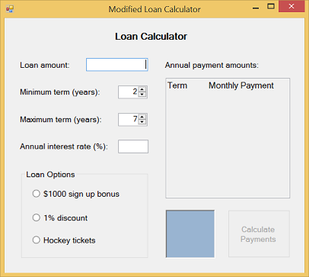
The user enters a value into the Loan amount TextBox:
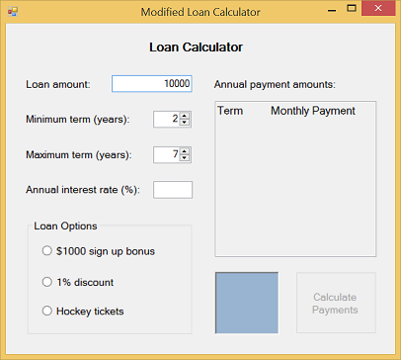
Notice that the Calculate Payment Button is still disabled. The user enters a value into the Annual interest rate TextBox:
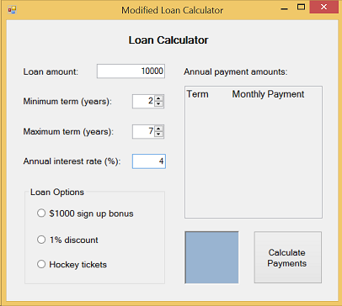
Notice that the Calculate Payment Button is now enabled.
The user then clicks the Calculate Payment button:
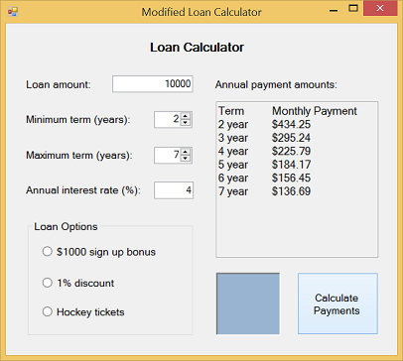
Each row in the payment Multiline ReadOnly TextBox indicates the monthly payment amounts that would pay down the loan balance to 0 by the end of the specified term. For example, the third line of output shows that if you took a $10,000 loan with a 3-year term at 4% interest, a monthly payment of $295.24 would be needed to pay off the loan after 3 years.
Notice that no image displays in the PictureBox because no loan option was selected.
The user selects the Bonus RadioButton:
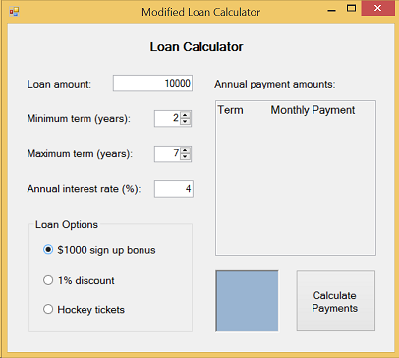
When the user selects a RadioButton, the contents of the Multiline ReadOnly TextBox are cleared (except for the heading line). This is done to keep the GUI in a consistent state.
The user then clicks the Calculate Payment button:
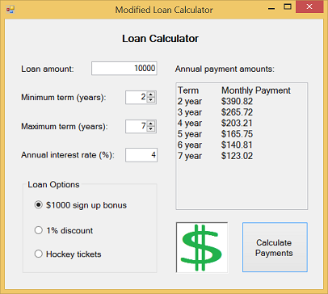
The new monthly payments are listed in the Multiline ReadOnly TextBox. The payments reflect a loan amount that is discounted by $1000, making the effective loan amount $9,000. Notice that the monthly payments for the 3-year term loan is now reduced from $295.24 to $265.72.
The user then clicks the 1% discount RadioButton:
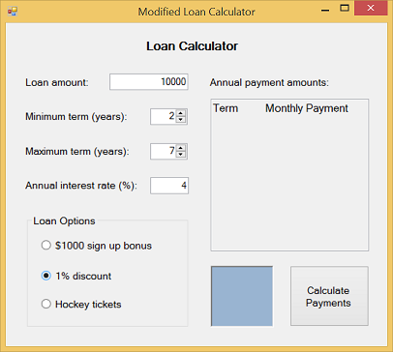
When the user selects a different RadioButton, the contents of the Multiline ReadOnly TextBox are cleared (except for the heading line) keeping the GUI in a consistent state. Notice that the BonusRadioButton is deselected automatically as required since a user can only have one option in this version of the application.
The user then clicks the Calculate Payment button:
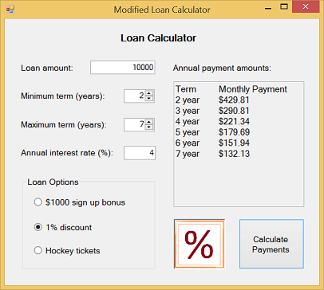
The new monthly payments are listed in the Multiline ReadOnly TextBox. The payments reflect a $10000 loan amount with an effective annual interest rate of 3% (resulting from 4% discounted by 1%). Notice that the monthly payments for the 3-year term loan is now $290.81.
The user selects the Hockey tickets RadioButton:
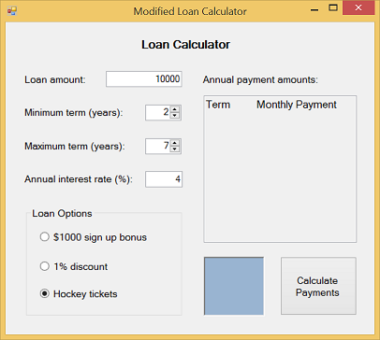
When the user selects a different RadioButton, the contents of the Multiline ReadOnly TextBox are cleared (except for the heading line) keeping the GUI in a consistent state.
The user then clicks the Calculate Payment Button to display the new monthly payment calculations:
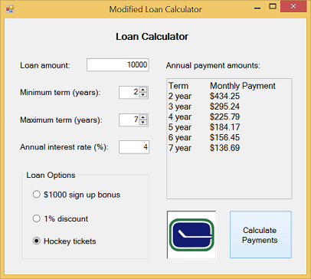
Notice that the new monthly calculations appear and the Vancouver Canucks logo appears.
Next, the user wants to change the loan amount to 12000 by first clearing the Loan amount TextBox:
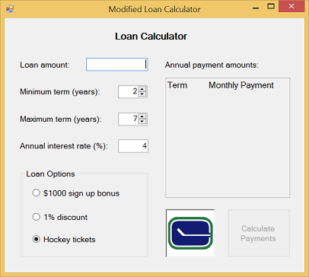
Notice that the contents of the Multiline ReadOnly TextBox are cleared (except for the heading line) keeping the GUI in a consistent state. Also notice that the Calculate Payments Button is disabled.
As soon as the user type the '1' of 12000 the Calculate Payments Button becomes enabled:
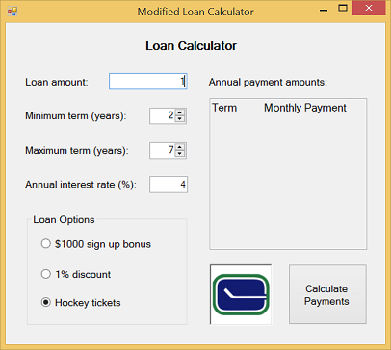
Notice the logo is still displayed in the PictureBox.
The user finishes entering the new loan amount 12000 and clicks Calculate Payments Button:
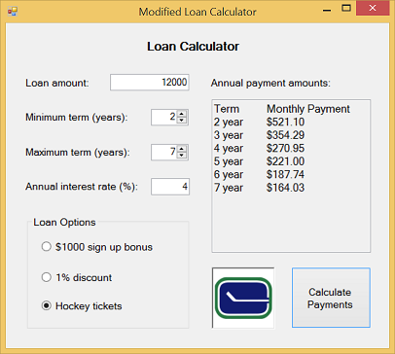
Now let's look at the NUD controls.
The user clicks the down arrow on the Maximum term NUD:
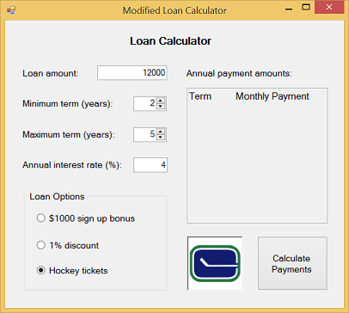
As soon as either of the NUDs change the contents of the Multiline ReadOnly TextBox are cleared (except for the heading line) keeping the GUI in a consistent state.
The user then clicks the Calculate Payment Button:
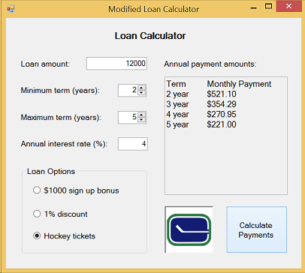
Notice that only the calculations are made for terms of 2 year to 5 years.
Now, let's say the user wants to display the calculations for terms in the range of 6 years to 10 years. The user could click the up arrow of the Maximum term NUD until it displays 10 followed by the user clicking the up arrow of the Minimum term NUD until it display 6.
However, if the user first clicks the up arrow of the Minimum term NUD until it displays 6, we could be in a situation where the minimum term is higher than the maximum term. To avoid this situation, as the user increases the Minimum term NUD, the ValueChanged event handler for the Minimum term NUD should check to make sure the Maximum term NUD has a Value property that is at least the Value of the Minimum term NUD. If it doesn't, the Value property of the Maximum term NUD should be increased to match the Value of the Minimum term NUD.
For example, suppose the new range the user wants is 6 years to 10 years. The user could click the up arrow on the Minimum term NUD until it displays 6. When she/he has clicked it to 5, the GUI would look like this:
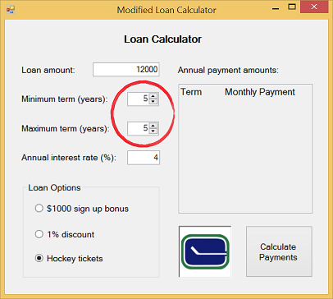
When she/he clicks the up arrow on the the Minimum term NUD one more time, the value displayed in the Maximum term NUD also increases by one to make sure the minimum term can never be greater than the maximum term:
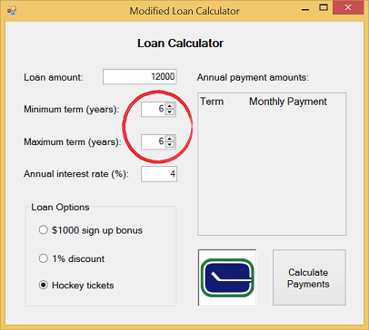
Note that a complementary effect should be handled in the case of the user decreasing the Maximum term NUD beyond the minimum term value.
To finish the adjustment for the 6 to 10-year term specifications, the user would click the up arrow on the Maximum term NUD until its value is 10 and then the user would click the Calculate Payment Button:
