NORFOLK HOUSE MUSIC ROOM

Furniture History

Norfolk House Music Room
French aristocrats, who spend more their time in the luxurious private estate, hosted parties and enjoyed life - that was the world where Rococo was originated. It was first established as a form of interior design. For this reason, to understand the concept of Rococo one cannot start with grand facades of buildings, it is necessary to look inside them.
Norfolk House Music Room was one of the entertaining rooms in the Norfolk House of the Duke of Norfolk and dated to 1756; it was designed by the carver Jean Antoine Cuanot and the plaster Thomas Clarke. The Music Room was decorated like an up-to-date salon in France. The Duchess of Norfolk was fond of all French things; consequently, she chose designers and artisans well-versed in French style. Both the designer Giovanni Battista Borra and his executive Cuenot came from Turin and Doubs, where French fashions prevailed.
The interior of the Music Room is a total work of art with lavish furniture, ornament mirrors. The Rococo style is characterized by playful themes; Rococo artists and designers` style was decorative and used light colors, especially white, broken curves, silver, and gold. Walls, ceiling, furniture, and works of gold and porcelain presented a picturesque, curious feature of carved stucco. The ceiling is full of Rococo trophies, the walls` sculptural forms expressed with abstract ornament using scrolling acanthus leaves. The interior includes all the main characteristics of Rococo: elaborately carved forms, natural motifs, the acanthus leaves and asymmetry. However, other elements like the overall proportions and the compartmentalized ceiling belong to the Palladian style. “The slightly `squashed` appearance of some of the Rococo decoration suggests that this may have been a later addition to the plans for the room`s decoration.” The general aesthetic was achieved through use of light colors, like ivory whites, polished marble, and gold. All materials and colors in the Music Room are visually light as well as opulent, creating an airy feeling. This aesthetics was reached in the furniture, flatware, and decorations as well.
In conclusion, the Rococo style was primarily used in furniture and interior, rather than in architecture. The Norfolk House Music Room is one of the brightest examples, that shows the strong French influence on British manner of design. In interior it manifests itself as curve forms, asymmetry, S and C strolls, the acanthus leaves on walls and ceiling, and combination of pastel and light colors.

Bibliography
"Norfolk House Music Room." Victoria and Albert Museum. http://www.vam.ac.uk/content/galleries/level-2/room-52nh-norfolk-house-music-room/.
"Rococo Interior Design: Style & Elements." Study. https://study.com/academy/lesson/rococo-interior-design-style-elements.html.
"Style Guide: Rococo." Victoria and Albert Museum.
http://www.vam.ac.uk/content/articles/s/style-guide-rococo/.

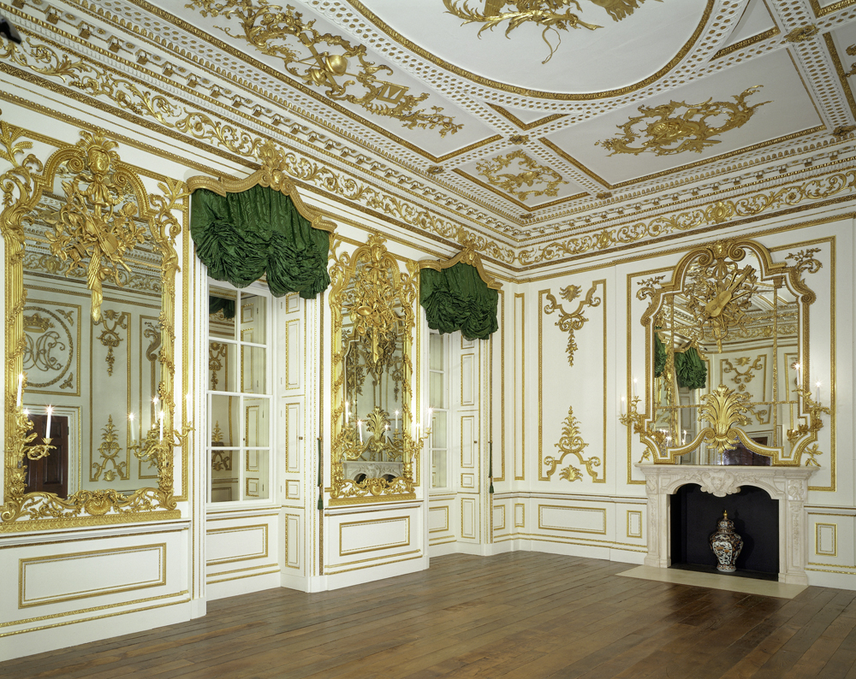

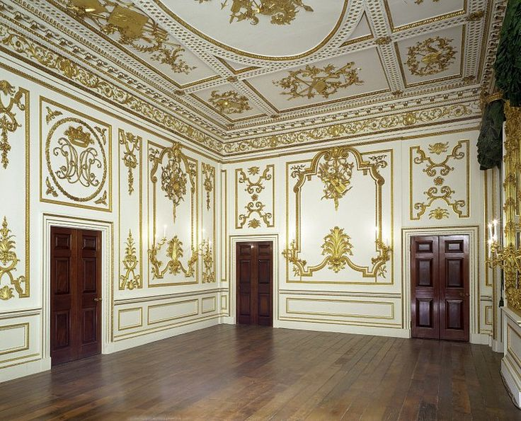

https://study.com/academy/lesson/rococo-interior-design-style-elements.html
http://www.vam.ac.uk/content/galleries/level-2/room-52nh-norfolk-house-music-room/
http://www.vam.ac.uk/content/articles/s/style-guide-rococo/
http://www.vam.ac.uk/content/articles/s/style-guide-rococo/

