Dr. XXXXXX

Dr. XXXXX

12/06/17

Team #44

XXXXX

XXXX

XXX



*Let us Show You How*

Table of Contents

1. Executive Summary 3

2. Situation/Problem Statement 4

3. Market 5

4. Customers Segment 5

5. Distribution Channels 6

6. Customer Relationship 7

7. Revenue streams 7

8. Key Activities/ Partners and Resources 8

9. Cost structure 8

10. The product 8

11. Appendices 9

12. Project Management 10

13. BMC 11

14. Product Initial Design: 12

***Table of Figures***

**Figure 1: Gantt chart for the Fall** 11

**Figure 2: Gantt chart for the Spring** 11

**Figure 3: Updated Business Model Canvas** 12

**Figure 4: Initial design to the front of the device.** 13

**Figure 5: Initial design to how to hang the device in the kitchen.** 14

***Table of Tables***

**Table 1: Customer Type** 6

**Table 2: Archetype Highlights** 6

**Table 3: Day in the life of Customer** 6

**Table 4: Evaluation of Product Substitutes** 9

## 1. Executive Summary

Our team has hypothesized that many people struggle to obtain healthy meals and maintain adequate diets. We had designed a survey from which we conducted 100 interviews regarding our hypothesis. The interview responses include stories from individuals providing their opinions regarding diet and health. All the interviewees have expressed that it would be nice to have assistance in preparing suitable meals in their kitchen. WholeHealth Diet provides a solution to the problem many face in maintaining a healthy and complete diet. We have invented at revolutionary device equipped with the latest software technology to enhance the user experience in the kitchen. This tool is a smart gadget with a friendly interface design that will be the answer to many concerns in how to make a proper healthy meal at home. 82 of the 100 interviewees expressed not having enough time and or not knowing how to cook or what portions to use for their type of body. Furthermore, the remaining 18% of interviewees are telling us that they normally tend to search the internet to cook and find info about ingredients or struggling to find a recipe that match what is in their inventory. This feedback validates our hypothesis that the WholeHealth diet product could be the solution for many of these issues.

The team observed from the obtained data that our target customer will be young urbanite professionals. These individuals are people who have smart technology at their home, and usually will spend the time searching for healthy topics on the internet. Also, time management is paramount with many of these individuals, and they do not have the time to prepare elaborate meals. Current competitors in this market either cover food management for the food service industry only, or provide phone apps that are limited in providing diet guidance, or sell luxurious appliances from Samsung and Whirlpool to serve a ‘smart’ kitchen. The phone apps are inadequate to address the meal preparations for the individual, since it lacks in addressing the health concerns as connected to diet. Also, companies such as Whirlpool require a major upgrade to ones kitchen. The channel distributions are using social commerce platforms to promote the device, and our website will be managed by one of the already existing online software companies. Regarding the customer relationship, we are intending to get an agreement with medical organizations to recommend the device’s benefits, and keep improving the software maintenance process remotely as well as sign partnership rewards with medical providers. Also, there is a plan to grow the customer base through investing in how to improve and optimize the benefits for the user and the referrals program. For now, the team is focusing on generating a prototype product as mockup which will include all the main features.

## 2. Situation/Problem Statement

The problem our team is solving is to provide a product technology, which will help people obtain a healthy diet. The 100 interviews reveal good dietary habits are very important to individuals.

The obtained data shows that our customers care so much about what is on their plates, and they would like to have a better way that enable them to gain control over their food intakes. During our interviews, we asked individuals how do they maintain and search for their healthy items.

Every individual expressed that they search the internet or certain websites to get advice on diet.

Their replies have encouraged our team to pursue the development of the WholeHealth Diet project, which is a technology product that will provide the right info or recipes within a timely manner for the user in their kitchen. Another important validation of our product was the response to the question, “What is the most valuable tool when they cook.” 80 of the 100 responses showed individuals used smart phones, the website, or phone application to describe their most valuable tool to make a healthy meal. All these findings indicate that there is a great need for our product. For the value propositions, the WholeHealth Diet product will save the consumer time by providing guidance for the individual’s dietary need. Our product eliminates the need for the consumer to spend time searching for recipes and ingredients’ on the internet. All the consumer needs to know is what is in their food pantry. In Addition, using the device will encourage the customer to cook at home, which will save a lot of money for the user.

## 3. Market

The current market offering dietary health information products addresses only some of the aspects an individual requires to have a healthy diet. These current products are dedicated to only addresses the needs of the food service industry such as restaurants, or require an expensive investment in a ‘smart kitchen’, or provide phone Apps which are limited in scope in addressing individual dietary needs. Our product will re-segment this market, by offering a unique service which involves assisting the individual in the preparation of meals at home in order to assist health requirements. As a consequence, the market is wide open for our product to compete. There is a trend for a growing number of individuals researching the internet to find healthy meal recipes for their diet needs. Since there does not exist any all in one products that completely address the diet needs of individuals, we anticipate an exponential growth over the next 5 years before others join this market. The health and nutrition market is estimated at about $277 Billion to date. [1] The products that are offered only partially address the specific needs of an individual’s nutrition needs. The current projected trend shows that the nutrition and health informational technology will most likely not change over the next 5 years from what it is at the present. The market appears to be influenced by two main factors which are taste and price and this will continue over the next 5 years to remain this markets influence. By 2020 this industry is projected to reach $1 Trillion. [2]

## 4. Customers

Our initial hypothesis was that the customer segment would be busy athletic students and nutritionists. After our collection of data from 100 interviews to date, we have found that are customer segment are young urban professionals between 25 and 35 years of age who spend time on social media every day and lack the experience in cooking meals themselves. Also, these individuals have time management constraints, but are curious about the latest technological trends. Based on our interviews, these individuals are eager to embrace our technology product since it informs them completely on diet and food preparation as well as saves them time. Below are three tables indicating Customer Type, Archetype summary, and a table giving a breakdown of the average day of a customer from this segment.

|  |  |
| --- | --- |
| **Customer Type** |  |
| End users | Young and busy workers between the age of 25 -35. |
| Influencers | Paid fitness vloggers, Amazon fee for showing the product in their main page, and partner or parents that might encourage buying the product. |
| Recommenders | “Too Good To waste”, A campaign by the EPA, [3] and health Organizations that support healthy habits. |
| Economic Buyers | Insurance companies and patients with bad healthy habits |

**Table 1: Customer Type**

|  |  |
| --- | --- |
| **Archetype Highlights** | **Customer Acquisition Guidance** |
| Age 25-35, moderate income | Paid social media vloggers and promotions |
| Busy young Professionals | Advertise only on the weekend |
| Cooks only if there is time | Send emails, tweets and text two days before the weekend |
| Having friends coming over every week. | Entertainment shows and vloggers to promote for the device. |

**Table 2: Archetype Highlights**

|  |  |
| --- | --- |
| **Day in the life of Customer** | **Acquisition Guidance** |
| Spend around 15 mins/day on social media | Twitter, YouTube and social media marketing |
| Read cooking receipts from websites and magazines | Advocate for press release in this field |
| Share and talk to friends about latest trends in technology | Provide recipes and discounts to circulate to friends. |
| Spend money on foods outside the house | Use banner ad near most visited restaurant |

**Table 3: Day in the life of Customer**

## 5. Distribution Channels

At the beginning, we hypothesize that our two main channels will be as follows; (1) a dedicated e-commerce, presented by hosting our own domain as a direct sales channel. This is accomplished by using a social commerce platform to promote the product through vloggers, bloggers who use video content, which will advertise the device within the healthy dining topics search for our targeted customers. (2) This channel consists of using Amazon Marketplace, which is a platform that facilitates anyone to sell directly to the end-user or online customer. For the second channel, we have obtained the information needed at the Amazon website which describes the relationship “fulfilled by Amazon”. The terms of the contract sited on their website include Amazon’s referral fees for any sale of product, storage fees for product storage, and shipping fees for any shipped product. Based on our interviews, we find that the our customer segment finds and purchases products over the internet far more than purchasing products by visiting physical store sites. This has a direct bearing on what we have decided to be our distribution channels.

## 6. Customer Relationship

We plan to contact medical organizations such as private physicians and hospitals to see if any of these individuals will endorse or promote our product. Also, we plan to research the avenues of federal campaigns to advertise our product and its importance to good diet and health. We are going to incorporate Google AdWords and search engine optimization, which will serve to attract attention to our product and as a result increase traffic flow for this product. We will maintain our customer base by maintaining our software and updating the product on a regular basis. This will all be accomplished remotely. Also, we will have a rewards program resulting from the use of the product in which will be enabled by the user. We will continue to research dietary needs and technology as to be able to enhance our current conception of this product.

# 7. Revenue streams

For the demographic sector of our product, we have found that the average individual is willing to pay $400 to have such a product which will assist them in their dietary needs by giving them the preparation directions for preparing appropriate meals. The product is sold in two forms which is either an interactive software product which can be purchased online or a handheld hardware unit which will be shipped to the purchaser. We will continue to update the software over time and these updates will be available for purchase online. If the customer has purchased our hardware unit they can download our updates through a common USB port. Currently, there is no such product as ours available. We will have to complete a prototype of this product to be demonstrated for these anticipated users. Our research tells us that these people prefer paying through the internet. They would rather purchase this way rather than going to a brick and mortar outlet as has been traditionally done. This means of purchase will be our sole source of revenue. Also, we will have contractual agreements with Amazon in order to handle purchase and delivery at some percentage yet to be investigated.

# 8. Key Activities/ Partners and Resources

The logistics of our business model involve manufacturing of the hardware product, software development, website maintenance, a permanent software development staff and shipping of the hardware device. Much research remains to be done on all of these items. We plan of having the hardware built in China and the software developed locally. Building the hardware in china we anticipate will be far less costly than having it built here. On the other hand we would like the software developed locally, since there are always bugs and modification issues which require ongoing communication. Communication is far easier when done locally. The shipping will be done though Amazon (at least this is our current projection). Our partners will be a software firm, web design and maintenance firm, and Amazon. At least this our current view.

# 9. Cost structure

Currently we do not have any ‘hard figures’, but we are researching this. We plan to retail the product at about $400 and would enjoy a 10% return on this retail price. Now we will need to pay out for initial software development along with hardware manufacturing cost. Also, we will need to pay for a permanent website maintenance service along with a delivery and warehousing costs to Amazon.

**10. Facility Planning:**

# 10. The product

WholeHealth Diet is a product designed to assist the user to prepare a proper healthy meal based on their food inventory. This device will have an interface which should be intuitive for the customer to use. Three primary features are available on the device; first, the individual will be able to track their food inventory through a barcode reader. Based on their inventory and their dietary needs, this device will seek a solution in the form of cooking preparation directions for a meal plan when possible. Second, the device will create a shopping list that can be synchronized to their phone. In addition, one will have the option to purchase everything online from this shopping list in order to save time. For online ordering the device platform will be connected to grocery stores around the customer’s area that participate in online purchases and delivery. Last but not least, it will have the ability to come up with recipes based on your inventory, and the user will have access to a huge database to search for ingredient’s , healthy tips, and other types of information that lead to a healthier plan for the user.

From the obtained data, our interviewees are struggling to find time to cook, lack of knowledge to prepare a meal and the user does not know nutrition facts unless he or she spends time to research for it. The main features will help the user to have a better confidence in their skills to make a healthy meal with the assistance of the device. These features will guide the user to make a meal from the start to finish. In term of competitors, there are three type of products that are similar to ours with differences in how to integrate these products into the kitchen. First, Family Hub Refrigerator from Samsung that has large touch screen with apps and camera feed shows what is inside the refrigerator. Second, Whirlpool interactive kitchen which is fully integrated and designed to learn the users’ habits to assist them better. Third, phone apps that have similar feature but are considered inadequate due to many factors. [4]

|  |  |  |  |
| --- | --- | --- | --- |
| Evaluation | Phone Apps | Samsung refrigerator | Interactive kitchen |
| The good | Easy to use, free and could be in your phone all time. | Touchscreen, apps and camera feel useful for the user. | Fully integrated kitchen and understand the user behavior. |
| The bad | Complicated design, lack of features, too many upgrades and bug issues. | User cannot delete apps neither add new ones, there is no Voice control. | It is not for sale yet, and it’ll be so expensive. |
| The bottom line | Apps get lost among other apps; distracted and frustration come along using these apps for its inadequate software. | It’s an expensive fridge that starts from $5,600. | This type of product fits customer with high budgets. |

**Table 4: Evaluation of Product Substitutes**

# 11. Appendices

[1] (Health and Wellness the Trillion Dollar Industry in 2017: Key Research Highlights, 2012)

[2] (Krom, 2016), http://www.womensmarketing.com/blog/2014/11/health-and-wellness-market/

[3] (Food: Too Good to Waste Implementation Guide and Toolkit, n.d.)

[4] (Crist, Ry, 2016), <https://www.cnet.com/products/samsung-family-hub-refrigerator/>

# 12. Project Management

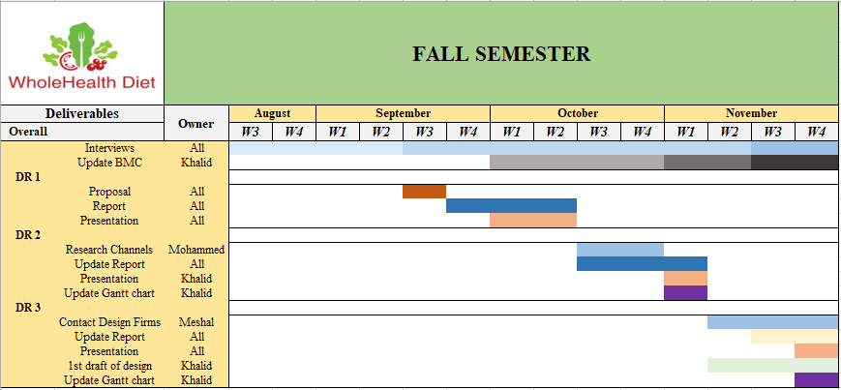

**Figure 1: Gantt chart for the Fall**

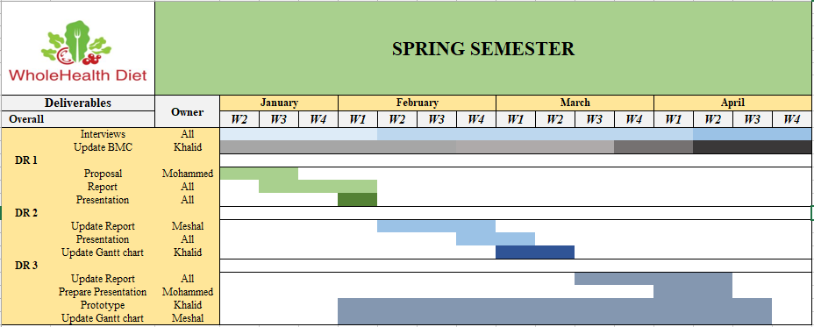

**Figure 2: Gantt chart for the Spring**

# 13. BMC

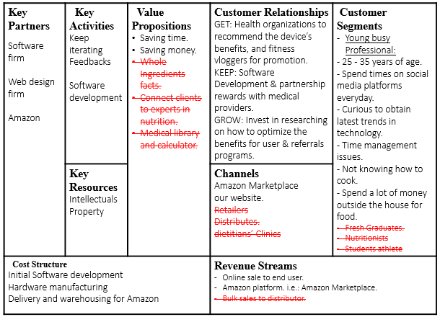**Figure 3: Updated Business Model Canvas**

# 14. Product Initial Design:

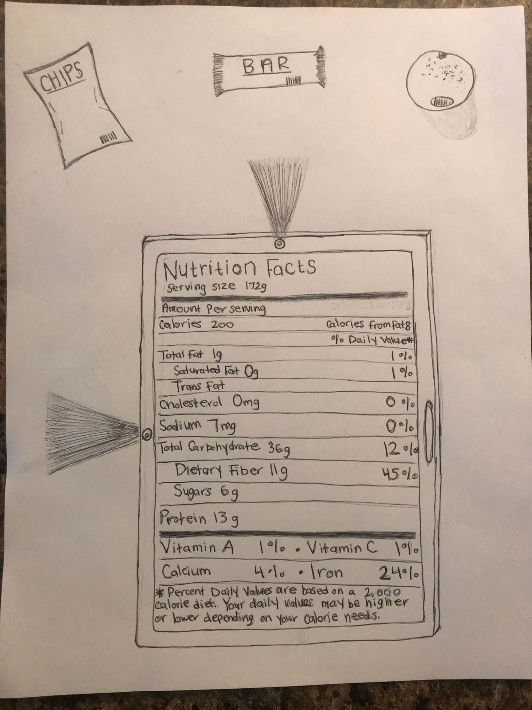

**Figure 4: Initial design to the front of the device.**

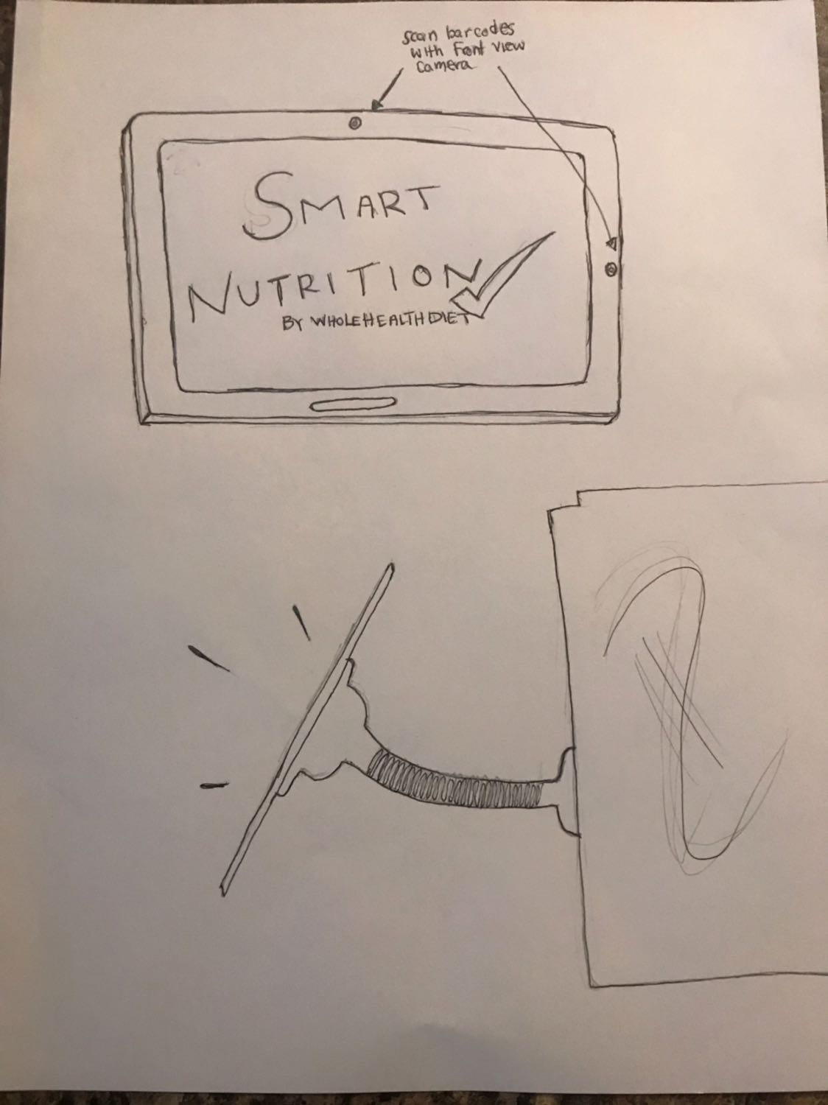

**Figure 5: Initial design to how to hang the device in the kitchen.**

**These guidelines can help you structure your written report:**

* **Title Page**
* **Table of Contents, Table of Tables, and Table of Figures**
* **Executive Summary**
* **Situation/Problem Statement**
  + “What is the big thing you are trying to solve?”
  + Why?
  + What are the value propositions? What do customers care about? Evidence!!!
* **Market**
  + Total market, market segments
  + Target market
  + Market trends (projected growth)
  + Applicable market research
  + Target market share
  + Cross-over market share
  + Market constraints
* **Customers**
  + Hypotheses about customer segments and what was learned leading to the current hypothesis
  + Customer archetype(s)
  + Preferences and problems/needs
  + Customer diagram
* **Distribution Channels**
  + Initial hypothesis about channels and what was learned leading to the current hypothesis
  + What have you learned about where the customer segments buy?
  + Channel diagrams
  + How would you get to them? - logistics/shipping and distribution
* **Customer Relationships**
  + Get/Keep/Grow
  + How to create end user demand?
  + Advertising and promotion
  + Long term value of customers
* **Revenues Streams**
* For what value are our customers really willing to pay?
* For what do they currently pay?
* How are they currently paying?
* How would they prefer to pay?
* How much does each Revenue Stream contribute to overall revenues?
* **Key Activities/Partners and Resources**
* **Cost Structure**
* The Cost Structure describes all costs incurred to operate a business model
* **Facilities planning**
* How are the products to be produced?

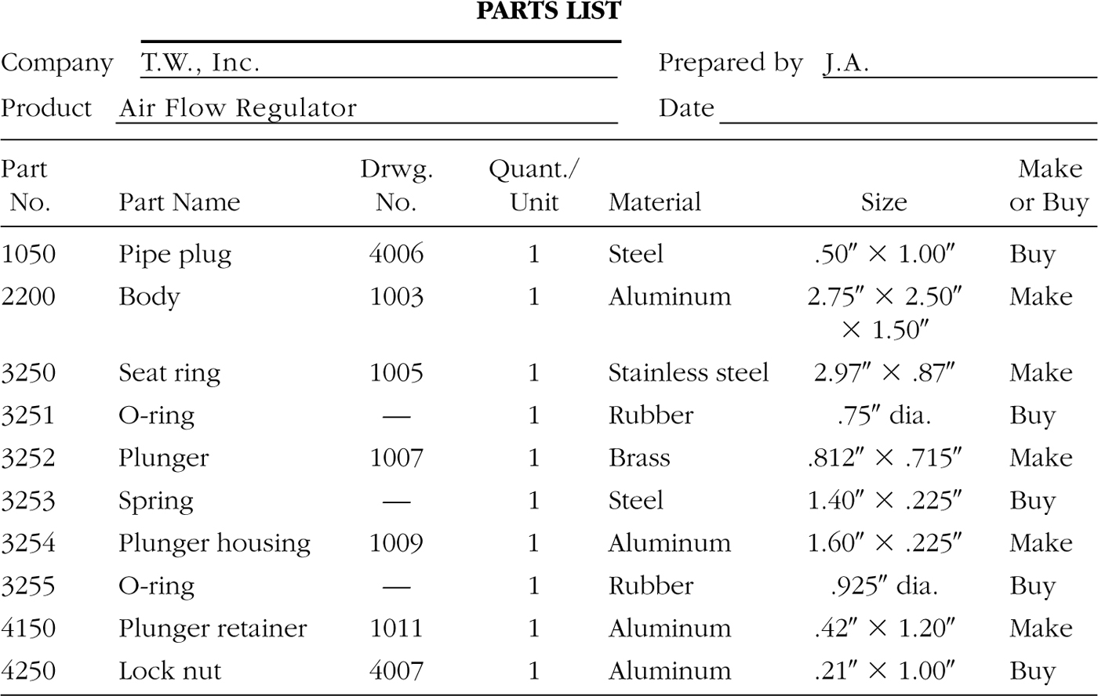

* When are the components of the products to be produced?
* How much of each item will be produced?

1. Facilities Location (Tampa Bay Area)

* How the location of a facility supports meeting the facility’s objective
* Placement with respect to customer, suppliers, and other facilities with which it interfaces
* Includes its placement and orientation on a specific plot of land

1. ¨ Facilities Design

* How the design components of a facility support achieving the facility’s objectives?

1. Facility Systems Design: Structural systems, atmospheric systems, enclosure systems, lighting/electrical/communication systems, life safety systems, sanitation systems.

* E.g., power, light, gas, heat, ventilation, a/c, water, sewage

1. Layout Design: Equipment, machinery, furnishings within the building

* E.g., production areas, production-related or support areas, personnel areas within the building ¨

1. Handling System Design: Mechanisms needed to satisfy the required facility interactions

* E.g., materials, personnel, information, and equipment-handling systems required to support production ¤ Transportation, receiving, storage, retrieval, packaging, etc.
* **The Product**
  + Description of the product
    - How the product solves customers’ problems/needs?
  + Competitive products/technologies: Strengths and weaknesses for each
  + Evaluation of product substitutes
  + Competitive advantage(s) of your product
  + Regulatory, legal requirements
  + Product pricing
* **Appendices (some possibilities as of now)**
* **Project Management** – updated until now
  + Tasks (sequential, coordinated). Timing
  + Persons accountable
  + Resources needed
  + Contingencies for schedule changes
* **Updated Business Model Canvas**
  + Evolution of business model canvas from initial to current with changes clearly marked
* **Product design/initial view/drawing**

Process identification: Make or buy analysis ¤ Parts identification

Process selection: Identify required processes to make the product

Process sequencing: How the components will be assembled

Parts list - List of items to be made and items to be purchased

¤ Bill of materials - Structured parts list with hierarchy

# WRITTEN REPORT FORMAT:

All documents must be computer-based (word processor, spreadsheets, and any other specific software required). All documents should be neat, clean, and professionally presented.

* All documents should have the following format:8.5”x11” pages
* Margins: Top 1”, Bottom 1”, Left 1”, Right 1”, Header 0.5” and Footer 0.3” from edge
* Spacing: 1.5 lines
* Font: Times New Roman - Size: 12
* Page Numbers: Bottom of page (Footer) - Alignment: Right
* All pages, including appendices pages, should be numbered
* All figures and tables should be numbered
* All sections should be numbered
* Make proper use of footnotes or references to show sources of data/information

Footer:

* Should include: name of the team, title of the report, date, and page number.
* Font: Times New Roman - Size: 10

All documents should have the following parts:

* Title page (with Business name, logo, and slogan)
* Contents page including tables and figures
* Executive Summary at the beginning