Forecasting Case Study: New Business Planning
Important Note: Students must access the “Entrepreneurship and the U.S. Economy” page of the Bureau of Labor Statistics website in order to complete this assignment.
Scenario
The generation of new business start-up is vital to the growth of the economy as it builds new jobs and creates new opportunities for the community. The Bureau of Labor Statistics tracks new business development and jobs created on the website for the United States Department of Labor. You have been tasked with forecasting economic growth and decline patterns for new businesses in the United States.
Forecasting
Access the “Entrepreneurship and the U.S. Economy” page of the Bureau of Labor Statistics website. Under the "Business establishment age" heading, the first chart reviews new businesses less than 1 year old during the March 1994 to March 2015 period. Click on the [Chart data] link below the chart:
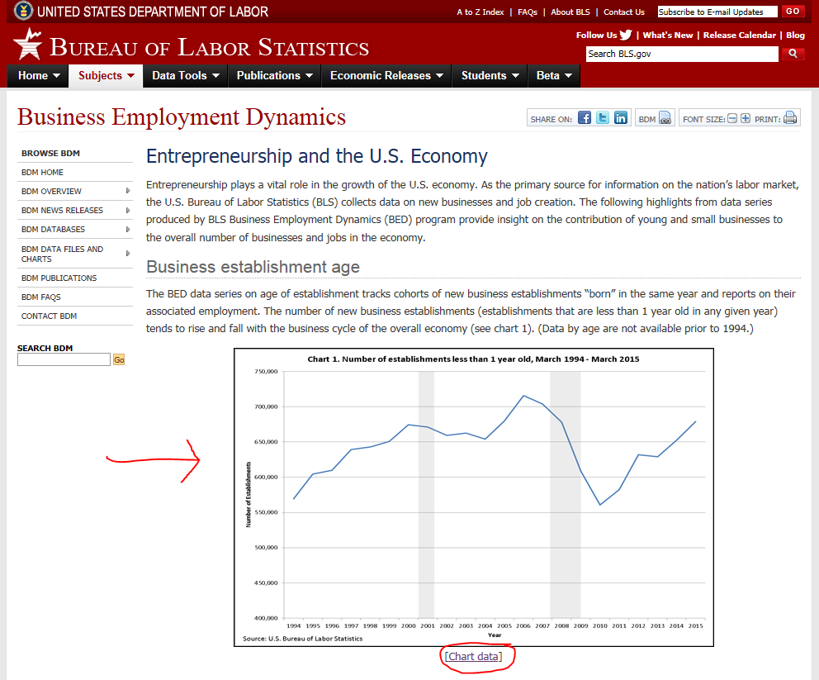

Once the chart data window opens, you will see the number of establishments that are less than 1 year old for each year during this period:
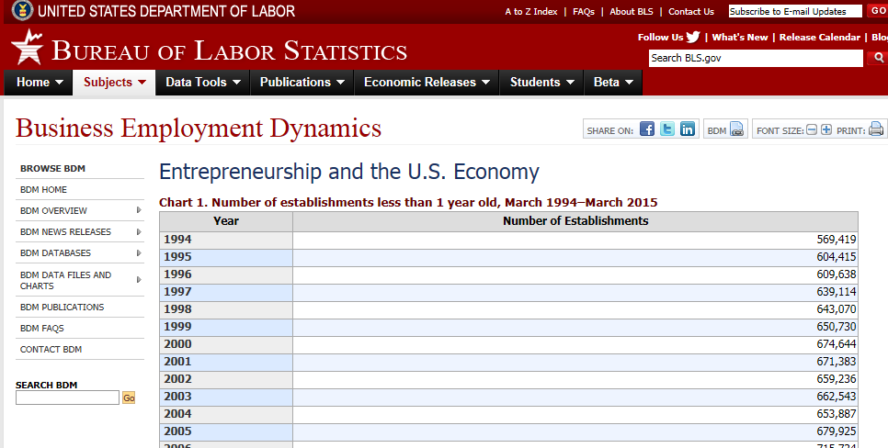

Using the five most recent years and the "Forecasting Template" spreadsheet provided, complete the forecasts for the next two periods and provide updated Totals and Average Bias, median absolute deviation (MAD), mean squared error (MSE), and mean absolute percentage error (MAPE) for all four charts. Provide a Summary Page in Excel with a 500-750 word report on the analysis completed by the forecasting models. Include review of error, recommendations on the best forecasting model to use, and analysis of the business trend data for new business startup in the United States.

