Students will create either a brochure or an infographic (NOT both) about their chosen community problem. See p. 156-164 of The Handbook for specific guidelines. Students will include a short reflection with their visual argument. Please last page for more detailed guidelines for the reflection.
Mini-lecture: The Visual Argument
In this assignment, you will advocate for policy change based on your Community Problem Report. You will argue for policy change using ethos, pathos, and logos. You will select a genre for your visual argument that suits the community you are composing to. Your choices are:
- A Brochure: There are brochure templates in Microsoft Word and Pages, but that doesn’t mean that it’s an easy assignment.
- An Infographic: A collection of images and data. You can google Infographic to see examples.

Choose from one of the following style of argument to use for the Visual Argument.
Mini-Lecture: Aristotelean Arguments
There are many different ways of creating arguments; in this class, we're going to go over two of them. The first is Aristotelian Arguments.
Aristotelian arguments are a “traditional” form of arguing--this is probably what you were taught in high school. You seek to validate your own position. Typically, you refute another person’s argument or create a “strawman” to attack. This style of argument follows this format:
  - Context/background (what is the debate; how did it start; why has it not been resolved; etc.)
  - thesis (what belief should your audience adopt; what set of actions should they perform)
  - support of thesis (major reasons and corresponding evidence for why your thesis is valid)
  - concession (in what ways MIGHT your opponent be correct)
  - refute opposition (in what major ways is your opponent incorrect)
  - conclusion (relevance or course of action)
This is one style you can use in your Visual Argument.

Mini-Lecture: Rogerian Arguments

A less common style of argument is Rogerian Arguments. Rogerian arguments focus on consensus building. Typically, you validate your opponent’s position and argue for a compromise that will benefit both you and your opponent.
Usually, you follow a method like this for Rogerian Arguments:
  - Validate your opponent's position: what is your opponent’s perspective and how is it understandable?
  - State your own position: What is your position and how is it similar to your opponent’s?
  - Suggest compromise: what outcome would be ideal for all parties?
This is another model that may work for your Visual Argument.

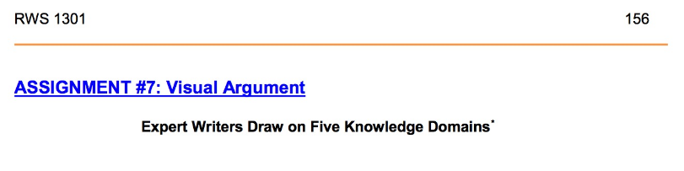
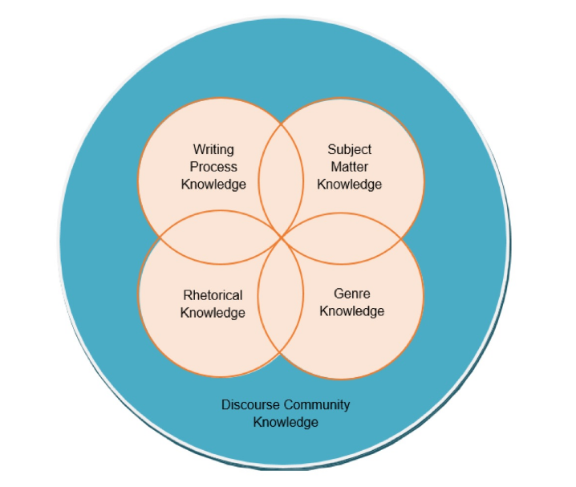
Helpful Link: https://multimodalstudies.wordpress.com/what-is-multimodal-literacy/
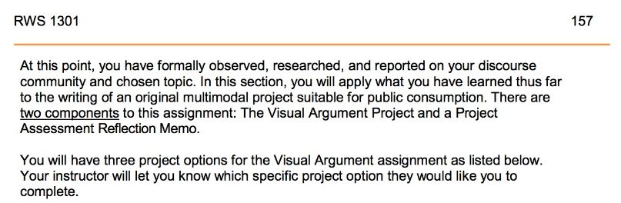
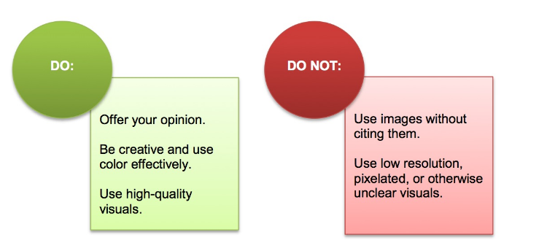
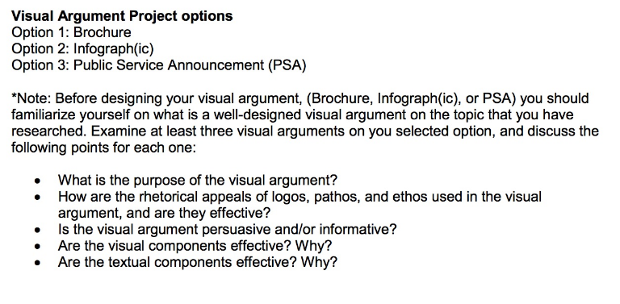
Please ignore the Public Service Announcement (PSA): Choose either Option 1 or 2 please.
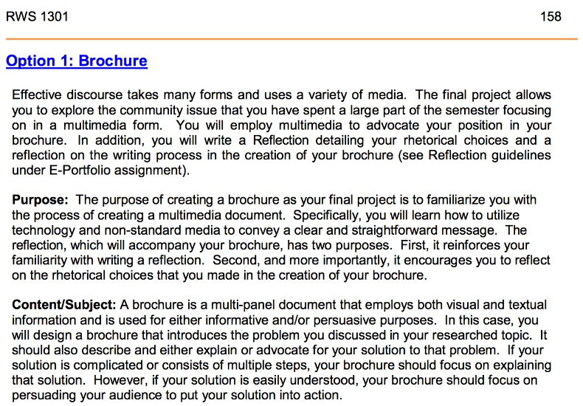
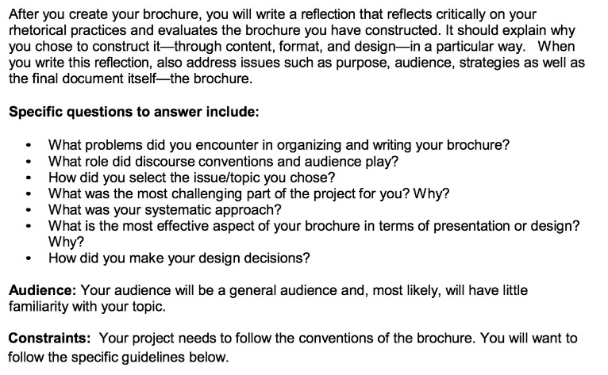
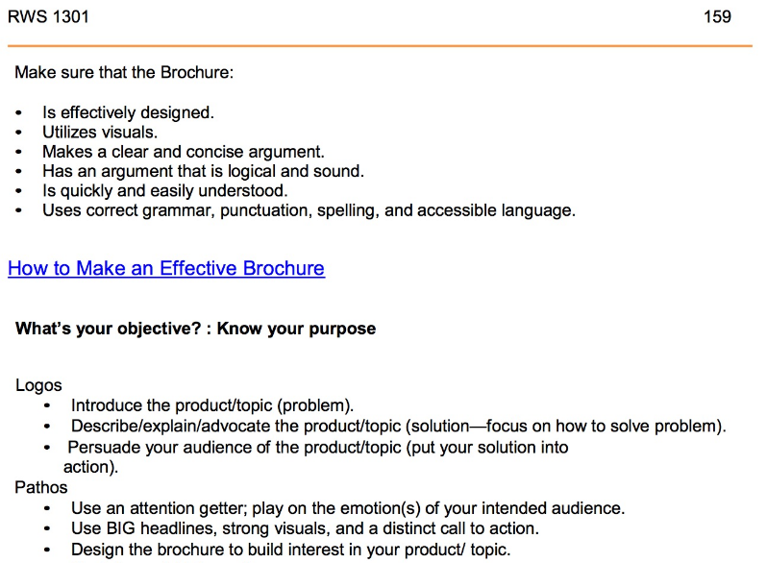
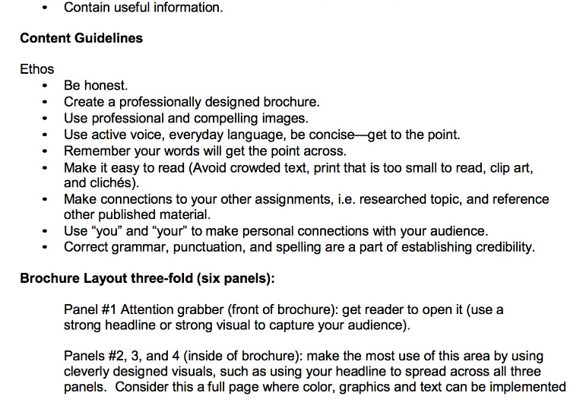
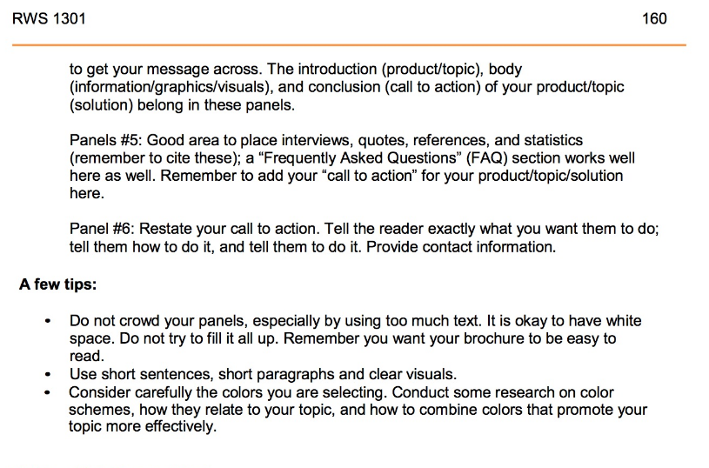
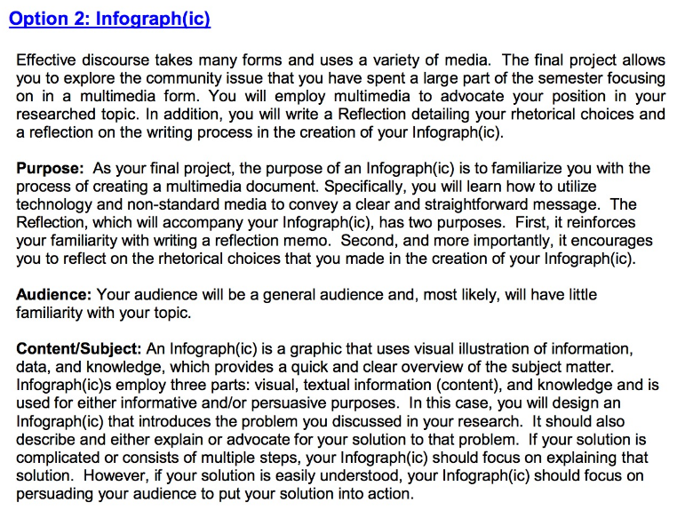
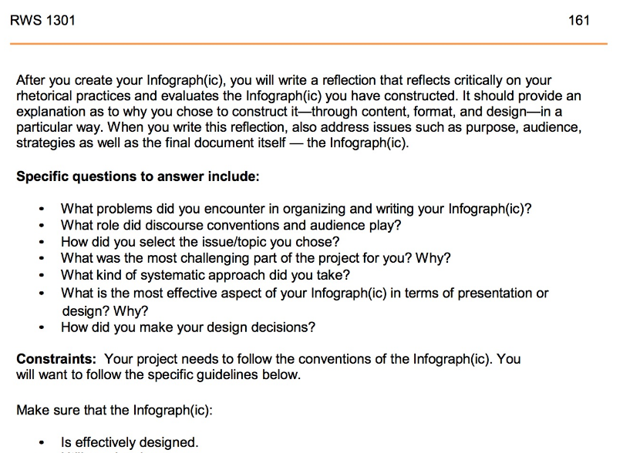
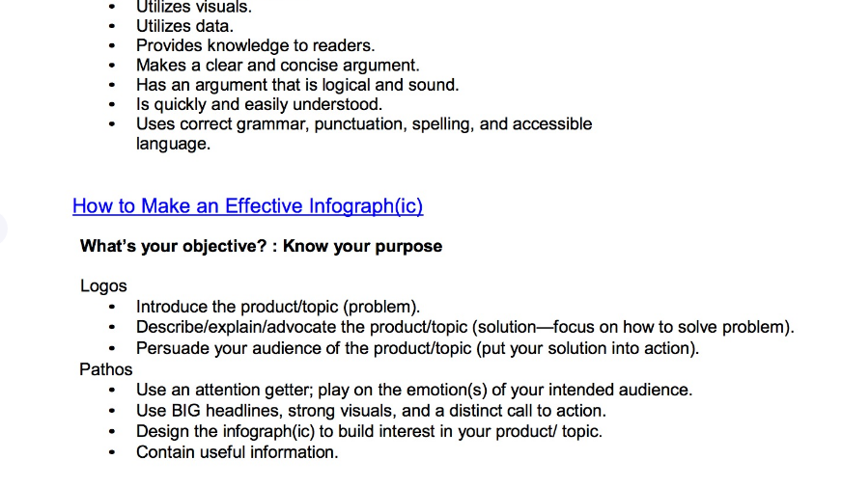

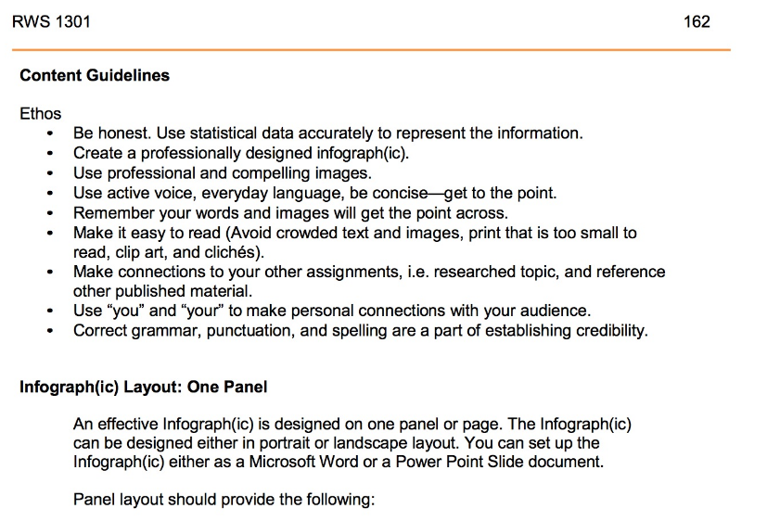
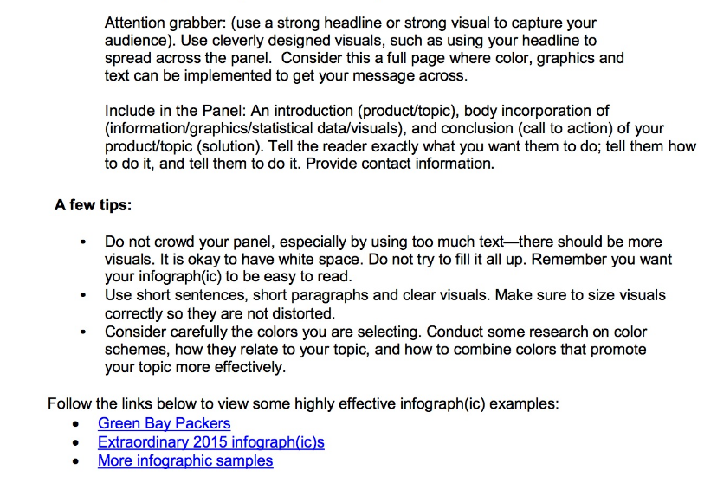

Links for the above page:
1. http://www.packers.com/news-and-events/infographic/article-1/Infographic-Green-Bay-Packers-2014-Schedule/37113ff8-274b-4045-aad1-2513c8a09c67.
2. https://blog.hubspot.com/marketing/best-infographics-2015#sm.0000bat3qwax9eij11h7bildhe45q
3. http://www.example-infographics.com/

