Assignment 2: Infographic and Blog Post on a Digitally-Enabled Movement

CCT 320, Professor Alex Hanna

Winter 2018
Primary source research relies on data which you collect yourself, which secondary source research summarizes what others have found. For this assignment, you will be doing primary source research on a social movement, which means you will be collecting some of your own data in order to present facts about a digitally-enabled social movement.
As we discussed in class, a digitally-enabled movement is a social movement which uses digital media tools for its activities. What you will do is collect data on a particular social movement and present those data in an infographic and blog post. We will go over how to do this research in class. You can use research tools of your own choosing and/or you can pick tools from this list:
- Twitter search - https://twitter.com/search-home
- Netlytic - https://netlytic.org
- Follow the Hashtag - https://followthehashtag.com
- Google Trends - https://trends.google.com/trends/
For simplicity’s sake, you should focus on one hashtag for a movement. You are open to do more than one hashtag, but it is going to be easier for you to do one.
In the infographic, you should make sure to include each of the following:
- Two charts based on primary research. This can be a graphic from one of the tools noted above. You can also use data you received from one of the tools and think through creative ways of illustrating or visualizing those data.
- One chart based on secondary research. This secondary research should focus on the movement’s issue. For instance, if you are focusing on #BlackLivesMatter, then you can include some statistics or a chart on police brutality, mass incarceration, or racial gaps in wealth and/or income.
- A list of the sources for all data at the bottom of the infographic.
- Make it clear which movement and hashtag you are studying. You should put this in the title of the graphic.
Some places where you can find supplementary research:
- Pew Research Center (American public opinion statistics) - http://www.pewresearch.org/
- Statistics Canada - https://www.statcan.gc.ca/eng/start
- GapMinder - https://www.gapminder.org/
The following is a good example of an infographic. It has a clear topic that it is addressing. It uses contrasting percentages (5% of population and 25% of world’s prisoners) and ratios (1 in 15 black men is behind bars).
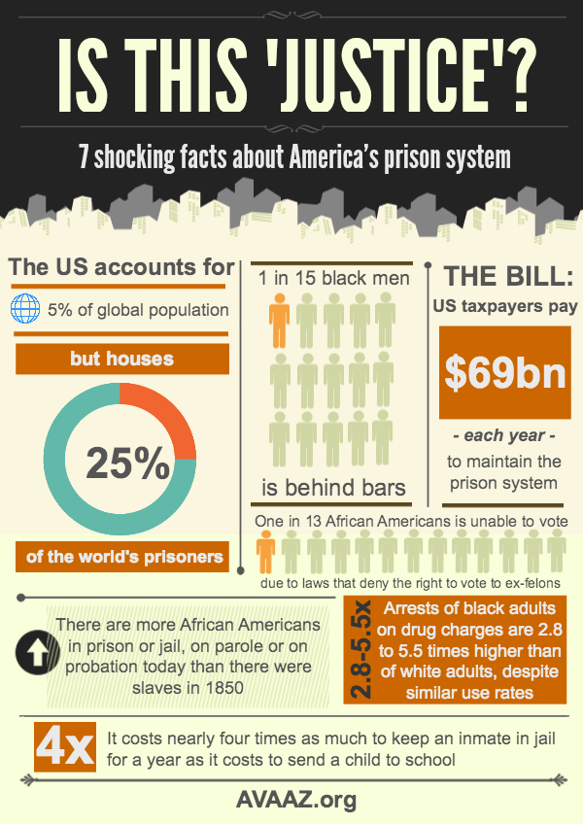
Along with the infographic, you will write a blog post about the graphic. This blog post will describe the social movement itself and discuss the movement issue from the secondary source. Then it will discuss the other two charts which come from your original research. It should be about 300-500 words, but I care more that the post discusses everything in the graphic more than I care about the word count.
This assignment will be due by the beginning of class on Friday, March 2, 2018. Please upload the infographic and the blog post in Microsoft Word format to Blackboard.

