One-Page Paper: Brainstorm for Essay 2 on Discourse Communities

Step 1- Re-read Essay 2 instructions. Pick a topic.

Step 2- Answer the following questions: What is unique about the discourse community you are writing about for Essay 2? What are rules that govern this discourse community? How do people within the community interact with each other? How do people outside the community interact with or make assumptions about this community? What art, music, pop culture etc. is associated with this community? How does this community contribute to humanity? What does it offer?

Step 4- Make sure you format your paper using MLA page layout guidelines (pages 540-548 in The Norton Field Guide). The following visual shows and example of MLA page layout:

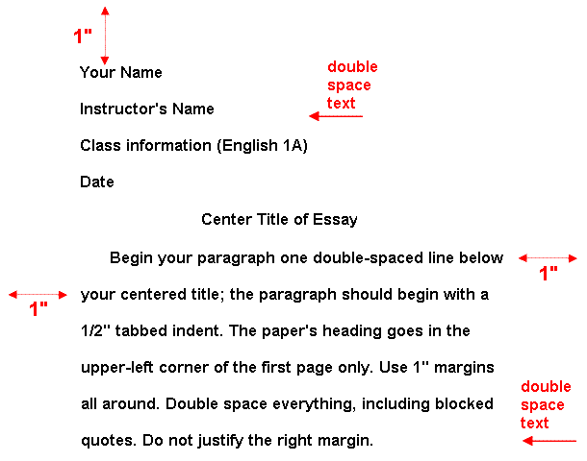
Figure 1 (CSUS, “MLA Page Layout”)
Works Cited
CSUS. “MLA Page Layout.” 20 Aug. 1998. http://www.csus.edu/owl/index/mla/mla_format.htm

