- a. Using the graph shown, analyze the effect a $300 price ceiling would have on
the market for ten-speed bicycles. Would this be a binding price ceiling?
(1 references, if any)

b. Using the graph shown, analyze the effect a $700 price floor would have on
this market for ten-speed bicycles. Would this be a binding price floor?
(1 references, if any)

c. Why would policymakers choose to impose a price ceiling or price floor?
(2 references)

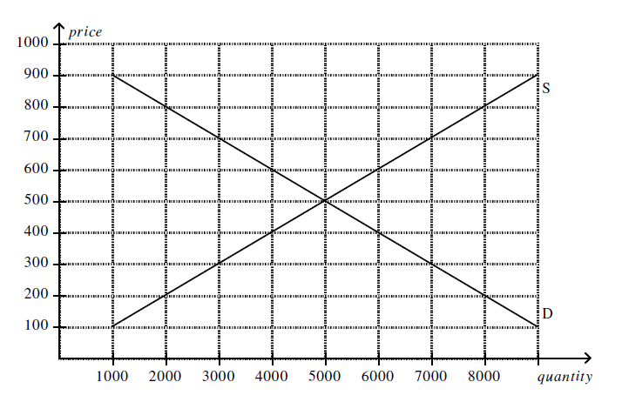

- Bob Edwards owns a business. Bob hires an economist who assesses the shape of the business’s average total cost (ATC) curve as a function of the number of units produced. The results indicate a U-shaped average total cost curve. Bob's economist explains what makes the ATC U-shaped. Explain the reasons as to why ATC is U-shaped. You are required to use practical reasons related to any business that you are familiar with in explanations.

(Around 1,000 words, 2 references)

