Dental Waxes
Waxes show a significant progression through their history. This progression is in their uses, components and nature. Wax was firstly discovered by romans in 500 BC. Waxes were used in variable forms. First, in producing flutes, wax is used as a coating layer in finishing which is the last step in flutes producing process. Second, wax was used by early Greeks in producing candles as a way of celebration at a certain time of the year. Third, using wax in sculpture starts from the middle age by the churches and then this art is progress to the wax dummies in the Griffin museum of Paris. Also, some types of papers are coated by wax to prevent sticking these papers are used in cooking. There is another technique called fruits waxing, this technique is based on coating fruits by artificial wax to prevent losing water from fruits. Wax is added to waterproof clothes and makeup during manufacturing. Old type of wax originates from secretions of bees and they are called beeswax. On the other hand, recent waxes are artificial and chemical products originate from animals, plants or petroleum.
Recently, waxes progress in their properties to be used in dentistry. It is used in all specialities such as fixed prosthodontics, operative, removable prosthodontics and orthodontic. To understand the dental waxes, their nature and how to work by them we should understand that they are thermoplastic materials which means that they are polymers with high molecular weight and weak bond which can easily break by increasing temperature. Also, waxes can get softening in high temperature and hardening in low temperature, its melting point is about 40 °C. This make it easy for reshaping and adding. Not all waxes can be used in dental field. According to the article “dental waxes” of Arad (4) the writer summed up that wax should have proper flow, dimensional stability, easily carved and smooth, accommodate the appliance which is to be made and boiling out without residue. Moreover, waxes of these previous qualities have a wide use in dentistry, there is no procedure in dentistry is done without dental waxes. All products of dental waxes have a standardized shape, composition and working characteristics. Dental waxes are combination of waxes and other resins. They are used in patterns, impressions and dentures.

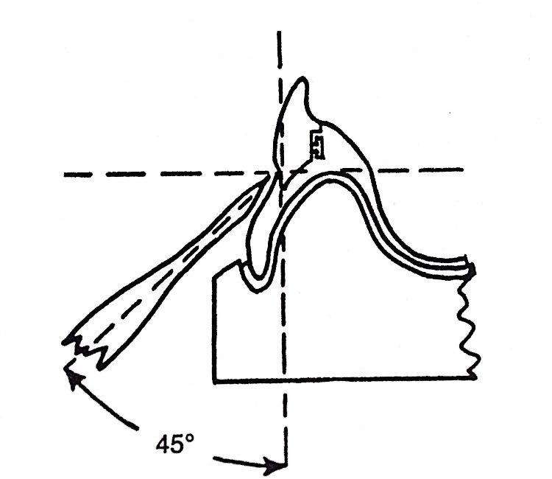
Waxes are classified according to their uses. They can be used as patterns, impression and in processing. First, in patterns they can be used in inlay and casting restorations. Inlay waxes are type of pattern wax which available in sticks or blocks. According to “Prep manual for undergraduate dental materials” book, Patil (1) said that inlay waxes can be manipulated by two methods, direct or indirect methods. Direct method is based on heating the wax on flam then rotate it rapidly and kneaded together then putting this piece of wax inside prepared cavity in patient’s mouth and apply pressure by dentist finger or let the patient bite on the wax. Wax should be soft to record fine details of the cavity. The other method is based on taking impression to the prepared cavity then pouring it by gypsum product and adding wax to the cavity in this die with excessive amount then carving the wax to give it a proper contour and take it outside the cavity. This type of wax is used in inlay restorations because of its properties. Its softened form is uniform, its colour is different from die material and tooth, when it burns it never leave residual excess, it is rigid and dimensionally stable, its thermal conductivity is low and coefficient of thermal expansion is high. Some errors can be done during processing of inlay such as wax distortion. Wax distortion may be due to contraction on cooling, release of internal stresses, including air bubbles, verities in carving and changing of shape in moulding. The most common error is that inlay waxes are always left in a state of internal stresses. This phenomenon is due to harden the outer layer of the wax before the inner layer so, the outer layer shrink and release its internal stresses and the inner layer will not be able to release its internal stresses because its confined by the hard outer layer. These residual stresses will release by time. To overcome this phenomenon, wax should be invested immediately. Casting wax is a specific type of pattern wax which is produced specially for lost-wax casting process. It is supplied in a form of sheets, readymade round rods or bulks. The process of casting is done by taking impression to the prepared tooth then making working cast then wax is added to the cast and carved to take the shape of the needed restoration. This wax pattern is invested and casted by melted base metal or gold then the restoration is disinvested and polished. This type of wax has excellent properties for casting. It is highly ductile, adhere to the cast and never leaving residual parts during burning at 500 °C. This type of wax can used in denture processing. Wax is represent the polished surface of the denture which means that after processing the wax portion will replaced by the polished surface. According to “prosthodontic treatment for edentulous patient” book (3) the writer summed up that the wax polished surface of denture should be properly carved to provide proper contour and setting of artificial teeth to achieve good esthatics and comfort to the patient. Also, to provide stability and retention to the denture. The procedure of making a denture has an accurate technique. The role of wax in this procedure is in occlusal rim and setting of teeth. Wax is the ideal material that should be used as a base for artificial teeth because it shrinks when it loses temperature so, artificial teeth will not be able to move. During wax carving it should take the curvature of the cervical line of each tooth to expose all the surface of the clinical crown for esthatic reasons. One of the most common errors is to cut this line straight that leads to food accumulation and will not be easy for the patient to clean these areas. To achieve this technique correctly, the dentist should handle the carver with 45° as shown in figure (1). This type of wax can carry artificial and porcelain teeth. It is called baseplate wax and mainly formed of beeswax. Baseplate wax is also unique in being stable and carrying teeth in both room and mouth temperature.
Figure 1. The degree of handling the carver during cutting (3)
Second, processing wax is used as boxing, utility, sticky and disclosing wax. Boxing wax is a type of processing wax that used to create margins around cast during pouring, vibration and mounting the cast to the articulator. It is supplied in form of ropes or sheets. Its properties are different from other types of wax, it is flexible that can be easily adapted and retain to its shape and it is combatable to gypsum and impression. Utility wax is also a type of processing wax which is used in raising the palatal portion of impression trays when it is needed to increase adaptation of trays to patients’ mouth, in the lingual portion of the pontic while the labial portion is pouring and in providing rim locks. It has a proper adhesion to build up and its fluidity is 65% to 80% at 37 C. sticky wax is the last type of processing wax with a brittle nature and good flow. It is used in joining parts together such as in denture repairing and used in combining metal parts of partial denture during soldering. Its special properties are stickiness in melting and rigidity in room temperature. Disclosing wax is used to determine the areas of high and low pressure inside patient’s mouth by escaping from places which need to be relived. There are another subtypes of processing wax but not commonly used such as block out wax, beading wax and white wax. Block out wax is used to block undercuts, beading wax is used to make a bead around the impression during pouring and white wax is used to make patterns similar to veneers in their esthatics (4).
Third, impression wax has two types: corrective impression wax and bite registration wax. Corrective impression is used in recording end saddles, correct impression and posterior palatal seal. Bite registration is used in recording jaw relation and transferring occlusion to cast. Some waxes are used in taking impression and they are called low fusing impression wax. This type of wax has high fluidity so, it can record details and there is no need for boxing. But it has a disadvantage that it is easily distorted so, care must be taken during handling the impression.
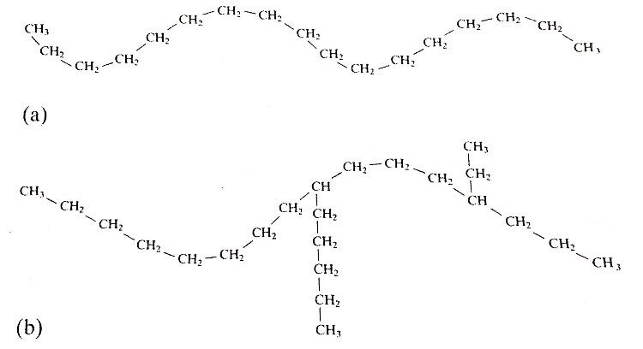
Waxes are formed from two or more components. They originate from either mineral, animals or vegetables. According to the book of “Applied dental materials” to McCabe (2) the writer argued that the main components of waxes are thermoplastic materials which are responsible for determining there softening and solidification temperature. First, waxes of mineral origin such as paraffin, microcrystalline wax, Litene, Barnsdahlm ceresin and Montan are obtained from petroleum. Paraffin has a simple straight chain of carbons. Its softening temperature is 37-55 °C and its melting temperature is 48-70 °C. Also, it is brittle at 20 °C. While microcrystalline wax has closely related micro crystalline branched structure as shown in figure (2). Its melting temperature is 65-90 °C and it can be raised by adding it to paraffin.
Figure 2. The composition of paraffin and microcrystalline wax (2) a)paraffin b) crystalline wax
Second, waxes of animal origin such as beeswax and kerr hard wax are derived from honeycomb and they are consist of polyester crystalline structure and it is a brittle structure. To overcome this brittleness paraffin wax is added to beeswax.
Third, waxes with vegetable origin such as carnauba, candelilla, ouricury and Japan wax are derived from plants and trees. They also added to paraffin to control melting and hardening temperature. To improve the properties of wax, a new type of wax is produced which is a mixture between paraffin and beeswax. This mixture is produced by melting the two types of wax together, melting paraffin first then adding beeswax in increments then adding some fillers. This mixture is left for twenty four hours then melted again and left in room temperature under pressure until solidification.
Mechanical properties are the reaction of a material against applied stresses or it is the relation between stresses and strain. Stress is defined as the force per unit area and strain is reaction of the material against applied forces or stresses. The most common mechanical properties of waxes that most studies talked about are strength, rigidity and fluidity. To understand the mechanical properties of the wax, there are some terms should be known. Strength is defined as amount of stresses that the material can absorb without plastic deformation. While rigidity is defined as the ability of the material of having low yield strength in stress strain curve. The most important disadvantage in wax is its potential distortion during stresses relaxation. So, recent studies are trying so hard to improve dental wax to avoid distortion by adding fillers. According to the article of “Experimental wax mixture for dental use” (6) the writer kotsiomiti argued that the mechanical properties of wax such as stress relaxation and fluidity is determined according to the type of incorporated fillers. If fillers are found, fluidity will be decreased. If fillers are absent, fluidity will be increased. That is because these fillers are act as seeds between wax particles which gives wax gelly texture. This type of improved wax is important in certain uses such as preparing wax pattern for casting.
Thermal properties is defined as the reaction of a material under different temperatures. Wax thermal properties which studies interested about are setting and melting range. To understand the thermal properties of wax, the definitions of setting and melting rang should be understood too. Setting range is the temperature in which the wax will be harden or is the temperature in which the wax will convert from fluid form to solid form while melting rang is the temperature in which the wax will convert from solid form to fluid form. Setting and melting rage is changes during to the composition of wax. As mentioned before, waxes are classified according to their origin to mineral animal and plant origins. Studies show that setting range of waxes of mineral origin is between 51°C to 87 °C, waxes of animal origin have setting range is between 61 °C to 63 °C and waxes of plant origin have setting rage between 41 °C to 82 °C. it is noticed that the setting range is wide in each single type. For example, paraffin is a type of mineral wax which has setting range between 51.5°C to 53 °C which is the lowest range among mineral waxes. On the other hand, the highest setting range in mineral waxes is barndahl, its setting range is between 85 °C to 87 °C. Also, the setting range in plant waxes is wide. For example, carnauba has the highest setting range which is between 80 °C to 82 °C, while Japan wax has the lowest setting range among plant waxes. It is between 41.5°C to 44 °C. This variety in setting ranges is due to different components of wax. It proves that all types of wax are not pure and contain different components such as oils, natural resins and colouring agents.

To sum up, waxes have an important role in our life generally and a vital role in dentistry. Waxes have multiple components and various functions. They can be used as impression material, wax patterns and in processing. Moreover, they are different in origin: animal, plant and mineral origin. Each type has its own properties according to its composition. Some of their components give them some disadvantages such as distortion and that is what the recent studies try to improve in new waxes products. On the other hand, another components give waxes their advantages such as being a thermoplastic material. Dental waxes have makeable mechanical and thermal properties. Some of them are pons and others are cons. One of the good mechanical properties of dental waxes is the highly fluidity and one of the bad mechanical properties is the low strength. Dental waxes are known of a unique thermal property which is the wide setting rang. Finally, the scientific society should work more on improving dental waxes to eliminate their disadvantages such as distortion and dimensional changes.

