Simulation of a Two Link Planar Anthropomorphic Manipulator

# Abstract

This report is a study into the design and development of a two-link planar anthropomorphic manipulator differential model simulation using Simulink in MATLAB software. To model the system it can be reduced and understood as a similar means to create standard sub-systems that can be reused. For each module present in the given system it is linked back to a Simulink block which has the mathematical models inside; this gives the user an open undefined system where they themselves can manipulate it to carry out specified tasks by defining the tasks in a language the robot will understand. Through the use of the mathematical blocks in Simulink, we can get an insight into previous simulation techniques and also gives rise to a number of new methods into kinematics for simulations. The use of robots has been embedded deep into society; there are many applications to mention which suggests robots are becoming more flexible and robust in their uses but remain simple in their design. In the modern world they can go from being used in the military to kill people, to be used in hospitals to save people, as for future applications they remain endless.

**Table of Contents**

1. Introduction2
2. Background Theory3
3. Results6
4. Discussion11
5. Conclusions12

References12

# Introduction

The purpose of a robot is to carry out tasks that can otherwise be done by human labour but to do it in a manner that eases the burden of m annual labour. In addition to this, they are expected to do a given task quicker, more efficiently and to bring about all these good traits whilst remaining safe. Robots aren’t defined as simply as they once were. Initially one would perceive them to be computerized beings that were able to not only obey commands but have a mind of its own – almost as though man created his own ‘man’. Later the idea of robots had been extended to mean any automated function. They have been highly popularised by movie culture and with these the expectations of the capabilities of robots have increased and rightly so. In the wake of technological advancements, robots can be programmed to carry out multiple tasks which are useful in a number of different industries such as medical, military, space, or even in a leisurely manner. For it to be this flexible in its uses, the programming must be able to fluctuate just as readily. The appropriate controls must be present for it to carry out relevant actions and a method through which it can be controlled is SIMULINK. The expected response can be keyed in and thus a simulation can be run however there are a number of different parameters upon which the desired output is dependent on; these can be set via SIMULINK.

To investigate the numerous factors which affect simple servo-controlled two link manipulators and link these back to simple analytical techniques. The objectives at hand are to attain a confident use of MATLAB to simulate different given scenarios under which a robot arm must be manipulated and comment on the validity and appropriateness of the results. With this it is expected to provide comments on how well designed the system is and to comment on the performance of the robot. The reason SIMULINK is used is it features a specialised design tool which is applicable to robot design in numerous industrial applications. To accommodate the functions the robot must carry out, it contains operating blocks which are contained within subsystems which allow for these complex operations to take place. With this, subsystems can be placed within larger subsystems which give rise to even more complex function – to ensure all of this is being done properly there are tools which verify and validate the inputs. All of these incorporated together make it an apt candidate for model based development.

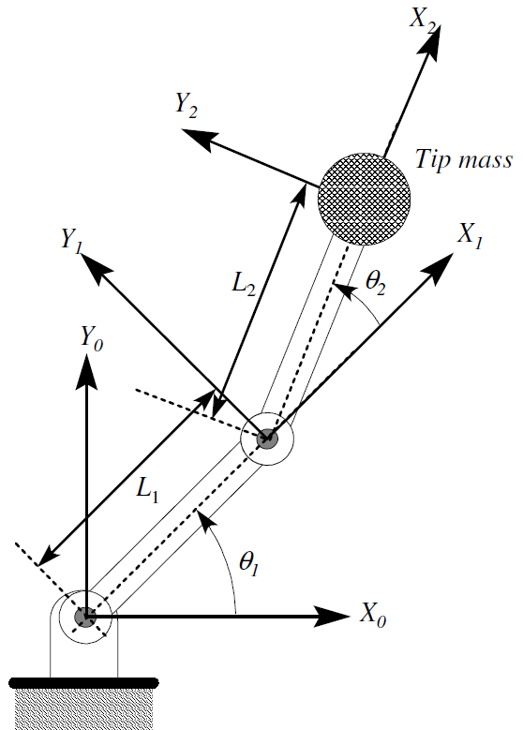

*Figure 1 - Set-up of two link robot manipulator*

# Background Theory

First it must be established what a two link robot manipulator looks like and the basic manner in how it works. The computed torque method must be applied in order to derive what’s known as the control law. The ideal case of a two-link manipulator is considered and the end-effector and its payload are modelled as a lumped mass, found at the tip of the outer link which abridges many of the calculations (Vepa, 2013). A diagram of the setup is shown in figure 1.

Figure 1 depicts the two-link planar anthropomorphic manipulator where the Z axes are all aligned normal to the plane of the paper (Vepa, 2013).

When we study how the system works, ultimately it is the dynamics that are assessed, more specifically the impact of forces and torques. These will have a subsequent effect on: rigid bodies, collections of particles and most importantly the motion of particles, and to provide the most insight to this, the whole system can be remodelled to resemble Newton’s Law of Motion.

To yield a dynamic equation for the two-link manipulator, Lagrange’s method can be used.

For link 1, kinetic energy is:

$T_{1}={\frac{1}{2}m_{1}L_{cg1}}^{2}(\dot{θ_{1}})^{2}$ [Equation 1]

And for link 2:

$T_{2}=\frac{1}{2}m_{2}\left(L_{1}^{2}+L_{2cg}{\left({\dot{θ}}_{1}+\dot{θ_{2}}\right)}^{2}\right)+L_{1}L_{2cg }cos({θ_{2})\dot{θ_{1}}}\left({\dot{θ}}_{1}+{\dot{θ}}_{2}\right)$ [Equation 2]

The kinetic energy of the mass is given by (x3, Y3,,)

Hence the kinetic energy for T3 is:

[Equation 3]

Combining all these values produces a Total Kinetic energy of

$$T=T_{1}+T_{2}+T_{3}$$

Thus:

$T=\frac{1}{2}\left\{m_{1}{L_{1cg}}^{2}\dot{θ_{1}^{2}}+m_{2}\left[{L_{1}}^{2}\dot{θ_{1}^{2}}+{L_{2cg}}^{2}{(\dot{θ_{1}}+\dot{θ_{2})}}^{2}+2L_{1}L_{2cg}\dot{θ_{1}}\left(\dot{θ_{1}}+\dot{θ_{2}}\right)\right]+M\left[L_{1}^{2}\dot{θ_{1}^{2}}+L_{2}^{2}{(\dot{θ_{1}}+\dot{θ_{2}})}^{2} 2L_{1}L_{2}\cos{{(θ}_{2}})\dot{θ_{1}}(\dot{θ_{1}}+\dot{θ_{2}})\right]\right\}$ [Equation 4]

Now, under the assumption that each link is acting under the influence of the centre of gravity, this means the potential energy of link 1 (V1) is written as

$V_{1}=m_{1}gL_{1cg}\sin{{(θ}_{1})}$ [Equation 5]

Similarly the potential energy for link 2 is written as:

$V_{2}=\left[m_{2}g(L_{1 }\sin{θ_{1}+L_{2cg}sin({θ_{1}+θ_{2})}}\right]$ [Equation 6]

And finally the potential energy for the tip of the mass V3 is written as

$V_{3}=Mg\left[L_{1}\sin\left(θ_{1}\right)+L_{2}\sin{(θ_{1}}+θ_{2})\right]$ [Equation 7]

Thus the total potential energy V is written as

$$V=V_{1}+V_{2}+V_{3}$$

Thus:

$V=g\left[\left(m_{1}L_{1cg}+m_{2}L_{1}+ML_{1}\right)\cos\left(θ_{1}\right)+(m_{2}L_{2cg}+ML_{2})\cos{(θ_{1}+θ_{2})}\right]$ [Equation 8]

Now a dynamic model using the Lagrange-Euler formula as a base can be formed from

$\frac{d}{dt}\left(\frac{∂L}{∂{\dot{q}}_{i}}\right)-\frac{∂L}{∂q_{i}}=τ_{i}$ for i=1, 2, 3…n [Equation 9]

From this it can be deduced that $L=K-P=K_{1}+K_{2}-P_{1}-P_{2}$

Now the total energies are differentiated with respect to $q_{i}$ and $\dot{q_{l}}$ where $q_{i}$ is representative of the number of degrees of freedom of the system, in this particular case the degrees of freedom are simply $θ_{1}$ and $θ_{2}$ and thus the total energies are differentiated with respect to $θ_{1},\dot{θ_{1}}, θ_{2},\dot{θ_{2}}$

Rearranging and simplifying the Lagrangian equation we get:

$$L= \frac{1}{2}\left(\frac{1}{3}m_{1}+m_{2}\right)L_{1}^{2}{\dot{θ}}_{1}^{2}+\frac{1}{6}m_{2}L_{2}^{2}\left({\dot{θ}}_{1}^{2}+{\dot{θ}}_{2}^{2}+2{\dot{θ}}_{1}{\dot{θ}}_{2}\right)+\frac{1}{2}m_{2}L_{1}L_{2}C_{2}\left({\dot{θ}}_{1}^{2}+{\dot{θ}}_{1}{\dot{θ}}_{2}\right)-\frac{1}{2}\left(m_{1}+m_{2}\right)gL_{1}S_{1}-\frac{1}{2}m_{2}gL_{2}S_{12}$$

Also: $$τ_{i}=\frac{d}{dt}\left(\frac{∂L}{∂{\dot{θ}}_{i}}\right)-\frac{∂L}{∂θ_{i}}$$

Based on the assumption that both of the links are equal dimensions and mass and that the gravity torques is negligible, this allows the equations to be written in state-space form as the following

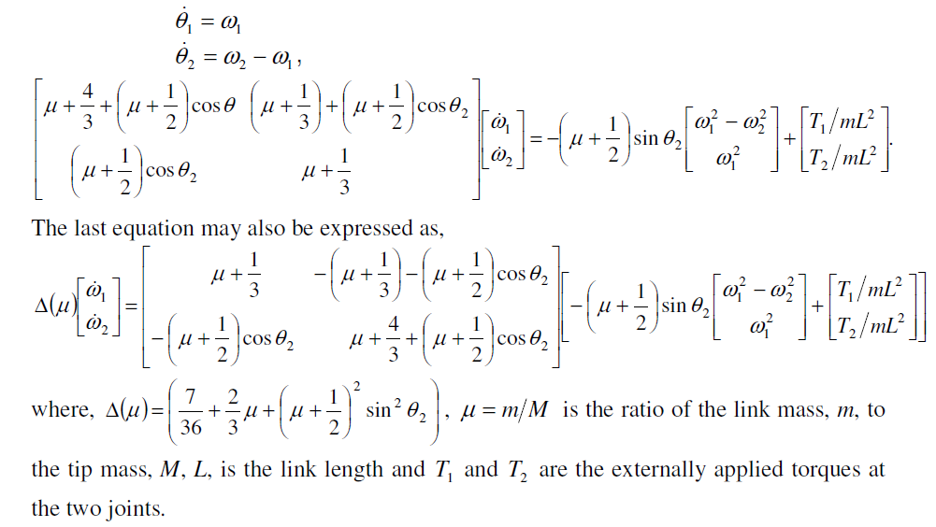



Figure 2 - The strategy for computed torque control

The control system in figure 2 is dependent on feedback to each of the joint servos. The signal that will be transmitted will counteract the effects of gravity, friction, the manipulator inertia torques as well as the Coriolis and centrifugal torques. The effects are considered disturbances and it is essential that they are cancelled at each of the joints. Forces are calculated based on the Euler-Lagrange dynamic model.

The calculated control technique can be comprehended as a feed-forward control and feedback component (Lee, 1983). The interaction forces are taken into account by this feed-forward component whilst the feedback component decides which correction torques are the most appropriate for any form of deviatory values to return it to the original desired point. The dynamic equations derived earlier are non-linear second order differential; these are present in the manipulators because of small but deciding factors such as inertial forces, centrifugal forces and even something as basic as gravitational loading (Lee, 1983). The method through which the torque is calculated manually is an effort to eliminate the effects of the aforementioned forces and thus resulting in a consequent decrease in the non-linearity of the system.

Elaborating on a specific subsystem within the robot needs some basic understanding before being delved into further. Referring back to figure 1, if a torque is applied to link one this can displace both link one and link 2 as they have a common joint between them however simply applying a torque to link 2 will not affect any movement in link 1.

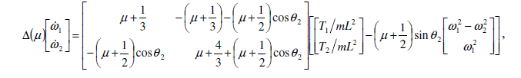[Equation 10]

Referring to equation 10, 11 and 12, a block diagram can be constructed given all of the information at hand to yield figure 3 below.

# Results

Below are the numerous graphs at the different stated masses at which the point mass at the end of link 2 will hold. Assuming there are no limitations to how freely the links can rotate, below in table 1 are the velocity and torque of the links

Key - V2

V1

T1

T2

|  |  |  |
| --- | --- | --- |
| mu | velocity | Torque |
| 0 |  |  |
| 0.1 |  |  |
| 0.2 |  |  |
| 0.5 |  |  |
| 1 |  |  |
| 2 |  |  |
| 10 |  |  |

Table 1

|  |  |  |  |  |
| --- | --- | --- | --- | --- |
| Mu | T1MAX | T1MIN | T2MAX | T2MIN |
| 0 | 3.81 | -1.201 | 1.496 | -0.1687 |
| 0.1 | 4.696 | -1.442 | 1.939 | -0.2176 |
| 0.2 | 5.582 | -1.686 | 2.382 | -0.2651 |
| 0.5 | 8.23 | -2.411 | 3.71 | -0.3999 |
| 1 | 12.67 | -3.59 | 5.925 | -0.6011 |
| 2 | 21.53 | -5.882 | 10.35 | -0.9551 |
| 10 | 92.39 | -21.18 | 45.78 | -3.456 |

Table 2

Based on the assumption the angle through which the link is restricted to 30o, below in table 3 is a reading of the potential energy.

Key - P2

P1

|  |  |
| --- | --- |
| mu | Potential energy |
| 0 |  |
| 0.1 |  |
| 0.2 |  |
| 0.5 |  |
| 1 |  |
| 2 |  |
| 10 |  |

Table 3

|  |  |  |  |  |
| --- | --- | --- | --- | --- |
| Mu (angle limit) | T1MAX | T1MIN | T2MAX | T2MIN |
| 0 | 0.4363 | -0.1764 | 0.1745 | -0.0658 |
| 0.1 | 0.541 | -0.2164 | 0.2269 | -0.0855 |
| 0.2 | 0.6457 | -0.2564 | 0.2792 | -0.1053 |
| 0.5 | 0.9599 | -0.3768 | 0.4363 | -0.1646 |
| 1 | 1.484 | -0.5782 | 0.6981 | -0.2634 |
| 2 | 2.531 | -0.9834 | 1.222 | -0.461 |
| 10 | 3.17 | -3.12 | 1.552 | -1.722 |

Table 4

# Discussion

The results above are necessary to comprehend whether or not the robot provides the responses in accordance to the input. The first thing that can be seen from the results in table 1 is the velocities of the links in the arm. Generally the velocity of link 2 is always higher than link 1. We know that V2>V1. As stated at first in the original question, the first link is only required to move by 30o but the second link must move by 240o in the same time as the first link moves. This in turn means the second link must travel at a higher velocity in every instance compared to link 1 even with the changes of the point mass at the end. Thus V2 is greater than V1 hence implying there needs to be a greater acceleration as there is a greater angle having to be travelled over the same time period. This is further reinforced by the sharp increase shown by the blue lines and the rather shallow green line on each graph for comparison. Similarly assessing table 1 and 2 the Torque values provide a valuable insight into the arms response. The torque values are only present in table 2 but can be related back to table 1 very easily. Firstly a trend that must be spotted is the fact that every T1 value regardless of the mass is always greater than the T2 value. The reason the first link has a higher torque than the 2nd link requires the use of figure 1 again. The joint through which X0 and Y0 originate from is where the whole arm must swivel about, being directly linked to link 1. X1 and Y1 originate about another joint which is associated with link 2. The first joint is responsible for the whole arm having to swivel thus encompassing the mass for the entire arm and thus a larger torque is required to ensure it reaches a threshold to move. T2 does not need to be as big as it would have already been in motion whilst being displaced by another angle. This can be seen for all of the torque graphs present in table 1. This also gives rise to momentum which is to be taken into account below.

The first negative point that can be highlighted is that from table 1 the values of Torque do oscillate ever so slightly which is not a desirable trait, in fact this can be damaging. The reason for this is that the point mass is going past the desired point then bringing it back which is done by the control system. The issue with this is that if this oscillation continues to be repeated eventually the robot arm will fatigue and stop working as efficiently as it could. Moving onto table 3 and 4, these are results under the impression there is a limitation in the amount the arms can rotate by. Thus to take this into account link 2 moves in steps of 30o 8 times resulting in a full 240o rotation. Looking over the values, the same correlation of T2>T1 is still apparent however all of the torque values are scaled down drastically. This is because with each step of 30o being displaced, the mass mu doesn’t need to move a large distance in a short amount of time, and rather it’s broken down. The main problem can be seen with all of the graphs in table 3 where the potential energy graphs are oscillating, this is a re occurring momentum problem as stated above. If this can be eliminated then the movement of the arm will appear fluid and less ‘jerky’. Another point that is obvious but may go unnoticed is the fact that with an increase in the mass mu, all of the torque values increase and this will give rise to an issue with oscillations if the time response is almost instantaneous.

Overall the desired outcome is achieved as ‘mu’ increased especially when coupled with the step response, the torque increased slowly. As a consequence of this, the step responses are not drastically affected by different masses for the potential energy at the auxiliary controls.

# Conclusions

Through this report it has been established that a two-link anthropomorphic manipulator can be successfully constructed. It has also been established that it can be used to achieve the desired movement to a particular set-point. This has been achieved for conditions that were constrained and for those that were not. It was evaluated that the constrained conditions are more desirable as there is less chance of the manipulator being damaged due to the smaller torque values it will use. Simulink has proven to be a very effective tool for this modelling a robotic system. It was able to tabulate a number of different equations and produce accurate results. One area where small issues were noticed. These issues were likely to be as a result of the gravity effects not being considered, had they been accounted for more accurate results may have been produced. This is a possibility for future investigations. Also another method to produce better results may be to alter the angle of the rotation by changing the geometry of the links. Overall, the manipulator was simulated successfully and the equation of motion for a two-link manipulator represents the robotic system quite well. Room for improvement still exists however, such as improving the over shoots and subsequent undershoots in the system. It is recommended this aspect be investigated for future and to improve robot performance making the transition smoother between positions.

# References

Lee, C. a. (1983). *Robot arm kinematics, dynamics and control.* Berlin.

Vepa, R. (2017). DEN408 Robotics. *Computer Aided Simulation Tutorial Exercise*, Queen Mary, University of London.

Peter Gorle, Andrew Clive, (2013). *Positive Impact of Industrial Robots on Employment,* London: Metra Martech.

DORF R. C. & BISHOP, R. H. (2011) *Modern control systems*. Twelfth edition. New Jersey: Pearson Education, Inc.