4.3 Financial Analysis
Hints (also for sub-sections): PLEASE FOLLOW CAREFULLY ***PLEASE***PLEASE***READ CAREFULLY***
You need to compare Cinemark with 2-5 competitors that you have selected in the competition analysis (Section 3.4) and with industry averages for those ratios and numbers throughout the whole Section 4.3. here is section 3.4 that I personally got the data from
3.4. Competition Analysis
Competition in the movie theaters industry is very strong. Companies compete for almost the same product, which is the reason why there is a high level of competition internally. The major companies in the industry experience a thorough external competition too. The major players in the industry operate in almost each US state, as they do in some other externally countries. Data and reports are showing that competition will encounter intense external competition as they never did because of the advanced technology and the substitute products, especially those offered by the streaming sites. Competitors also share the same range of customers which make it hard for them to retain customers.
3.4.1 Industry Competitors.
Companies are ranked by number of screens, revenues, employees, and per capita as the time elapse. There were 40,174 indoor and drive-in screens in the United States and Canada in 2015. Total admissions reached 1.32 billion, up slightly from 1.27 billion in 2014 (Reporter, 2015). Cinemark Holdings Inc. is not the first in the top movie player in the Movie Theaters industry, it is ranked in the third place with 4,499 screens after Regal Entertainment Group with 7,295 screens, and AMC Entertainment Holdings Inc., with 4,960 screens. Other important competitors in in the industry are Carmike cinemas: 2,892, Cineplex Entertainment L.P: 1,635, Marcus Theatres Corp: 681, Harkins Theatres: 446, Southern Theatres: 445, B and B Theatres: 409, and National Amusements with 409 screens (Reporter, 2015). These are ranked based on the number of screens they run in 2015. The truth is, these numbers are increasing or decreasing over the years. Then, key competitors are strategically working to be better today than they were yesterday, by offering almost the same product; which are ticket sales that account for two-thirds of revenue, food and beverage sales for more than 20 percent (Markets, 2013).

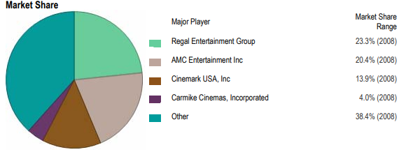
Figure 6: Majors competitors in The Industry by Market Share: 2008 and 2017. (IBISWorld, 2017).

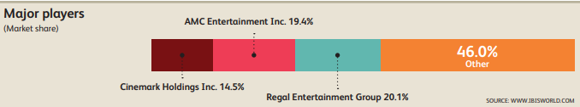
Figure 7: Leading cinema circuits in the United States and in Canada as of July 2017, by number of screens. (Statista, 2015).

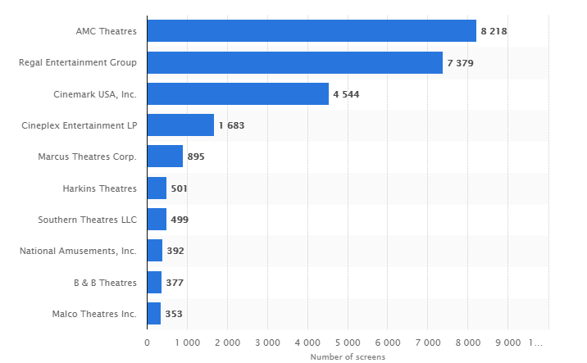
Figure 8: The Top Ten Leading Movie Theaters in 2017. (Statista, 2015).
Figure 8 shows the rank of the top ten leading movies theaters as the year of 2017, based on the number of screens they disposed (Statista, 2015). Obviously, the graph demonstrates the power of the three major players in the movies theaters Industry. According to the IBISWORLD.com, in their Industry Report 512113, the major players displayed more than 50% of the Industry market share. The Regal Entertainment Group had 20.1%, AMC Entertainment Inc. had 19.4%, and Cinemark Holdings Inc. had 14.5% (IBISWorld, 2017).
In some other reports, such as Business Rankings, these companies are classified based on other characteristics such as employment growth, per capita disposable income, and revenues. However, as of the year 2012, these three major players in the Industry show the lowest number of employees. Regal Entertainment Group ranked 8th with 23,000 employees, and AMC Entertainment Holdings Inc. and Cinemark Holdings Inc. both ranked the 10th with 22,000 employees (Draper, 2015). In the next section three major competitors, Regal Entertainment Group, Cinemark Holdings Inc., and AMC Entertainment Inc. are to be discussed.
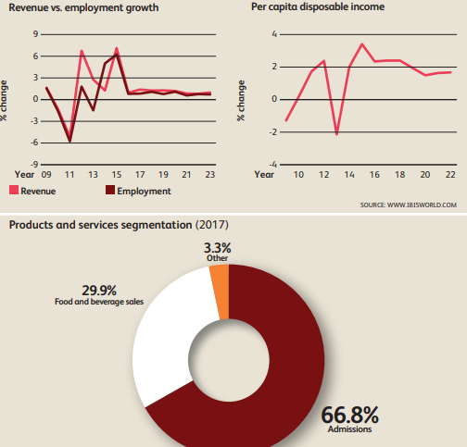
Figure 9: Market share, Revenue vs. employment growth, and Per capita disposable income for the year 2017. (IBISWorld, 2017).
3.4.2 Rivals Anticipated Strategic Moves
3.4.2. 1 Regal Entertainment Group (RGC)
Regal Entertainment Group (NYSE: RGC) functions as one of the largest and most geographically diverse theatre circuits in the United States, in 43 states along with Guam, Saipan, American Samoa and the District of Columbia as of December 31, 2017 (Group, 2013). Regal Entertainment Group generated 3.2 billion U.S. dollars of revenue in 2016, up from 3.13 billion a year earlier (Statista, 2015). RGC says that they believe that the size, reach, and quality of the Company's theatre circuit not only provide its patrons with a convenient and enjoyable movie-going experience but is also an exceptional platform to realize economies of scale in theatre operations (Group, 2013). This slogan is used to continually increase the company’s size and quality of their product to reach the maximum possible of their customers.
RGC realized that it is not the only one in the industry, so that it must work strategically. According to the IBISWORLD, things such as film offerings, ticket prices, auditorium quality and concessions offerings, and the ability to show films in 3D are the major basis that companies in the industry compete each other for. Thus, in the past two years, the company has focused on upgrading its facilities to take advantage of digital and 3D cinema technology; it now operates 7,333 screens outfitted with digital projection systems, about half of which are 3D capable (IBISWorld, 2017).
Similarly, according to the Newswire article “First 4DX Theatre in Washington, DC at Regal Gallery Place”, RGC announces that Regal Gallery Place Stadium 14 will be the first theatre in the Washington, DC area to feature the 4DX experience (newswire, 2018). Accordingly, in partnership with CJ 4DPLEX, Regal Gallery Place will be home to the immersive theatre technology that features moving seats and environmental effects such as wind, fog, rain, lightning, vibration, snow, bubbles and scents. Other moves employed by RGC to attract more moviegoers and increase its revenue are the expansion of its offerings regarding lunch and dinner meals ready to order, high value products like beer and liquor, and the offering of luxury reclining seating in most locations (IBISWorld, 2017). Another move made by RGC was its agreement with the Cineworld Group PLC, when RGC announced that it has entered into a definitive merger agreement with Cineworld Group PLC (LON: CINE) (“Cineworld”) for Cineworld, the U.K.’s largest cinema operator (RGC, 2017). RGC’s CEO said, “we believe that this partnership with Cineworld will enhance Regal’s ability to deliver a premium movie-going experience for customers and further build upon our strategy of introducing innovative concepts and premium facilities designed to enhance the value of our theatre assets” (business wire, 2017). 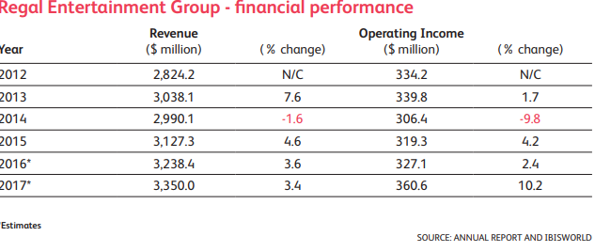
Figure 10: RGC’s Change in Revenues and Operating Income for the Five Years.
3.4.2.2. AMC Entertainment Inc
AMC Entertainment Inc is another major competitor to Cinemark Holdings Inc. after RGC. It owns, partially owns, or operates about 660 theaters with 8,200 screens, most of which are in megaplexes (units with more than 12 screens and stadium seating). Total attendance at AMC Theatres worldwide reached record levels in 2016, with over 215 million attendees. This led to the company announcing all-time high revenue of over 3.23 billion U.S. dollars for the year (Statista, 2015).
It also has a significant presence in Europe through London-based subsidiary Odeon & UCI Cinemas Group which gives the company the power to own many screens. According to AMC website in the article “AMC Theatres® Statement about MoviePass Announcement: “Not Welcome Here”’, AMC has propelled innovation in the exhibition industry by: deploying more plush power-recliner seats; delivering enhanced food and beverage choices; generating greater guest engagement through its loyalty program, website and smartphone apps; offering premium large format experiences and playing a wide variety of content including the latest Hollywood releases and independent programming ( AMC, 2017). Another important move about AMC Inc. is its ability to operates internationally through: Through its Odeon subsidiary, AMC operates in 14 European countries and is the #1 theatre chain in Estonia, Finland, Italy, Latvia, Lithuania, Spain, Sweden and UK and Ireland. Also,
Moreover, AMC focus is operating in rural areas as it does in the major cities such as New York City, Los Angeles, Chicago and Philadelphia). AMC has expanded its concessions offerings as a secondary revenue stream, with franchises sales growing 14.1% in 2015 (IBISWORLD, 2017). Offering beverages and food is as well a move employing by AMC in over 100 theaters. It is stated by the IBISWORD that at the end of 2016, a deal for AMC to acquire theatre company Carmike, previously a major player, was approved for $1.2 billion. AMC will acquire Carmike’s 275 theaters with 2,938 screens in 41 states (IBISWorld, 2017). Likewise, updating its existing theaters and acquiring recently built locations has given AMC an edge over its competitors. Showing its movies in 3D way, especially its IMAX exhibition helped AMC to become the one strongest popular moviegoers.
Another type of trend among the movie industry competitors is the advanced technology. According to Ben Fritz, in the article “Ticketing Startup Lands Deals with Two Biggest Theater Chains”, Digital movie-ticketing startup Atom Tickets has signed partnerships with the two largest theater chains in the U.S., assuring that its nationwide launch this summer will cover much of the nation (Fritz, 2016). In this partnership, AMC hopes to make it easier for friends and family to plan film outings on their phones, which will boost theater attendance and refreshment stand sales, particularly among young people.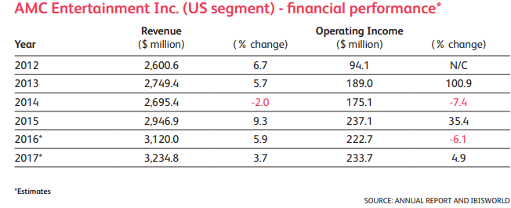
Figure 11: AMC’s Change in Revenue and Operating Income from 2012-2017.
- When you do analysis and make tables, please use longer period of data, for example, 8-10 years’ annual data or longer, because a longer period of data will give more accurate information about trends and shocks, especially the possible impact of the financial crisis starting from 2008.
- From here you can find company’s financial information. Filings to SEC from the Company’s web site; Website of key competitors and their filings to SEC or other authorities; Financials in spreadsheet format are available in our online databases (including Mergent Online and D&B Hoovers).
- Make sure the financial data are comparable between companies. If a company you selected for comparison has very different businesses or in different industries, please find financial data for its divisions that are comparable to Cinemark. (Many companies do have major financial data divided by division in their filings.)
- ***Don’t copy and paste all the tables. Please just include the data that are relevant to your analysis. A normal mistake is putting many tables on paper with only a few sentences for analysis, which makes this section quite long, but less meaningful and less constructive. ***
- For each of the following sub-sections, you need to give meanings to those numbers, and also offer your “verdict”, i.e., how Cinemark is doing after you compare it with major competitors, industry average, and its historical performance, and possible solutions to make the Company stronger.
- As you will have detailed analysis in sub-sections, just a few bridging paragraphs are needed under this section title.
- Length recommendation for Section 4.3 (including all sub-sections): at least ten pages (APA format)
4.3.1 Valuation Analysis
Hints:
A. You should find more information from your textbook and other materials for what should be included in a valuation analysis.
Comparisons needed to interpret the data and ratios.
4.3.2 Growth Analysis
Hints:
- Again, review your courses you have taken about growth analysis;
- Read the sample reports for the indicators you might include;
- Make sure that you compared those indicators of Cinemark with its past data, industry
averages, and those of major competitors.
- Make sure you give your “verdict” about the Company’s growth based on the data
comparison and trends.
4.3.3 Profitability Analysis
Hints:
- Dupont Analysis Model is a nice way to analyze profitability. The following materials give you some information about Dupont analysis (URLs): 1) DuPont Financial Analysis Model: http://www.cdp.wisc.edu/publications/dupont model.doc; 2) DuPont System of Analysis: http://www.aaec.ttu.edu/faculty/phijohns/AAEC%204316/Lecture/notes/DUPONT.h tm . Definitely you can find more by search on Google.com.
- Comparisons needed to interpret the data and results.
4.3.4 Financial Strength Analysis
Hint:
A. Use those financial strength ratios, and compared with industry major competitors, top performers, industry average, and past data. Our sample reports offer a good example, although it is not perfect. Again, comparisons needed to interpret the data and results.
4.3.5 Management Efficiency Analysis
Hint:
A. First you need to know what those efficiency measures are. You can follow the sample reports, although it is not perfect. Again, comparisons needed to interpret the data and results.
4.3.6 Summary of Financial Analysis
Hint:

You should summarize the financial healthiness of Cinemark based on your analysis by comparing its data to the ideals, its past, and/or the major competitors/industry averages. Find out financial strength and weakness.

