FEDTAX2_3 PROJECTS:
CLASS LECTURES:

Corporation—Distributions
After you set up a firm, you need to explore the various tax regulations that govern its distributions. All funds provided to shareholders are considered dividends. This distinction is important because of the specific tax application. Any distribution that is more than the shareholders' initial investment is considered a gain when stock is sold.
If you have taken an accounting course before, you have probably heard the terms "net income" and "earnings and profit." Earnings and profit, although being derived from net income, are, indeed, different from net income. Although earnings and profit do relate to a firm's capital, they differ in how they are computed. A firm's earnings and profit are determined by tax laws, not Generally Accepted Accounting Principles (GAAP). Section 312 details the guidelines for computing earnings and profit.
There are three types of corporation distributions:
- Earnings and Profit
- Dividends
- Stock Redemption

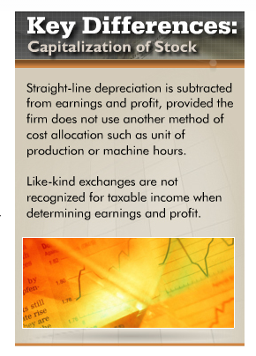

Role of Earnings and Profits
To increase your firm's taxable income, you can add back any accounting tax-exempt items such as any municipal bonds interest or excluded life insurance proceeds.
It is necessary to also subtract any nondeductible expenses and losses such as related party losses or excess of capital losses.
In addition, a timing adjustment must be made. Timing adjustments refer to specific transactions that affect the year the adjustments are recorded. An example of such a transaction is excess net operating losses.
Furthermore, adjustments resulting from various accounting methods need to be made.
Tax laws require that the firm use the alternative depreciation system when calculating earnings and profit. Let's understand this with the help of examples.

Example 1
A corporation sells property with a basis of $10,000 to its sole shareholder for $8,000. Because of Section 267 (disallowance of losses on sales between related parties), the $2,000 loss cannot be deducted when calculating the corporation's taxable income. However, because the overall economic effect of the transaction is a decrease in the corporation's assets by $2,000, the loss reduces the current earnings and profits for the year of the sale.

Example 2
At the beginning of the year, Gemini Corporation has earnings and profits of $15,000. The corporation generates no additional earnings and profits during the year. On July 1, the corporation distributes $20,000 to its sole shareholder, Brenda, whose stock basis is $4,000. In this situation, Brenda recognizes dividend income of $15,000 (the amount of earnings and profits distributed). In addition, she reduces her stock basis from $4,000 to zero, and she recognizes a taxable gain of $1,000 (the excess of the distribution over the stock basis).

Treatment of Dividends
There are various types of dividends, and as a result, various tax treatments based on whether the shareholders who obtain the dividends are corporations or individuals. Dividends received by a corporation are treated as ordinary income, and tax regulations allow a deduction. If an individual receives dividends, the individual must pay taxes based on a specific rate schedule. Nonqualified dividends received by an individual are taxed as ordinary income.
Let's understand this with the help of an example. In January, Widget Corporation declared a dividend of $1.00 per share to be paid in February. Mary Black and James Brown are common stockholders of Widget. Each of them owns 2,000 shares. Although both will receive a $2,000 dividend, the number of days they hold the stock will determine their dividend rate.

Property Dividends
A firm can issue cash dividends as well as property dividends. Provided a corporation distributes property instead of cash as a dividend, the value is determined based on the fair market value of the property on the date of distribution. Note: The value of the dividend property is reduced by any associated liability.
Taylor Corporation distributes property (basis of $10,000 and fair market value of $20,000) to Maria, its shareholder. Taylor recognizes a $10,000 gain. Taylor's earnings and profits is increased by the $10,000 gain and decreased by the $20,000 fair market value of the distribution. Brenda has dividend income of $20,000 (presuming sufficient earnings and profit).

Stock Redemptions
Stock redemptions are discussed in code section 317(b) of the internal revenue service (IRS). This section defines corporate distributions of cash or other property in exchange for a shareholder's stock as stock redemption.
Section 302(b) stipulates that stock redemption, which qualifies, is treated as a sale or exchange. The IRS has implemented these regulations, provided such distribution is either substantially disproportionate, complete termination, or not essentially equivalent to a dividend. To determine whether a transaction is not essentially equivalent or disproportionate, you have to apply attribution rules. When qualifying for a stock redemption, the earnings and profit account of the distributing corporation is reduced by an amount not in excess of the ratable share of its earnings and profit attributable to the stock redeemed.

COURSE TEXTBOOK:
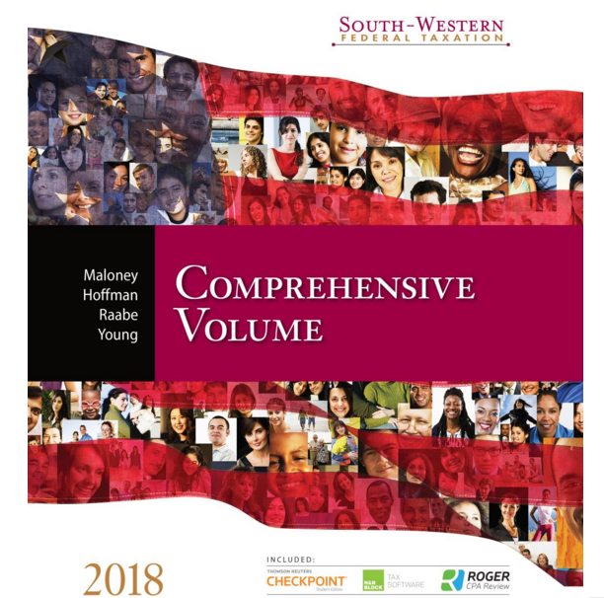

Title: | South-Western Federal Taxation 2018: Comprehensive
Author: | William H. Hoffman; James C. Young; William A. Raabe; David M. Maloney; Annette Nellen
Edition: | 41
Copyright Date: | 2018
Publisher: | Cengage South-Western
ISBN: | 9781337386005

From your course textbook, South-Western Federal Taxation, read the following…
Chapter 19: Corporations: Distributions not in complete liquidation

ASSIGNMENT:
Listed below are the instructions for Project 1 and 2. Answer all questions pertaining to BOTH Projects.

Project 1:

Instructions:

Tax Characteristics and Dividends
From the textbook, answer the following questions:
- Heather, an individual, owns all of the outstanding stock in Silver Corporation. Heather purchased her stock in Silver nine years ago, and her basis is $56,000. At the beginning of this year, the corporation has $76,000 of accumulated earnings and profits and no current earnings and profits (before considering the effect of the distributions). What are the tax consequences to Heather (amount and type of income and basis in property received) and Silver Corporation (gain or loss and effect on earnings and profits) in each of the following situations?
  - Silver distributes land to Heather. The land was held as an investment and has a fair market value of $54,000 and an adjusted basis of $42,000.
  - Assume that Silver Corporation has no current or accumulated earnings and profits prior to the distribution. How would your answer change?
  - Assume that the land distributed to Heather is subject to a $46,000 mortgage (which Heather assumes). How would your answer change?
  - Assume that the land has a fair market value of $54,000 and an adjusted basis of $62,000 on the date of the distribution. How would your answer change?
  - Instead of distributing land to Heather, assume that Silver decides to distribute equipment used in its business. The equipment has a $14,000 market value, a $1,200 adjusted basis for income tax purposes, and a $5,200 adjusted basis for earnings and profits purposes. When the equipment was purchased four years ago, its original fair market value was $18,000.
- Kristen, the president and sole shareholder of Egret Corporation, has earned a salary bonus of $30,000 for the current year. Because of the lower tax rates on qualifying dividends, Kristen is considering substituting a dividend for the bonus. Assume that the tax rates are 28% for Kristen and 34% for Egret Corporation.
  - How much better off would Kristen be if she were paid a dividend rather than salary?
  - How much better off would Egret Corporation be if it paid Kristen a salary rather than a dividend?
  - If Egret Corporation pays Kristen a salary bonus of $40,000 instead of a $30,000 dividend, how would your answers to above change?
  - What should Kristen do?
Submit your answers in a 2-page Microsoft Word document.
Support your responses with examples.
Cite any sources in APA format.

Project 2:

Instructions:

Tax Consequences
Pedro owns 700 of the 1,000 shares outstanding of Indigo Corporation (earnings and profits of $950,000). Pedro paid $170 per share for the stock 12 years ago. The remaining stock in Indigo is owned by unrelated individuals. What are the tax consequences to Pedro in the following independent situations?
- Indigo redeems 350 shares of Pedro's stock for $175,000.
- Indigo redeems 450 shares of Pedro's stock for $225,000.
Robert and Lori (Robert's sister) own all of the stock in Swan Corporation (earnings and profits of $700,000). Each owns 500 shares and has a basis of $25,000 in the shares. Robert wants to sell his stock for $400,000, the fair market value, but he will continue to be employed as an officer of Swan Corporation after the sale. Lori would like to purchase Robert's shares and, thus, become the sole shareholder in Swan, but Lori is short of funds. What are the tax consequences to Robert, Lori, and Swan Corporation under the following circumstances?
- Swan Corporation distributes cash of $400,000 to Lori, and she uses the cash to purchase Robert's shares.
- Swan Corporation redeems all of Robert's shares for $400,000.
Buy-sell agreements are frequently used to address the disposition of a retiring or deceased shareholders' stock in a closely held corporation. Using the Internet as your research source, prepare an outline on the planning opportunities and pitfalls of using a buy-sell agreement in conjunction with the qualifying stock redemption.
Submit your answers in a 3-page Microsoft Word document.
Support your responses with examples.
Cite any sources in APA format.

