University of Salford
Visual Arts
Level 5

Student Module Guide
Contemporary Debates

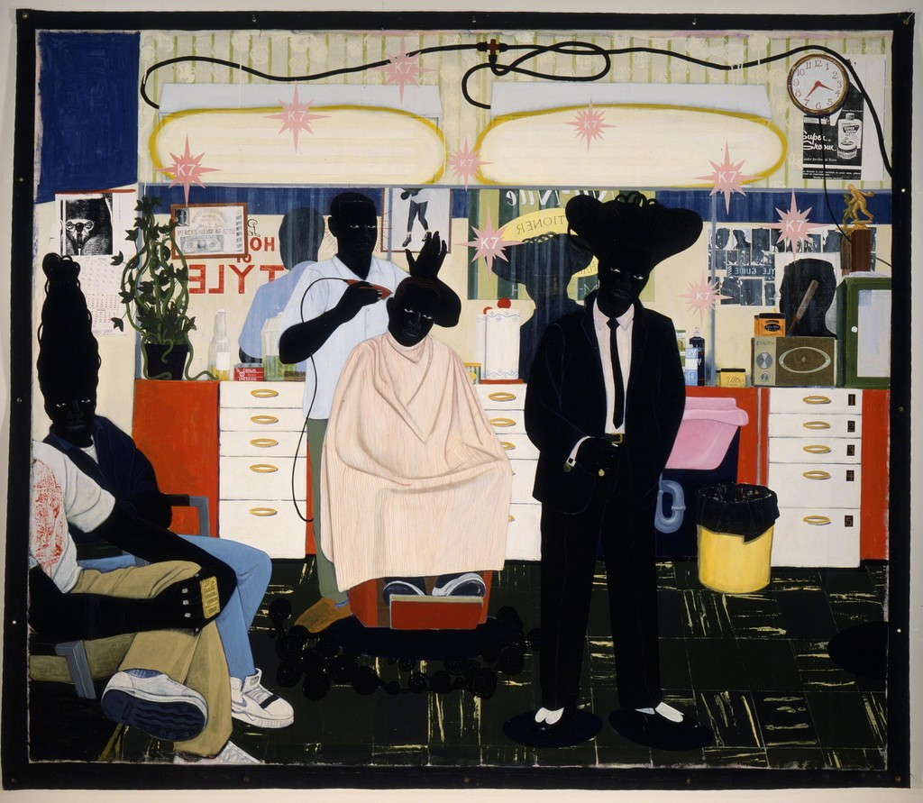

Academic Year 2016/17

The Module

Introduction

Contemporary Debates is the second of your two theory modules in Level 5 of the programme. It is a 20 credit module. The submission requirement is a 4000-5000 words written essay or equivalent (see assessment Option 2). The essay must follow the standard academic protocols prescribed for the task. The module is delivered in six lecture presentations and two seminars and other forms of structured support.

The module offers the opportunity to study and discuss the cultural conditions that characterise contemporary societies and their cultural activities and products and well as their underlining debates and discourses

Rationale

For many years artists and theorists have discussed the period in which they live and work as ‘postmodern’ – a cultural condition in the advanced capitalist economies of the world. But, the term is beginning to outlive its usefulness. Many critics and curators now believe the term characterises a particular period (circa 1970-1990) in which case the postmodern era has been and gone.

So what then are we to make of the contemporary world today - the digital age, the post-truth era, the social media age - and how we navigate our way through it.
Contemporary Debates offers an opportunity to explore art practices, with their richness, inclusivity and experimental flair and examine them.

The module renews the framework for studying and reflecting on debates and discourses that underline contemporary art and curating practices, creative attitudes, values and aspirations.

Aims of the Module

- To further develop students’ awareness of the range of critical debates within contemporary fine art practice.
- To develop a critical understanding of the socio, political, economic and/or cultural contexts which frame the debates within contemporary fine art practice.
- To equip students with a detailed understanding of a subject-specific debate within contemporary art practice and articulate an informed position.

Learning Outcomes

At the completion of the module, students should be able to:

- Demonstrate and communicate a critical understanding of the socio, political, economic and/or cultural contexts in which contemporary fine art is embedded.
- Demonstrate a detailed understanding of a subject-specific debate of individual relevance within contemporary fine art practice.
- Employ appropriate academic research, critical, analytical methods and communication skills in written and visual presentation.

Assessment Criteria

- Critical judgement and analytical ability
- Enquiry and use of sources
- Knowledge and understanding of subject matter
- Technical skills
- Written communication

Transferrable Skills

- Criticality
- Organisation & Planning
- Communication Skills
- Information Technology
- Presentation Skills

The Task: Essentials

Submission Requirements

You are asked to identify a key debate within contemporary art practice and explore its emergence, its impact and reach and its expression in contemporary arts practice.
The debate must be ‘contemporary’, i.e. it must be a debate that is topical and one that artists, curators, theorists are discussing in their work, their curated exhibitions and their writing.
This does allow for debates that may be ‘historical’ if they have been debated anew (re-evaluated) and discovered to have a contemporary resonance in the form of a new work, exhibition of publication.
You may select any subject but it is recommended that you discuss your choice with a tutor before you commence your research and writing.
The lecture series will cover a number of other topics as exemplars of how you might approach your essay, e,g. Art in the Post-truth Era, Art & Big Data etc.
This module offers a choice of two assessments based on a topic of individual relevance.

Option 1 consists of an essay of 4000-5000 words.

Option 2 consists of an oral presentation of 20 minutes and a 2500 word essay (each component to be weighted equally).

Students will be offered guidance in selecting which option is most appropriate to their chosen topic and interests. Option 2 is available to students, in negotiation with the module co-ordinator, in cases where it can be determined that a student would be disadvantaged by selecting option 1.

It is envisaged that option 2 will be offered to students only where there is clear evidence of a learning difficulty that precludes a student from submitting a 4000-5000 word essay.

Option 2 is not an easy option. Academic standards must be maintained. The equivalence of research, analysis and understanding must be maintained between both assessment options. The PowerPoint must be presented with the same attention to academic protocols (including Harvard citation) as the essay.

A student offered Option 2 must be confident enough to present their work in a viva to the assessment team and the shorter form essay must be meet the same academic test as all other students.

The Submission Deadline:

Students must submit work on or before the deadline via Turnitin:

4.00pm Friday 04th May 2018

Assessment Feedback Delivery Deadline:

4.00pm Friday 25th May (Promptly)

Works submitted after the deadline will be penalised.

Students with Reasonable Adjustment Plans (RAP) may be entitled to an extension on the deadline. Each RAP is individually tailored and students must check the terms of their own plan.

Re-submission and Re-assessment

Students who achieve a mark under 40% are who are unable to submit work (Non-submission) are entitled to a re-assessment opportunity. The re-assessed work will be capped at 40%.

Level 4 students are offered an opportunity to retrieve their assessment before the Board of Examiners meets in June 2017 to enable them to pass the year and progress on to Level 5. Students who are unable to retrieve their assessment during trimester 2 will be invited to resubmit in August 2017.

Students who fail to achieve a mark of 40% on a second attempt will be offered an opportunity to re-take the module (Students are required to pay the full cost of the module for this third and final attempt).

Student Support

There are formal tutorials - individual or group. The staff team endeavour to offer additional informal support on a daily basis.

If any student if facing difficulties on the module, however large or small, that impact and affect their performance on the module, please speak with the module co-ordinator or programme leader and alert them to your concerns so that additional support can be tailored to your needs.

Student Obligations

- Student must submit work to deadline
- Students must submit their essay via the Turnitin electronic submission (see below) and also a bound copy of their essay (following academic protocols)
- Academic Protocols: Arial/Times new Roman, double spaced, 12 point, Harvard Method and hardcopy bound)
- Students with a Student Support Plan may be entitled to hand in work up to one week later. They must consult the terms of their support plan.
- PMC’s must be submitted within ten days of the deadline
- Students must make themselves aware of the university policy on Unfair Means and
- All marks are provisional until ratified by the exam board

Turnitin®

The university uses an electronic plagiarism detection tool service called Turnitin® which is hosted in the UK by JISC. The university is using the Turnitin® service where appropriate for assessments which students are required to submit by electronic means starting in the academic year 2010/11. by registering with the university you consent (insofar as your consent is needed) to the following:

- The university will submit your assessments (including details of your name and course details) to the Turnitin® service so that your assessments can be compared with the database of works that is maintained by the Turnitin® service and that is drawn from various sources including the internet; and
- Your assessments may be stored in that database of works indefinitely (or until the university stops using the Turnitin® service and requests their deletion) to help protect your assessments from future plagiarism. Where there is a match between content in your assessments and content in other works, then your assessments may also be copied by the university and other users of the Turnitin® service to allow closer analysis.

A link to key questions students ask about Turnitin® is as follows:

http://wwwturnitin.com/resources/documentation/turnitin/sales/Questions_Students_Ask_About_Turnitin.pdf

Advice

The Contemporary Debates module is a difficult module. It is your most challenging theory module to date.

You are invited to research and explore a key issue in contemporary fine art discourse.

What do we mean by the term contemporary fine art discourse?

Contemporary refers to the here and now. It must be topical, current and relevant.

Discourse refers to the sum of conversations, discussions and means by which we define our subject, set its boundaries and explore its possibilities. In terms of fine art practice the discourse can be found in the art and cultural products produced, the texts written about them, the curated exhibitions that offer interpretation and the critical reviews in newspapers, periodicals and academic texts etc.

What issues emerge in our understanding of contemporary fine art practice?

In truth every discussion we have about art contains social, economic, cultural and political issues embedded within it.

For many years we discussed art as if it were universal and timeless, a world filled with masterpieces created by geniuses. This conception of art does not invite critical reflection. It does not invite us to unpick the assumptions that underpin its foundations.

Today, contemporary artists, curators and writers are much focussed upon understanding the social, economic, cultural and political contexts in which they work and operate.

Consider the following recent exhibitions in the last 12 months:

Coming Out: Sexuality, Gender and identity at the Walker Art Gallery in Liverpool

Soul of a Nation: Art in the Age of Black Power at Tate Modern.

Both exhibitions explore art, culture and politics in the twentieth century. Although many of the works can be considered ‘historical’ (they were not made recently; nor in the 21st century), the debate is taking place right now. For a variety of reasons curators have not felt able to tackle these subjects previously. The climate of public opinion was not deemed ready and receptive.

Both exhibitions explore neglected art and artists and seek to offer a revision of our view of art history that is happening right now; i.e. a contemporary discourse.

Your approach to the subject of contemporary debates may be less overtly social or political.

You could choose to explore the way in which contemporary artists approach a particular genre: the portrait, the history painting, the still life.

You could explore contemporary artists approach to an issue that is being discussed widely in the leading critically engaged magazines and explored in contemporary exhibitions, e.g. colour/‘chromophobia’, decay, ruins, materiality, sexuality, education, nature, collaboration, memory, failure, documentary, the quotidian, beauty, the sublime, appropriation, chance, outsider art, the archive, digital culture, big data, etc.

The Whitechapel Gallery produce a series of books under the banner ‘Documents of Contemporary Art’ that cover a number of the topics listed above. They offer an entry into the discussions that artists, writers, critics, curators, academics are leading.

The Key

The key to this module is to choose a subject that connects with your own practice and your own research interests in the studio.

The module will become onerous and difficult if you pluck a subject from random and begin to research and write an essay. It is important your head and your heart are engaged in this task.

The difficulty the module poses is twofold:

One: Identify a research subject of individual relevance to you

Two: Identify a ‘question’ or an ‘argument’ worth pursuing for your research and writing.

Start by identifying a subject, a topic, an issue or concern. Reflect upon your studio practice, your media area, your key visual idiom (figurative/abstract/conceptual), key motifs etc. and see if you can select a subject in negotiation with your tutor; don’t be afraid to seek advice. Staff are here to help.

How can you frame a question?

Consider how contemporary artists approach the subject. What makes their approach to the subject different from artists of another time or period?

Why are people discussing this issue today? Why has it become so important and relevant?

Is the subject of your essay politically sensitive?

Does the subject of your essay concern the representation of people?

Does the work you are examining have a particular social function?

Timetable

Week | Date | Lecture | Delivery | New Adelphi Building  5.21
1 | 30/01 | Module Briefing | Brendan Fletcher | Tuesday11.00am
2 | 06/02 | Contemporary Art & Big Data | Brendan Fletcher | Thursday 11.00am
3 | 13/02 | Art in the Post-Truth Era | Brendan Fletcher | Thursday 11.00am
4 | 20/02 | Immersivity | Dr David Hancock | Thursday 11.00am
5 | 27/02 | Appropriation | Dr David Hancock | Thursday 11.00am
6 | 06/03 | Absence & Prescence | Dr David Hancock | Thursday 11.00am
7 | 13/03 | Group Tutorials | Brendan Fletcher/  David Hancock | Thursday 11.00am
8 | 10/04 | Group Tutorials | Brendan Fletcher/  David Hancock | Thursday 11.00am
9 | 17/04 | Group Tutorials | Brendan Fletcher/  David Hancock | Thursday 11.00am

Student Obligations

- To submit work by the deadlines stated above and the completed document via Turnitin
- Students with a Reasonable Adjustment Plan (RAP) may be entitled to hand in work up one week later (two weeks in exceptional cases). They must consult the terms of their RAP plan.
- PMC’s must be submitted within ten days of the deadline
- Students must make themselves aware of the university policy on Unfair Means and
- All marks are provisional until ratified by the Board of Examiners

Academic Protocols:

- The word count for your assignment (all three components combined) is 3000 words, but you are allowed a leeway of 10% above or 10% below the word count for each component.
- Account for all your research sources.
- Use a word processor and an Arial or Times Roman Script, Font 12. Your submission must be typed and a hard-copy must be printed out and submitted in addition to the digital submission. Type on only one side of each sheet of paper you use and number the pages correctly.
- Use double spacing for your text
Do not place your assignment in individual plastic folders

Reading List

Core Texts

Bishop, Claire (2012), Artificial Hell’s: Participatory Art and the Politics of Spectatorship, Verso Books

Lange-Berndt, Petra (2015), Materiality: Documents of Contemporary Art, MIT Press

Jones, Amelia (2015), Sexuality: Documents of Contemporary Art, MIT Press

Jones, Amelia (2006), A Companion to Contemporary Art Since 1945, Blackwell

Further Indicative Reading

Series of Books: Documents of Contemporary Art, MIT Press

Harvard Citation

Harvard Citation: What is Harvard Citation?

Harvard Citation is a system that enables you to compile an alphabetical list, or 'Bibliography’, of all the material you have used in researching for your essays. It also provides a way of referring directly specific items of this research in your essay itself. It is widely used in academic and professional circles and can be described as a universal method for organising and presenting research.

A comprehensive guide to Harvard citation is available on the Art & Ideas Blackboard page.

Quick Guide to Referencing Harvard Style

‘Citing a book from which you copied a sentence is paying a debt’, Umberto Eco

General

In the text
(Surname, year, page number)
In Bibliography
Surname in bold, Initial. (date in brackets) Title of book in italics, Location of publisher: Publisher’s name

Books
One author
In the text
Short quotes in the main body of the text should be in speech marks:
Critiques of subcultural theorists are “their failure to consider the internal diversity” (Crawford, 2012, p.99)
In the Bibliography
Crawford, G. (2012) Video Gamers, Abingdon: Routledge
In the text
Long quotes over two lines should be indented:

In his book Art Practice as Research (2010), Graeme Sullivan discusses curator, Robert Storr’s 52nd Venice Biennial in 2007. Sullivan suggests that Storr, as a curator, “offers a structure that speaks to artists, critics, historians, educators, cultural theorists, and the public” (Sullivan, 2010, p.224). He continues,
“Storr’s central premise is that art making is a personal process and public practice that is a primary source for creating and critiquing new knowledge that has important individual and cultural value. This claim resonates with those made by advocates of art practice as research” (Sullivan, 2010, p.224).
In the Bibliography

Sullivan, G. (2010) Art Practice as Research – Inquiry in Visual Arts. 2nd edition. Thousand Oaks: Sage Publications, Inc.

References within other Books

In the Text:
(Carr quoted in Bell, 2007, p.170).
In the Bibliography
Carr, D. (2002) Playing with Lara. in Bell, D. & Kennedy, B. (2007) The Cybercultures Reader. 2nd Edition. London: Routledge
Two or more authors
In the Text:
(Bennett & Kahn-Harris, 2004, p.23)
In the Bibliography
Bennett, A. & Kahn-Harris, K. (2004) After Subculture – Critical Studies in Contemporary Youth Culture. Hampshire: Palgrave MacMillan.
Magazine articles
In the text
Pinchbeck describes Dear Esther as “a mood piece; it’s about the atmosphere, not about ‘solving’ the plot” (Pinchbeck & Woolley, 2010, p.23).
In the Bibliography
Pinchbeck, D. & Woolley, T. (2010) Games That Will Break Your Heart – Dan Pinchbeck in conversation with Tom Woolley. Archive. No.18. October 2010, p.22-25. Bradford: National Media Museum.

Online Articles
In the Text:

He suggests, “each franchise entry needs to be self-contained enough to enable autonomous consumption” (Jenkins, 2003).
In the Biblography:
Jenkins, H (2003) Transmedia Storytelling. MIT Technology Review 15/1/2003. Online. Available at http://www.technologyreview.com/biomedicine/13052/page3/ - Last checked 13/7/14
In the text:
(Dorfman, undated)
In the Biblography:

Dorfman, E. (undated) Fandomania – Artists Statement. Online. Available at
http://elenadorfman.com/fineart/fandomania/fandomania-artist-statement/ - Last checked 29/7/14

Images taken online

With the Image:
Fig. 7. William Holman Hunt, The Shadow of Death (1873)
In the list of images:

Fig. 7. William Holman Hunt, The Shadow of Death (1873) Oil on Canvas, 214 x 168cm, Manchester Art Gallery Collection. Online. http://en.wikipedia.org/wiki/The_Shadow_of_Death (Accessed 30/1/15)

Your own Images

With the Image
Fig. 11. David Hancock, Charlotte & Stormtroopers (2013)
In the list of images
Fig. 11. Charlotte & Stormtroopers (2013) Photo: David Hancock

Images provided by artists

With the image:
Fig. 166. Ulrika Wärmling, Victoria in a dress from Pomp-A-dour (2012)
In the list of images:
Fig. 166. Ulrika Wärmling, Victoria in a dress from Pomp-A-dour (2012) oil on linen, 130 x 95 cm. Courtesy of the artist.

Key Policies

Ethical Approval
The University of Salford requires all research to be consistent with basic ethical principles. These are those general judgements which serve as a basic justification for the many particular ethical prescriptions and evaluations of human actions.
The University in particular is guided by three specific basic ethical principles:
- Respect the autonomy of human research subjects
- Do no harm to researchers or human research subjects
- Act justly towards those who contribute to your research
There are instances when Visual Arts students may need to consider their ethical responsibilities. E.g. students photographing children, students engaged in placements, students working in the public sphere etc.
If students have any concerns regarding the ethical nature of their research project they should contact a member of the staff team.
Health & Safety/Studentship

It is vital for the safety of staff, students and visitors to the department and for the smooth running of the department that some basic rules of conduct are followed and maintained.

Health & Safety: Studentship

It is vital for the safety of staff, students and visitors to the department and for the smooth running of the department that some basic rules of conduct are followed and maintained.

Health & Safety/Studentship: Studio

The university has a statutory duty to ensure all staff and students engage in safe working practices and that risk assessments are in place for any potentially hazardous activities.

In an art school and within fine art practice there are a great many hazardous activities. Contemporary fine art practice has expanded from the narrow focus on painting, sculpture and fine print and encompasses a range of practices that include interdisciplinary and non-traditional forms. It is our duty, in this case to ensure we put in place measures to ensure safe working practice.

Perhaps understandably students do not always recognise the risks when they undertake a particular activity.

Hazards can take many forms: using tools, electrical equipment, heavy objects, working from height, bio-hazards, hazardous substances etc. Please be alert to the dangers in the studio and your working practice. If you are in any doubt, please consult the Programme Leader. We will contact the health & Safety team and work with you to facilitate the development of a safe working practice to enable you to continue.

- Please ensure that you dispose of rubbish sensibly. Do not put sharp objects (e.g. glass fragments) into the bin. (Please consult the caretaker)
- Students must mop up any spillages immediately
- Students are not permitted to bring their own furniture into the studio without approval.
- Students must take care to ensure electrical cables do not become a tripping hazard. (Consult Instructor/Demonstrator Craig Tattersall in the workshop).
- Hazardous substances are subject to strict controls: please seek advice and approval if you have need to employ them in the manufacture of your work.
- Please ensure that all music is no more than low level background noise. Please respect other students’ right to work in privacy and quiet.
- Mobile phones must be ‘on silent’ or switched off during tutorials, seminars and crits

The university has a statutory duty to ensure all staff and students engage in safe working practices and that risk assessments are in place for any potentially hazardous activities.

In an art school and within fine art practice there are a great many hazardous activities. Contemporary fine art practice has expanded from the narrow focus on painting, sculpture and fine print and encompasses a range of practices that include interdisciplinary and non-traditional forms. It is our duty, in this case to ensure we put in place measures to ensure safe working practice.

Perhaps understandably students do not always recognise the risks when they undertake a particular activity.

Hazards can take many forms: using tools, electrical equipment, heavy objects, working from height, bio-hazards, hazardous substances etc. Please be alert to the dangers in the studio and your working practice. If you are in any doubt, please consult the Programme Leader. We will contact the Health & Safety team and work with you to facilitate the development of a safe working practice to enable you to continue.

- Please ensure that you dispose of rubbish sensibly. Do not put sharp objects (e.g. glass fragments) into the bin. Consult the staff team if you are unsure how to dispose of items.
- Students must report any spillages so they can be mopped up immediately.
- Students are not permitted to bring their own furniture into the studio without approval.
- All electrical equipment must be PAT tested.
- All electrical equipment must run on 10 amps or less
- Students must take care to ensure electrical cables do not become a tripping hazard.
- Hazardous substances are subject to strict controls: please seek advice and approval if you have need to employ them in the manufacture of your work.
- Please ensure that all music is no more than low level background noise. Please respect other students’ right to work in privacy and quiet.
- Mobile phones must be ‘on silent’ or switched off during tutorials, seminars and crits.

We are also keen to support your professionalization. In any workplace in the professional world you will be required to commit to fulfilling the statutory duty to support and maintain Health & Safety.

You will be required to complete a Health & Safety risk assessment for work that is carried out that is deemed to be a potential risk.

Here at the University of Salford, within and without the studios we will be asking students to follow Health & safety best practice and to complete risk assessments (with assistance) as required to prepare you for the world of work.

Please see the Risk Assessment pro-forma at the back of this document. If you have any concerns please consult a member of the staff team for further advice

Health & Safety/Studentship:
Lecture Theatre

- Food and drink is not permitted in the lecture theatre
- Mobile phones must be switched off or ‘on silent’.
- Text messaging is not permitted in the lecture theatre
- Recording devices must be approved by the lecturer in advance

Health & Safety/Studentship:
Fire Safety

- This is a NO SMOKING building
- This is a NO E-CIGERETTE / VAPING Building
- Please keep fire doors closed at all times. Fire doors must not be ‘wedged’ open.
- All walkways must be free of tables, easels, materials, artwork and debris. Please ensure a 1 metre wide clearway. Do not place any items in front of the fire doors or fire exits.
- Students are not permitted to ‘burn’ materials in the studio.
- Students are not permitted to use aerosols in the studio
- Please acquaint yourselves with the locations of the fire exits
- In the event of a fire, the alarm will sound. Please leave the building by the nearest fire exit and congregate on the Peel Park Campus..

The New Adelphi Building Fire-Marshalls:

Level 6
Paul Marsden/Fire Marshall
Brendan Fletcher/Fire Marshall

If You Discover a Fire

Sound the alarm using the break glass alarm point
Dial 53333 to call the fire brigade
If safe to do so, tackle the fire using the appliances provided
Do not take personal risks

If You Hear the Fire Alarm

Leave the building by the nearest available exit
Close doors behind you
Report facts to the Building Control Point

Your Assembly Point Is:

Academic Good Conduct

The University makes awards to students that properly reflect your achievement. Unless instructed otherwise, you are expected to work on your own and to ensure that material you submit for assessment does not contain the work of others, except for properly referenced sources where appropriate. The University takes a very serious view of any attempt to gain unfair advantage from the work of others. The use of unfair means in any assessment is likely to result in severe penalties. Gaining unfair advantage can take many forms such as:
a) Plagiarism
Plagiarism involves taking the work of another person or source and using it as if it were your own, for example written work, ideas, musical compositions, computer programs, laboratory or survey results, diagrams, graphs, drawings and designs.
b) Collusion
Collusion involves working with others on tasks that should be carried out on an individual basis. Collusion should not be confused with collaborative work which is sometimes used as a means of learning. It will be clearly stated when collaborative work is permitted in an assessment. Unless advised otherwise, any work which you submit for assessment must be produced by you on an individual basis.
c) Falsifying experimental or other investigative results
This could involve a range of things that make it appear that information has been collected by scientific investigation, the compilation of questionnaire results, etc. whereas in reality it has been made up or altered to provide a more favourable result.
d) Taking unauthorised material (including electronic devices) into an examination
This involves deliberately taking in materials or electronic device of any sort, not specifically permitted, that could be used to gain advantage, whether you use it or not.
e) Contracting another to write a piece of assessed work
This involves any means whereby a person does work on behalf of another. It includes assessments done for someone else in full or in part by a fellow student, a friend or family member. It includes sitting an examination for someone else. It also covers obtaining material from Internet ‘cheat sites’ or other sources of work. Penalties for this type of unfair means are likely to apply both to a student who does work on behalf of another and one who has work done for him/her.
Particular care should be taken with regard to poor referencing. If you use work which has been produced by other people within an assignment you will need to ensure that you acknowledge or reference the source of the work. Marks may be deducted for poor referencing. If poor referencing is extensive throughout a piece of work it could appear that you are trying to claim credit for the work and you may be deemed to have committed plagiarism.

