Oaky North lock-out lengthens
28th Sep 2017 1:39 PM

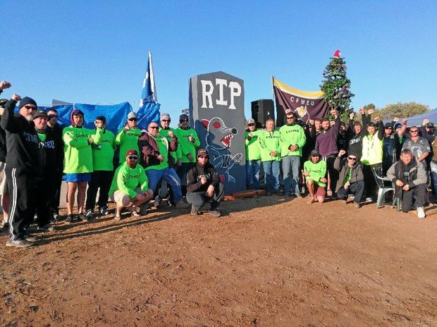
TOUGH SITUATION: The lock-out at Glencore's Oaky North Mine is now on its 88th day. Contributed
by Louise Shannon
TODAY marks the 88th day of the controversial lock-out of 190 men at Glencore's underground Oaky North Mine, as the long-running dispute over a new Enterprise Agreement (EA) continues and concerns are raised for the welfare of the men and their families.
Fresh talks yesterday morning were "better received by both parties" and were "constructive", according to Chris Brodsky, Queensland District Vice President of the Construction, Forestry, Mining and Energy Union (CFMEU) Mining and Energy Division.
Mr Brodsky said the three union representatives and three representatives from Glencore "were more receptive to each other's positions" throughout the meeting, and Glencore had offered a revised remuneration package.
However, he said the two sides still disagreed over the details of three areas: workplace representation, disputes procedure, and severance and retrenchment. A new meeting date has not been set, but the union and Glencore have agreed to ongoing email communication as they review their stances on these clauses.
The two sides have been attempting to settle a new EA after the previous contract expired in 2015. Initial negotiations soured, and on May 10 workers began to strike until Glencore made the decision to lock them out without pay on June 9, saying protests were costing man hours. Contractors are now being used at the Oaky North Mine, 20km outside Tiery.
Mr Brodsky said the Central Queensland mine employees were receiving weekly or fortnightly emails about their ongoing unpaid, lock-out status, with the next notification due on Tuesday morning.
Glencore has said it wants to create modern, flexible and streamlined EAs to reflect modern work environments.
But workers believe Glencore is attempting to use the new EA to favour cheaper, contract labour, and that the dispute has become about casualising the workforce and protecting the rights of contractors.
The CFMEU believes the company would limit the issues workers can raise during a disputes procedure.
Mr Brodsky said, "Currently, any matter can be brought forward. We have something that is better than the Fair Work Act, so why would we want to give that up?"
The way forward was "to continue to have decent discussions as we did today," Mr Brodsky said. "Even though we're still apart on our three major points, it was not adversarial."
He said the mental state of locked-out employees was "solid" but "there's cracks appearing because sitting for 12 hours a day, not being able to do your job, that's going to have an effect on anyone.
"They're a solid group of blokes who are sticking together and they're supporting each other.
"It's the families - wives and kids - who are probably doing it the toughest because being a small community, and sharing the community with staff of Glencore, is difficult at times.
"This used to be a tight-knit community where the interaction was pleasurable, and now it's divided."
Gai Sypher, community leader and resident, said she was also concerned about the effects of the lock-out on local families.
"It can affect children at school because they don't know what's happening with their parents and the workplace," Ms Sypher said.
"Also it's the stress of not knowing. Little kids don't understand the uncertainty of 'is daddy going to have a job' and 'where are we going to live?'"
She said she was also worried about the mental health of locked-out employees.
"They don't know what's happening in their future, and they don't have the income they had to meet their mortgage payments.
"Our whole region needs to understand how this community is suffering and I don't think there's enough acknowledgement of that."
Ms Sypher said the men were becoming "very apprehensive" and "very unsure" about their future. "There's despair, but they're also strong and determined."
Member for Gregory, Lachlan Millar, said he was "disappointed" workers remained locked out.
"With many local families struggling to put food on the table and prolonged negotiations undoubtedly interfering with productivity at the site, I am urging Glencore to cease the lock-out.
"I would like to see these workers returned to their existing roster while ongoing negotiations with union representatives regarding pay and working conditions continue.
"Protecting the welfare of the community is of the upmost priority."
Peter Freyberg, head of Global Coal Assets at Glencore, said last month the union wanted to "tell us when and where we can employ contractors", wanted to control the rosters - "of course we will consult but cannot have unions dictating which roster the business will use" - and wanted "to tell us how to interact with our employees".
Mr Freyberg said Glencore was seeking: "Modern, flexible and streamlined EAs that reflect the realities of today's work environment. Ones that focus on safety, training and unrestricted use of every employee's experience skills and capabilities and positions our business in competitive world market."
Recently, Glencore has called the behaviour of some union officials and members on the picket line "nothing short of disgraceful".
"We remain available for meaningful discussions with the CFMEU in pursuit of a modern, flexible Enterprise Agreement at Oaky North that is not only consistent with agreements accepted by the CFMEU at other mining operations but also maintains wage levels that are currently around $100,000 higher than the average annual Australian wage," the company has said.
Source: https://www.cqnews.com.au/news/oaky-north-lock-out-lengthens/3229078/

See also: https://www.youtube.com/watch?v=KsoVZ92PMD0

