Wireless communication networks

- Consider Classless Inter Domain Routing (CIDR) is adopted to allocate the IP addresses to three subnets: Subnet A, B, C. Supposed all of the interfaces in each of these three subnets are required to have the prefix 134.161.154.0/23. Also suppose that Subnet A is required to support up to 250 hosts, Subnet B and C are each required to support 120 hosts. Determine the network address allocations for the three subnets in the form a.b.c.d/x to satisfy the constraints. Please show the process.

- A Network is shown in the following figure. Please answer the questions based on the configuration given in the figure.

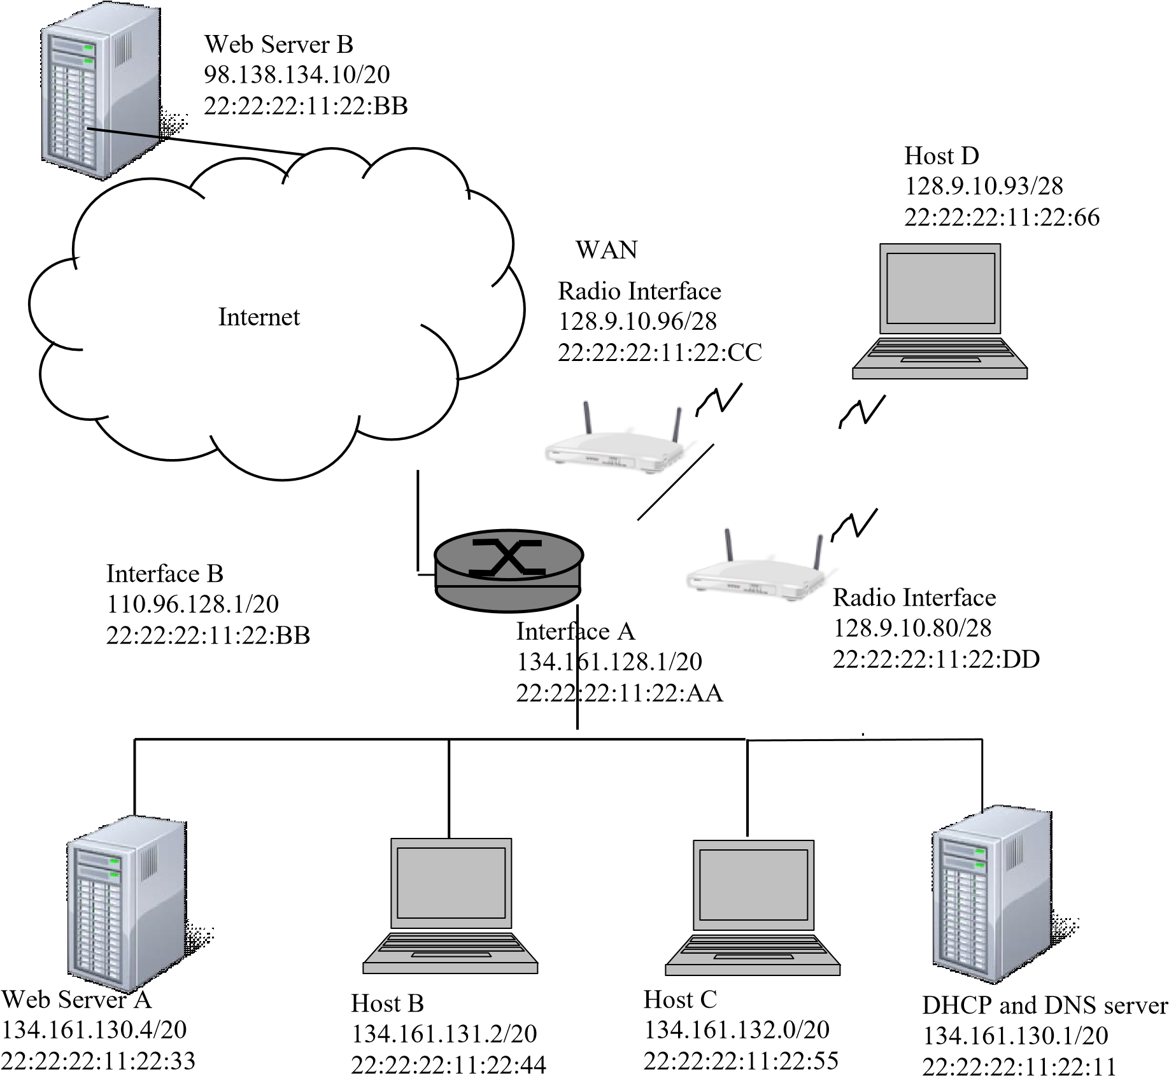
- For the following questions, assume the hosts have the entry of server A and B in their DNS cache.
  - If Host C needs to send a DNS request to the Server, specify the MAC and IP address for the frame leaving Host C : Destination MAC address ______________________
Source MAC address ___________________
Destination IP address _________________________
  - If Host B needs to send a HTTP request to Server B, specify the MAC and IP address for the frame leaving Host B :
Destination MAC address ______________________
Source MAC address ______________________
Destination IP address _________________________
- If the Host C is just turned on and it does not have its IP address assigned yet, explain how the messages will be exchanged before Host C is be able to send the HTTP request to Web Server A.

4. Answer the following TCP/IP suite related questions.
- Complete the five layers of TCP/IP suite in the left column in the table below. Indicate the layers the following protocols/standards work on in the right column: UDP, TCP, IP, HTTP, SMTP, DNS, 802.11, Ethernet (7pts)

TCP/IP layers | Protocols/standards
Network Access & Physical layer

- The following figure is a screen capture after running Ping command.
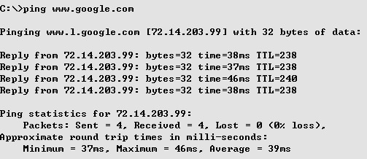
Answer the following questions:
- What is the IP address corresponding to the universal resource locator (URL) www.google.com ? (1pts)

- Which protocol is used to perform the translation from the www.google.com to its IP address? Does this protocol use TCP or UDP service? (3pts)

- What does the time mean in the above figure? What does the TTL mean in the above figure? What is the possible reason that the TTL and time values are different in the figure? (4pts)

