Modeling a Desert Ecosystem

This paper focuses on understanding an ecosystem structure to provide a visual analysis of plant–animal Interactions in the desert.
Due to constant climate change that occur annually in California such as drought and high rainfall, some shrubs and animals that exist in the same desert are affected by these changes annually. For instance, some annual plants are absent in drought years but frequent in higher rainfall years and vice versa. Also, some stress-tolerant species of plants survive more in drought years, while competitive species survive more in high precipitation years.
In this study, we model desert ecosystems, focusing on the positive and negative interactions between some Lizards species (Gambeliasila) that exist in the same desert, Shrubs and other plant species, and how they are affected by extreme weather conditions, such as drought and high precipitation.
During drought, the plant productivity will generally reduce while in high precipitation, it is expected to increase. In periods of drought, Lizards are frequently observed under shrub canopies indicating that Shrubs and Burrows can positively influence Lizards and other animals in the desert by providing food resources, such as seeds and leaves, as well as shelter during high precipitation. Lizards can as well be impacted negatively when there is increase in hostile grass cover which usually interferes with animals’ movements and increases vulnerability on the animals as a result of drought.
From the research it is noted that the adaptations to environmental extremes such as drought and high precipitations by some desert lizard species are not similar to the adaptations of other lizard species in other environments. The study explores the effects of environmental extremes on the desert lizard species as affected by shrubs and other plant species in the desert.
Burrows and shrubs are also important shelters for lizards (Milne, Bull, & Hutchinson2003; Sunday et al. 2014).
Also, shrubs can have a passive influence by acting as a physical designation of territory (Muller 1998, in Filazzola, 2017) or as a perching site for birds that live in the same environment (Aukema&Martínez del Rio 2002 in Filazzola, 2017).
Shrubs and cacti in California are both candidate representative functional grouping of plant species that benefit other plants and often animals within a region.
Practical study has shown that the relationship between desert shrubs and the Lizards and other plant species exist as a result of stress-tolerant traits, such as lower light and soil moisture found under shrub canopies (Filazzola et al., 2017).
It is therefore rational to recommend that expressly looking at the beneficial effects of shrubs on animals species in deserts will form our comprehension of environmental and ecosystem structure and give a model of plant–animal interactions in the desert.
In this study, it is observed that that the ecological habitat for a species is defined by its abiotic requirements and affected by the limitations associated with negative interactions such as parasitism and consumer pressure. Hence positive interactions reduces biotic pressures such as competition from neighbors or consumer pressure, and increases the suitable habitat of a beneficiary species (Filazzola et al., 2017).The study uses a systematic review to propose a conceptual framework or model that highlights the interactions including the functional roles of the interacting species, and further explores a bidirectional plant-animal interaction using a network approach (Lortie et al., 2016).
Positive interactions can be divided into environment builders or constructors, which are those that modify the environment to create suitable habitat, and environment expanders, which are those that modify the beneficiary species to tolerate the habitat.
The shrubs within this study would therefore be classified as environment constructors because they increase environmental heterogeneity to match the inhabited requirements of the beneficiary species.
This study analyses and models the environmental interactions of the plants and animals species present in the desert ecosystem and provides and empirical visual representations of the observations of the species interactions in the ecosystem as affected by climate change and environmental uncertainties.
The report will predict the fate or destiny of the ecosystem using the available data in view of ongoing climate change as displayed in the increasing amount of those extreme events which are droughts and high precipitation. Model how shrubs affect lizards, how lizards affect shrubs, how shrubs affect soil etc.

Animal species in the desert to be included in the ecosystem modeling:
- Consumers (Desert cottontail, the black-tailed jackrabbit, and the heerman’s kangaroo rat.
- Blunt-nosed leopard lizards (GambeliaSila)
- Shrubs (Ephedra Californica or Mormon Tea): Population 700
- Mojave shrub species (Ambrosia Dumosa, Artemisia Tridentata, Ephedra nevadensis, and ColeogyneRamosissima, Larreatridentata)
- Other pereneial plants: MarrubiumVulgare, JuniperusCalifornicaand EriogonumFasciculatum
- Burrows:
- Mediterranean annual grasses and forbs.
- Grass (BromusMadritensis)

Study Data extract
- In high rain periods shrubs can reduce consumer pressure by obstructing consumers with thorns of dense branching.
- Consumers respond to high amount of precipitation.
- During droughts, shrubs improve the microclimate below their canopy by reducing evapotranspiration and increasing soil moisture.
- Water addition did not change the interaction frequency in both the drought and high precipitation years.
- Consumer pressure had no detectable effects in the dry year, but in the wet year exclosures had significantly higher biomass relative to control quadrats. The frequency of positive interactions decreased when consumer pressurewas buffered by exclosures in the wet year

Measurements:
There are 700 shrubs and they are placed 2meters apart and then 2cm above the soil surface.
The images below shows the shrubs as located 2 meters apart and 2 centimeters above soil level.

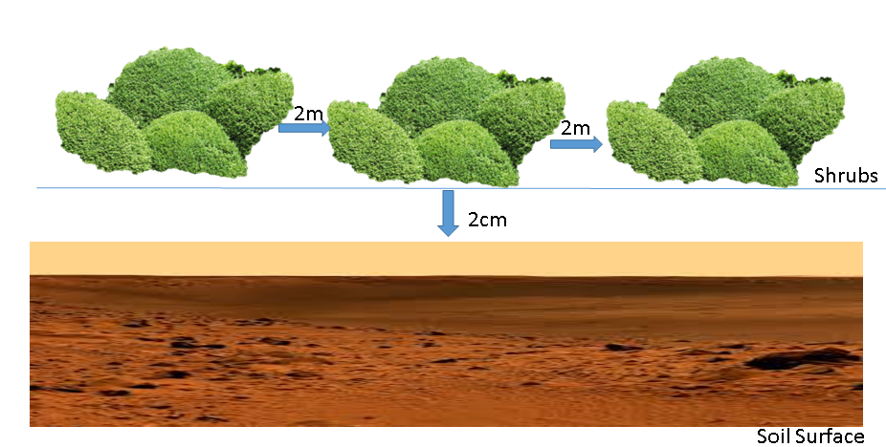
Figure 2: Image showing Shrubs as separated 2m apart and 2cm above the soil surface.

Image below models the lizard as getting shelter under the shrubs.
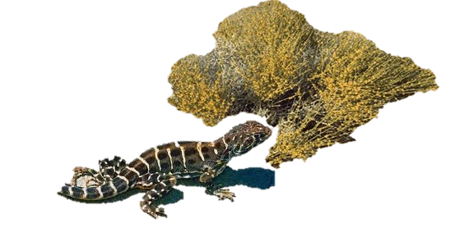

Figure 4: Lizard (Gambeliasila) under the shrub canopy in drought

References:
Filazzola, A., Liczner, A., Westphal, M., &Lortie, C. (2017). The effect of consumer pressure and abiotic stress on positive plant interactions are mediated by extreme climatic events. New Phytologist, 140-150.

Filazzola, A., Westphal, M., Powers, M., Liczner, A., Woollett, D., Johnson, B., &Lortiea, C. (2017). Non-trophic interactions in deserts: Facilitation, interference, and an endangered lizard species. Elsevier, 20, 51-61.

Filazzola, A., Sotomayor, D., &Lortie, C. (2017). Modelling the niche space of desert annuals needs to include positive interactions. Nordic Society Oikos, 1-9.

Lortie, C., Filazzola, A., & Sotomayor, D. (2016). Functional assessment of animal interactions with shrub-facilitation complexes: a formal synthesis and conceptual framework. Functional Ecology, 30, 41-51.

