5 Discussion (each discussion includes 2 replies) the discussion must have references
– each discussion 300 words (Finish this part first)
--each reply 100 words (I will attach two of my classmate’s answer for each discussion after they posted)
ACC-645-Discussion
https://www.sec.gov
https://aflcio.org/paywatch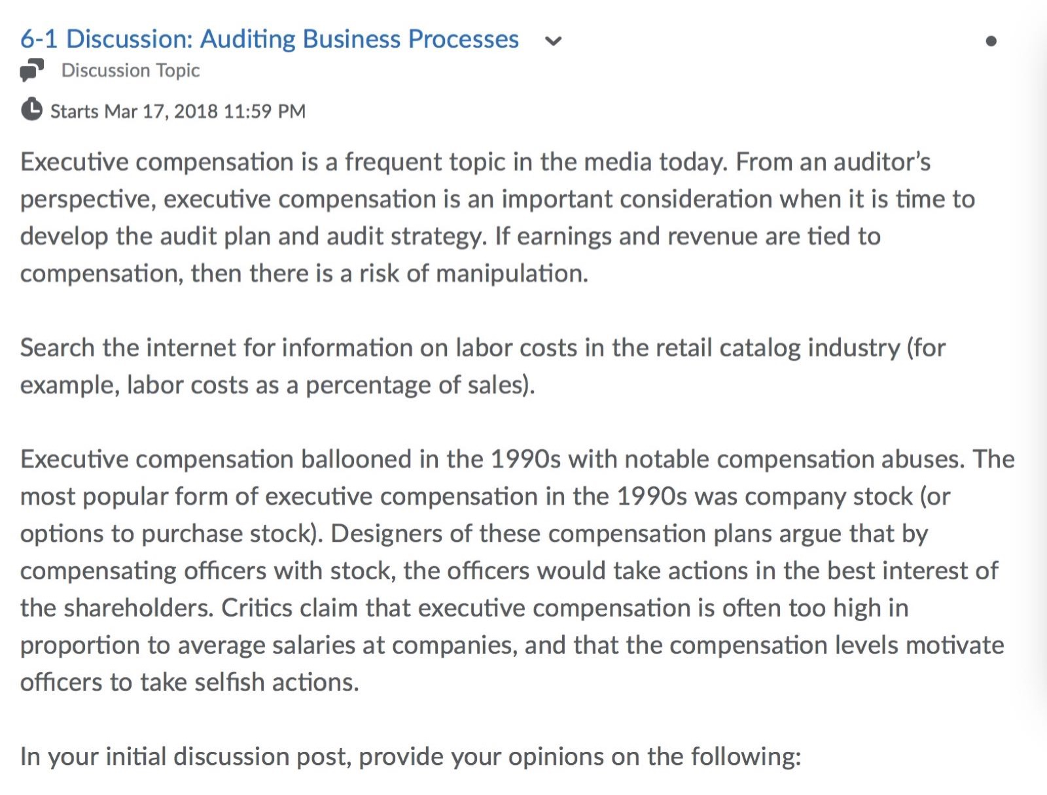
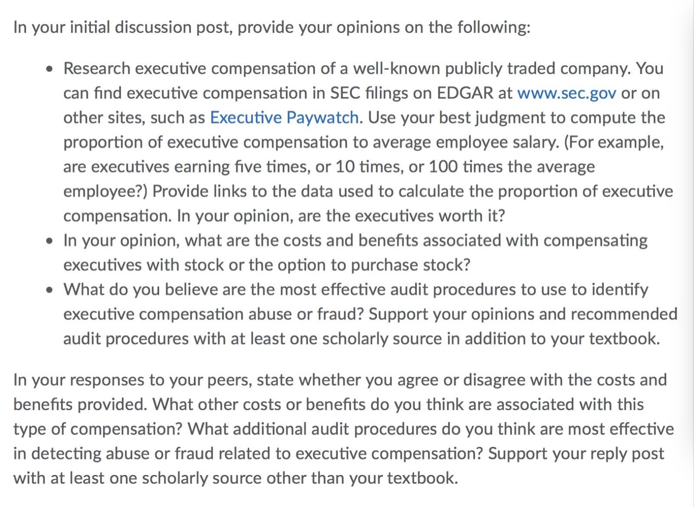

TAX-670-Discussion
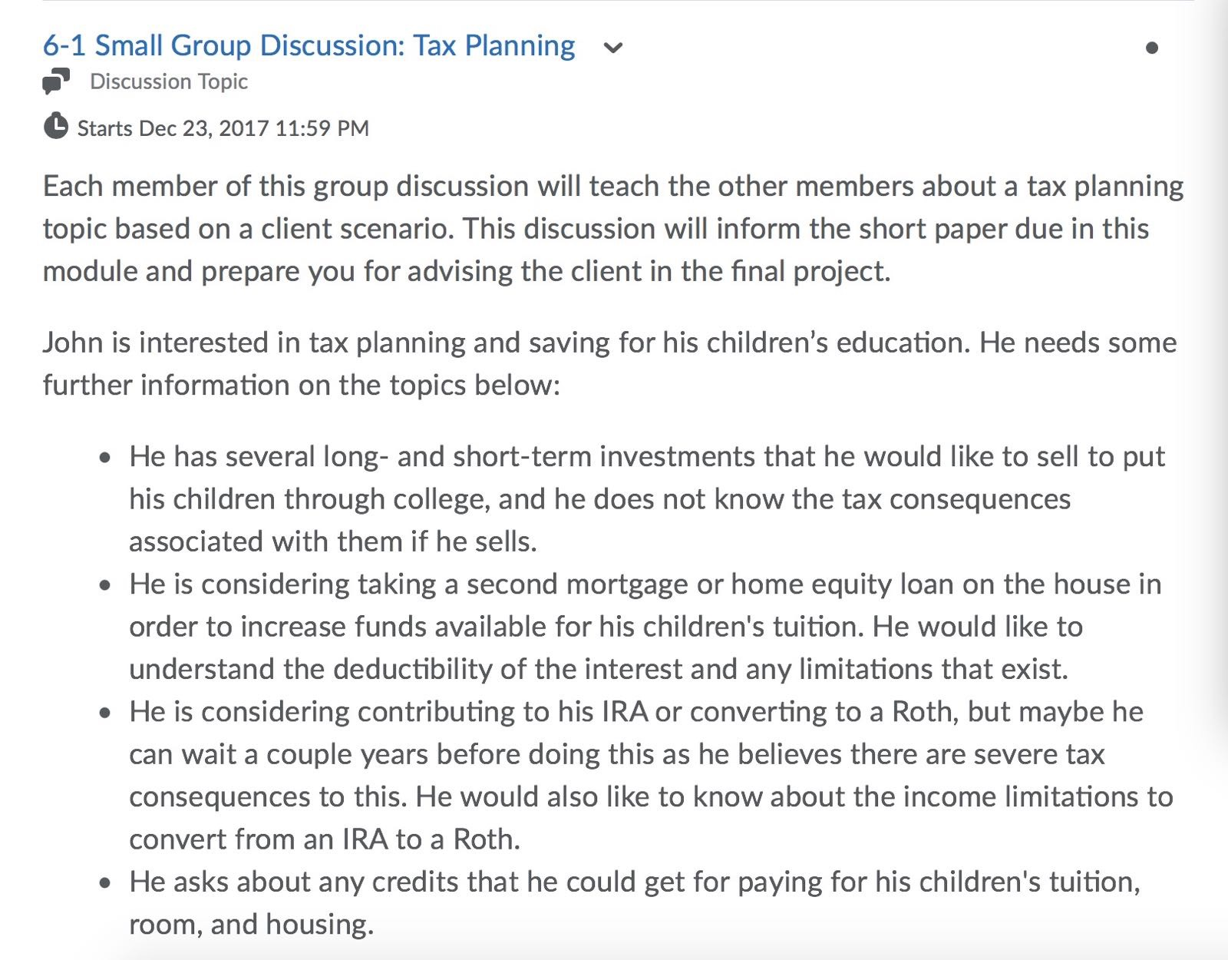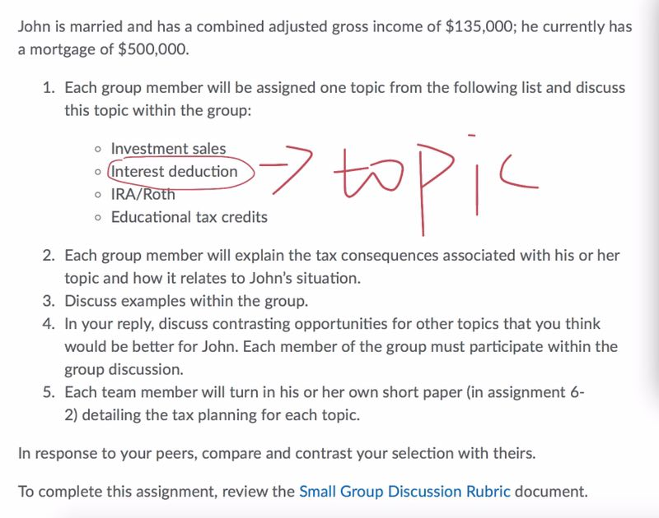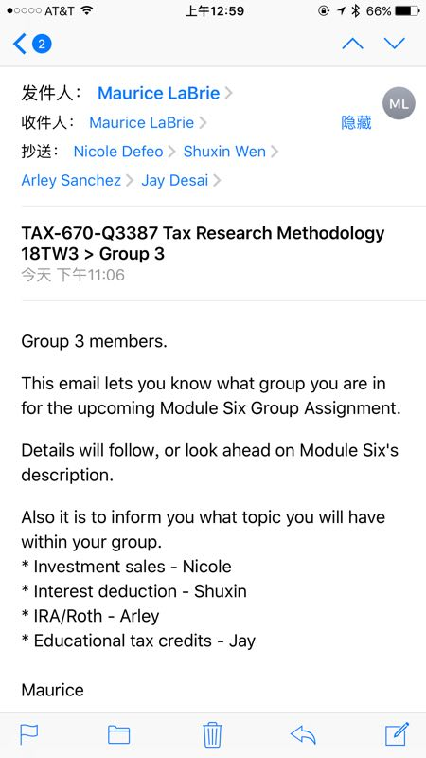

MBA-610-Discussion
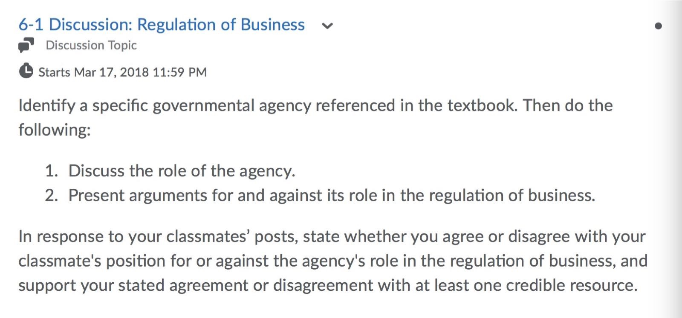

MBA-610-Discussion 2
https://marketrealist.com/2015/12/introducting-mega-deal-monsanto-syngenta
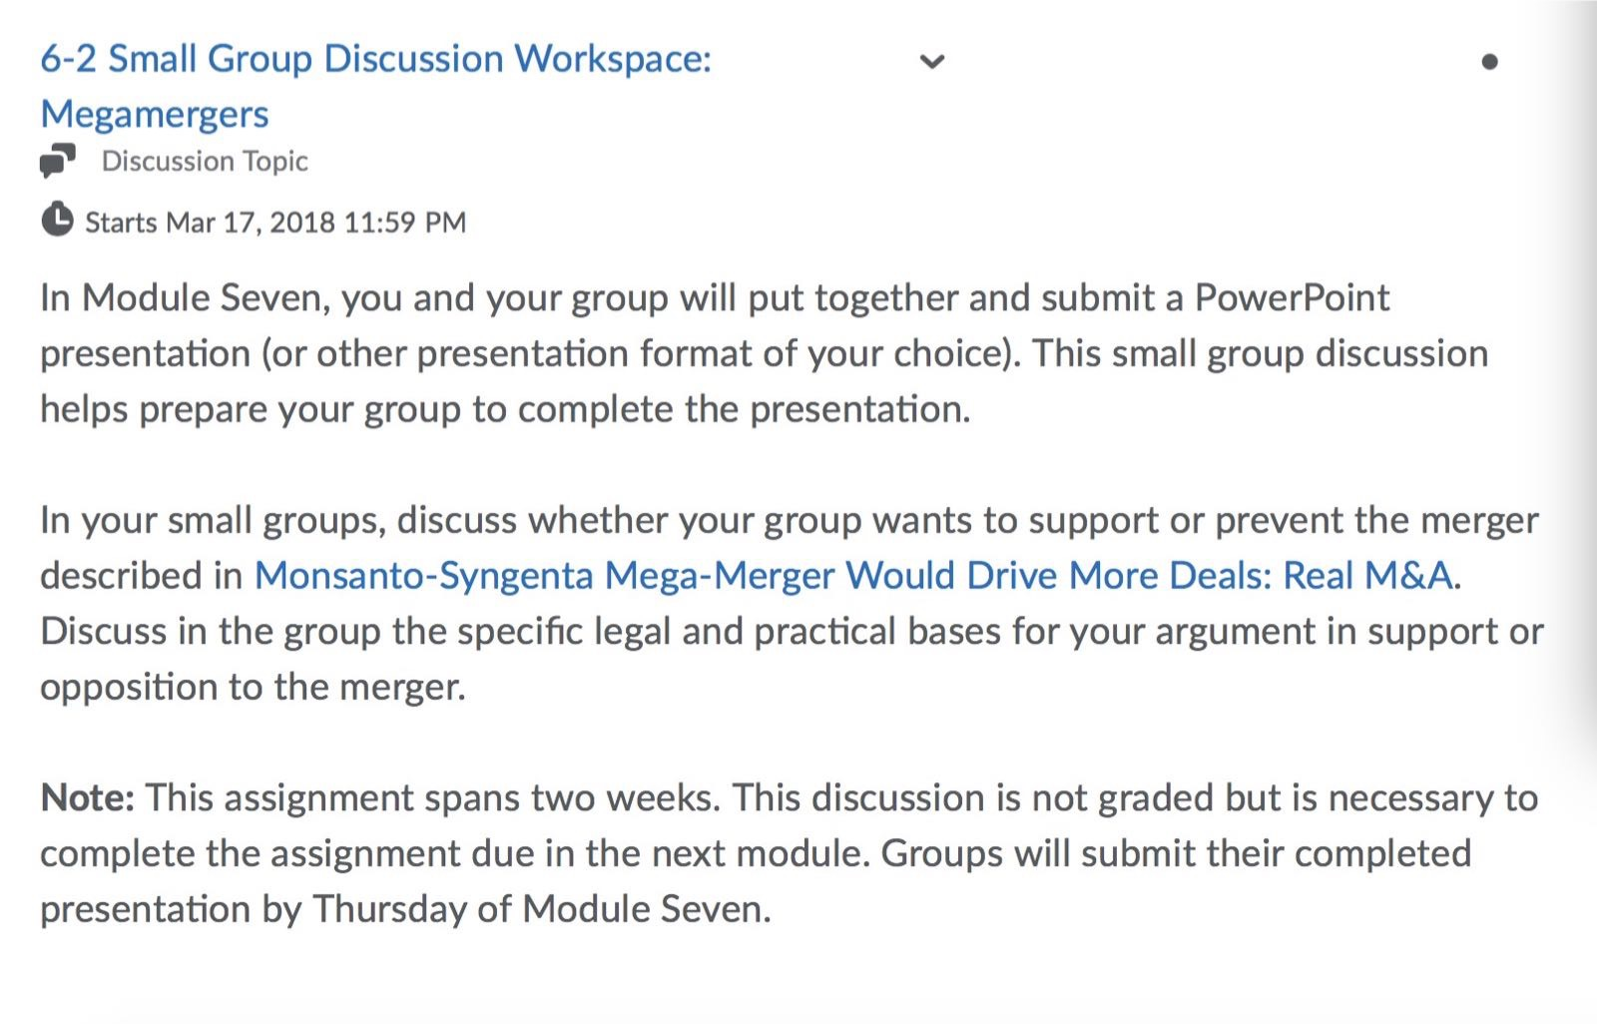

ACC-646-Discussion
https://www.aicpa.org/research/standards/codeofconduct/downloadabledocuments/2013june1codeofprofessionalconduct.pdf
http://federalevidence.com/rules-of-evidence#Rule702
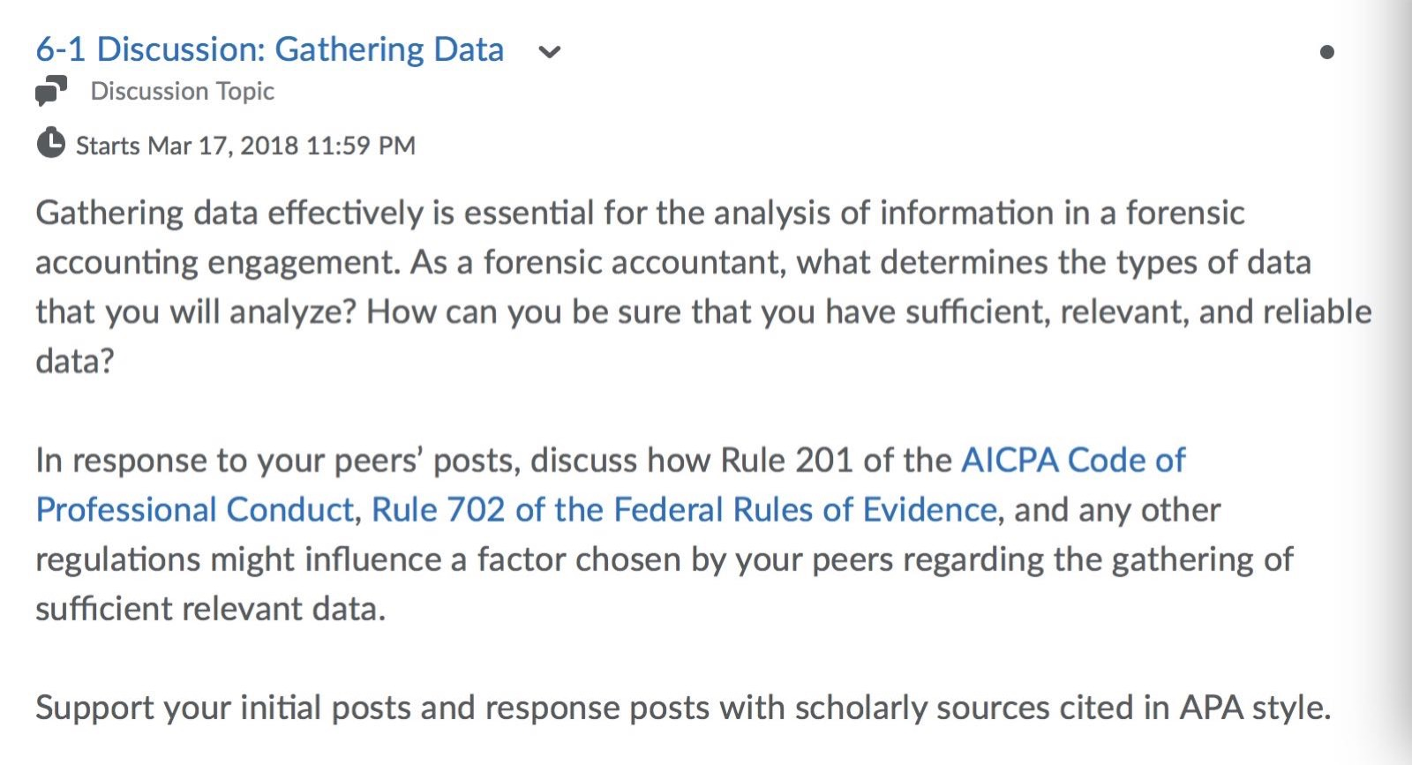

ACC-646- Activity (2 pages must have references) 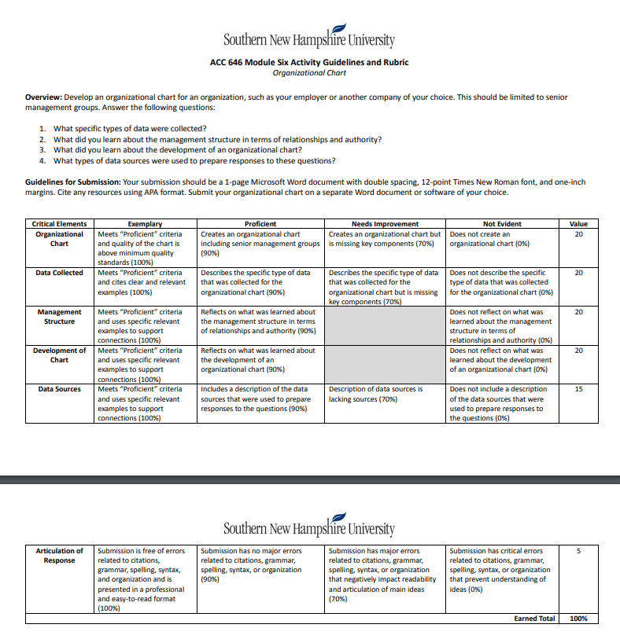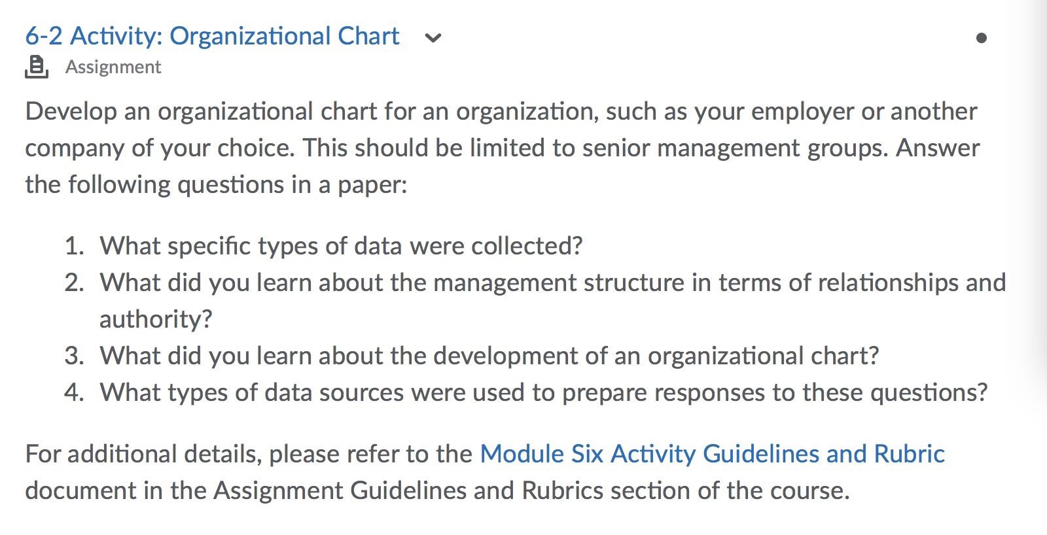

TAX-670-Short Paper (3 pages, must have references) 