**1. INTRODUCTION**

**1.1 Computer Aided Diagnosis**

Computer Aided Diagnosis (CAD), are structures that assist doctors within the interpretation of medical photographs. Imaging techniques in X-ray, MRI, and ultrasound diagnostics yield a super deal of information that the radiologist or other scientific professional has to research and compare comprehensively in a brief time. .It also has ability destiny applications in digital pathology with the appearance of whole-slide imaging and machine learning algorithms.It is an interdisciplinary generation combining factors of synthetic intelligence and computer vision with radiological and pathology image processing. a regular application is the detection of a tumour. for example, some hospitals use CAD to guide preventive medical check-ups in mammography (diagnosis of breast most cancers), the detection of polyps within the colon, and lung cancer. .computer-aided detection (CADe) structures are typically constrained to marking conspicuous structures and sections. computer-aided analysis (CADx) systems evaluate the conspicuous structures.

It become a part of the habitual scientific work for detection of breast most cancers on mammograms at many screening websites and hospitals within the usa. This appears to indicate that CAD is starting to be applied broadly inside the detection and differential analysis of many exclusive styles of abnormalities in scientific pics received in numerous examinations via use of various imaging modalities. In fact, CAD has grow to be one of the important research topics in medical imaging and diagnostic radiology

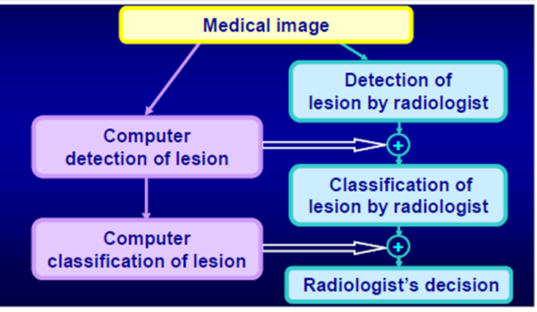

Fig1.1: Computer aided Diagnosis

Early studies on quantitative evaluation of scientific images with the aid of laptop had been stated inside the 1960. At that time, it become generally assumed that computer systems ought to update radiologists in detecting abnormalities, because computer systems and machines are better at performing certain tasks than are human beings. thus, the concept of pc analysis or computerized analysis in radiology changed into installed at that point. even though exciting outcomes had been reported, those early tries had been not successful, because computer systems had been no longer sufficiently effective, advanced image-processing strategies had been now not available, and digital images had been no longer accessible.It has been spread widely and quickly.

It offer second opinion to radiologist in the detection and diagnostic techniques. Radiologist is the primary reader and selection maker. A analysis made through a radiologist the use of the output of a automated scheme for automated photograph analysis as a diagnostic useful resource .With CAD, the performance by way of computers does no longer need to be corresponding to or higher than that with the aid of physicians, but wishes to be complementary to that by way of physicians (synergy). It has been utilized in scientific environments for over 40 years, it usually does now not replacement the medical doctor or different professional, but rather performs a supporting role.

**1.1.1 WHY CAD**

* Interpretation of clinical pictures is by no means 100% accurate
* Detection error
* Characterization mistakes
* Intra-reader variability
* Inter-reader variability

**1.1.2 TYPES OF AID**

* Computer-aided Detection (CADe)
* Computer-aided Diagnosis (CADx)
* Computer-aided simple triage(CAST)

**1.1.2.1Computer-aided Detection(CADe)**

A big observe suggests that the usage of computers to help study older girls's mammograms – known as computer-aided detection (CAD) – manner more invasive breast cancers are observed earlier and greater DCIS (ductal carcinoma in situ) is observed. ... With CAD, a laptop application highlights regions on the mammogram image that may be abnormal

It is commonly constrained to marking suspicious structures and sections to begin with accredited by FDA-united states in 1998 for mammography

**1.1.2.2 Computer-aided Diagnosis (CADx)**

It is commonly focused on to categorise detected structures or areas (extra educational).It is hastily getting into the radiology mainstream. It has already become part of the habitual scientific work for the detection of breast cancer with mammograms. The computer output is used as a "2nd opinion" in assisting radiologists' image interpretations.

**1.1.2.3 Computer-aided simple triage(CAST)**

CAST is every other form of CAD, which performs a totally automatic preliminary interpretation and triage of studies into a few meaningful classes (e.g. negative and tremendous). It is specially applicable in emergency diagnostic imaging, where in a activate diagnosis of crucial, life-threatening circumstance is required.

**1.1.3 REQUIREMENTS OF CAD**

CAD has to satisfy several needs to be used broadly in medical practice. We distinguish 4 primary requirements:

1.CAD ought to enhance radiologists’ overall performance.

2. CAD ought to save time.

3. CAD should be seamlessly integrated into the workflow.

4. CAD need to not impose liability worries and the incremental prices ought to be negligible or reimbursed.

**1.1.4 Methodology**

CAD is basically based on highly complicated sample recognition. X-ray or different forms of images are scanned for suspicious systems. Generally some thousand pix are required to optimize the algorithm. digital images data are copied to a CAD server in a DICOM-format and are organized and analyzed in numerous steps.

**1.1.4.1 Pre-processing**

Many CAD structures start by way of preprocessing the image facts. Scanned pix need to be calibrated, information may ought to be resampled to a set decision, and noise elimination can be implemented. The purpose of preprocessing is to get rid of differences among information from distinct assets or obtained with specific protocols. computer systems, being blind range crunchers, are without difficulty misled with the aid of differences that human beings can readily ignore. If a CAD device is skilled with and examined simplest on statistics from one group, as is generally the case for studies stated within the clinical literature, preprocessing may not be essential, but the results won't be generalized and won't maintain true in different settings. Reduction of artifacts (bugs in images).Image noise reduction.Thisleveling (harmonization) of image quality (increased contrast) for clearing the image's different basic conditions e.g. different exposure parameter.It is used in Filtering.

**1.1.4.2 Segmentation**

The second one step is segmentation, the division of an photo into anatomic areas. Segmentation may be very challenging and is taken into consideration the pinnacle of laptop vision and one of the maximum studied regions in medical image evaluation . Human beings depend upon a spread of cues, on prior expertise, and on reputation of associated systems to parse an photograph and straight away see “what is wherein.” in comparison with this, cutting-edge pc algorithms for segmentation are still crude. Computer-aided detection structures commonly do not display what they have segmented, arguably because this isn't always the records the consumer is typically interested in. however, incomplete segmentation could make CAD systems pass over lesions in the unsegmented areas. Differentiation of various structures in the image, e.g. heart, lung, ribcage, blood vessels, possible round lesions.It Matching with anatomic databank.It pattern gray-values in quantity of interest.

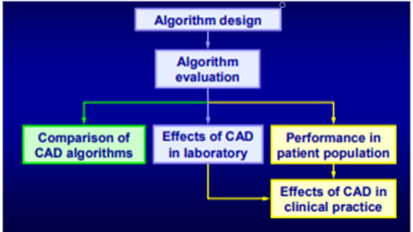

Fig1.2:Development of CAD System

**1.2 CAD System**

* Detection
* Characterization
* Combined detection and characterization

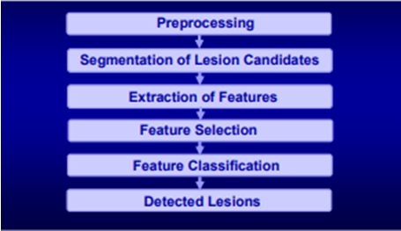

Fig1.3: General Scheme Of Detection System

**1.2.1 Pre-processing**

* Trim off areas not of interest
* Suppress structural heritage, and enhance signal decorate signal-to-noise ratio

Linear spatial filtering

Non-linear enhancement

Multi-scale wavelet transform

**1.2.1.1 Image Segmentation**

perceive gadgets of interest

* contrast
* sign-to-noise ratio
* Gradient field convergence
* Line convergence – spiculated lesion

**1.2.1.2 Object Segmentation**

Extract object from image heritage

* grey level thresholding
* vicinity developing
* area detection
* energetic contour version

**1.2.2 Feature Extension**

* Descriptors of item attribute

Morphological highlights, form, length, side, surface harshness, spiculation, …

* gray degree functions

assessment, thickness, …

* Texture capabilities

designs, homogeneity, angle

* wavelet capabilities

**1.2.3 Feature selections**

* select powerful functions for the pick out compelling highlights for the type mission
* lessen the dimensionality of characteristic decrease the dimensionality of function space
* lessen the requirement of education lessen the prerequisite of preparing test estimate
* Exhaustive seek
* Stepwise characteristic determination
* Genetic set of rules
* Simplex enhancement

**1.2.4 Feature Classification**

* Detection

**Distinguish** authentic abrasion from everyday anatomical shape

* Simulating Characterization

Separate dangerous from benevolent sores

* Multi-class category

**Distinguish** ordinary tissue, threatening

**1.2.5 Feature Classifiers**

Straight classifiers

Non-straight classifiers

* Quadratic classifier
* Bayesian classifier
* Neural networks
* Support vector machine

**1.2.5.1 Other classifiers**

* K-means clustering
* N nearest neighbours

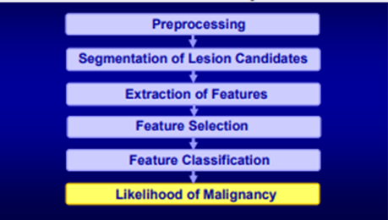

Fig1.4: General Scheme Of Characterization System

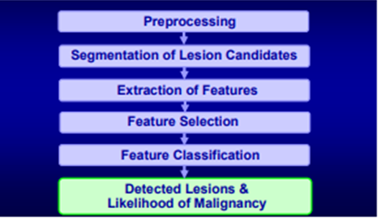

Fig1.5: General Scheme Of Combined System

**1.3 CAD applications**

**There are different type of Computer Aided Diagnosis application such as breast, lung, and colon cancer.**

* **And also used in** Coronary artery disease, diabetic retinopathy
* Congenital heart defect, nuclear medicine these are also used in Computer Aided Diagnosis

**1.3.1 Breast Cancer**

Computer Aided Diagnosis is utilized as a part of screening mammography (X-beam examination of the female bosom). Screening mammography is utilized for the early discovery of bosom cancer. Computer Aided Diagnosis frameworks are frequently applied to help characterize a tumor as dangerous or generous. It is specially hooked up in US and the Netherlands and is utilized as a part of expansion to human assessment, normally by using a radiologist. The primary Computer Aided Diagnosis framework for mammography became grow in a research assignment at the university of Chicago. .Computer Aided Diagnosis frameworks have a tendency to have low specificity and advantages of the use of CAD remain uncertain.Computer-Aided detection in screening mammography presumed that CAD does not sizable impact on malignancy detection cost,, however does unfortunately growth don't forget fee method to assess mammography in view of attractive reverberation imaging exist as well.

**1.3.2 Lung Cancer**

Early discovery of lung malignancy is significant. The five-yr-survival-fee of lung disease has stagnated in the last 30 years and is presently at roughly simply 15%. Lung most cancers takes greater sufferers than bosom growth, prostate tumor and colon disease together. this is because of the asymptomatic increase of this most cancers. Computer Aided Diagnosis framework for recognition of lung nodules (spherical abrasion much less than 30 mm) in chest radiography and CT and Computer Aided Diagnosis structures for analysis. Philips became the primary seller to offer a Computer Aided Diagnosis for early recognition of spherical lung abrasion on x-beam pic.Digital double-electricity imaging stepped forward the overall execution of CAD frameworks in chest radiography.

**1.3.3 Colon Cancer**

Computer Aided Diagnosis is accessible for discovery of colorectal polyps within the colon in CT colonography. Polyps are little developments that get up from the internal covering of the colon.Computer Aided Diagnosis recognizes the polyps through figuring of their trademark "knock like" shape. To evade immoderate fake positives,It disregard the everyday colon divider, which includes the haustral folds.Computer Aided Diagnosis is able to stumble on polyps “neglected” with the aid of radiotherapist. In advance scientific path,Computer Aided Diagnosis helped radiologists find greater polyps inside the colon than they located preceding the use of Computer Aided Diagnosis.

**1.3.4 Coronary artery disease**

Computer Aided Diagnosis is accessible for the automated identification of vast (inflicting extra than half stenosis) coronary artery sickness in coronary CT angiography (CCTA). A low false positives charge (60-70% specificity consistent with patient)permits utilizing it as a pc-aided easy triage (solid) instrument recognizing at intervals superb and negative examinations and yielding a preparatory record. This, for instance, may be utilized for chest torment sufferers' triage in a crisis setting..

**1.3.5 Congenital heart defect**

Computer Aided Diagnosise can be done by auscultation with a computerized stethoscope and particular software, also known as Computer-aided auscultation. Murmurs, unpredictable heart sounds, caused by blood coursing through a deficient heart,can be identified with high affectability and specificity. Compute-aided auscultation is delicate to outside clamor and substantial sounds and requires a relatively quiet condition to work precisely.

**1.3.6 Nuclear medicine**

CADx is accesible for nuclear remedy pictures,industrial Computer Aided Diagnosisx framework for the detection of bone metastases in complete-frame bone examine and coronary supply sickness in myocardial perfusion photographs exist.

**1.3.7 Diabetic retinopathy**

Diabetic retinopathy is a sickness of the membrane this is recognize predominantly by fundoscopic pictures.Sugar patients in industrialised nations normally go through normal screening for precondition. Pictures are utilized to apprehend rapid symptoms of extraordinary retinal blood vessels. guide evaluation of those pix may be time-eating and unpredictable.Computer Aided Diagnosis has been utilized to enhance the exactness, affectability, and specificity of automatic recognition technique, using few Computer Aided Diagnosis framework to substitute human graders can be secure and worthwhile.

**1.4 Limitations of CAD**

* medical success depends on CAD having a high sensitivity, an inexpensive specificity, and the reader taking appropriate action while interpreting the CAD activates. All of those features work in conjunction, and all want to be optimized for the machine to be precious. because mammography is a less than perfect machine, particularly in the detection of most of the greater subtle cancers in denser breast tissues, to have affordable sensitivity, the fake-fantastic price of CAD activates ought to be excessive; for this reason, the specificity is low. for that reason, the balance is not easy to achieve.
* CAD structures have to be very touchy to stumble on all or most cancers, mainly the difficult ones (ie, the ones which can be most in all likelihood to get missed)CAD overall performance varies with the form of lesion. most radiologists do not pass over the surprisingly suspicious (Breast Imaging Reporting and facts system [BI-RADS] lesions. it would be anticipated that most CAD systems might also discover such lesions.

**1.5 IMAGING MODALITIES:**

Therapeutic Imaging is playing increasingly vital position in lots of clinical systems and in identifying and recognize unique humane illnesses. The inside parts can accomplish without extremely opening an excessive amount of a frame. The 3 dimensional perspective of the body may be seen and imaged by using Ultrasound, Computed Tomography(CT) Scanner and Magnetic Imaging which assumed control X-Ray imaging. Resonance Imaging using CT Scannerhas taken over X-Ray imaging. frame's in poor health location can be identified simply and this strategy make no agony the influenced individual. Ultrasound imaging usually acclimated discover and categorize deformity of the glands.It is low steeply-priced, obtrusive, and extremely smooth to apply and may be performed via many photo processing algorithms which encompass photograph pre-handling, subdivision, gathering extraction, include determination and grouping..

In scientific application and progress of equipments a need in scientific field.The hidden records and the relationship of records objects assist in the medical applications. Therapeutic image is assuming control over an inexorably more uncertain function in well being industry as it endeavoring to low the prices and to obtain advance ailment recognition.

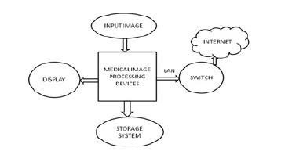

Fig1.6: A typical medical imaging system

A era and manner the way of which inside components of the body is optically presented for clinical investigation and incursion is known as scientific imaging. It sets up a database of everyday structure for figuring out deformity. A tactics through imaging of a organs and tissues which is eliminated for scientific functions are the additives of pathology. The arrival of excessive innovation and numerous imaging modalities, extra demanding situations of delivering excessive first-class statistics arises by means of preparing and examine quantity of pictures for malady analysis and remedy.

Many imaging strategies had been determined for scientific functions. Those imaging strategies are known as Imaging Modalities.They are divided as Anatomical Modalities and Pratical Modalities.

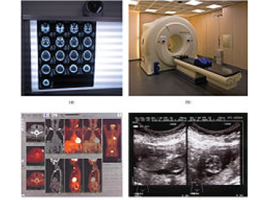

Fig1.7 : (a)The Results of a CT scan of the head (b)An MRI machine generates a magnetic field around a patient (c)PET scans (d)Ultrasound technology

**1.5.1 Radiography**

Radiography is an imaging approach which uses X-ray that had been utilized in diagnostic strategies earlier than impacts which might be extremely destructive for humans because of the radiation of ionisation changed into determined.Penetration of X-beam in a frame and the ingestion of their radiation is different and relies upon the tissue's thickness. X-ray photo is delivered on the bright display / a photograph movie through a specific densities of a tissues inside the body.Fluoroscopy and Projectional radiographs are two sorts of radiography..

**1.5.2 Fluoroscopy**: Inside of human frame the ongoing pix are display by the use of less price X-beams as steady enter.A radiation which moves via the influenced component is transformed inside a photo through a picture organ. This is valuable in catheter steerage.

**1.5.3 Projection radiographs**: This approach uses X-beam which build up a character and stage of seperation and come across the distortion within lungs. A shape of belly and digestion tracts may be imagined through the use of radio-hazy assessment media like barium for identifying ulcers and kinds of colon most cancers.

**1.5.4 Magnetic Resonance Imaging(MRI)**

The composure property of attractively energized hydrogen cores of water particles are utilized as a part of attractive reverberation imaging. it is likewise named as Nuclear Magnetic Resonance (NMR) tomography.The hydrogen cores of water atoms in human tissues is left with the aid of polarized effective magnets to provide distinguishable sign that is structural cryptograph.Due to non ionizing radiations it is favoured to the Computed Tomography.A affected person is presented to the radio recurrence power, and this is placed the nuclei in a improved vitality country inside nearness of the attractive subject. The atoms shed their vitality as they experience the ordinary, minuscule rumbling.This is known as unwinding. A distinction inside a rest charges of different tissues are occupied to make the pics. It makes use of robust attractive fields and non ionising radiation inside the radio prevalence range.It demand the pair of sturdy and uniform attractive discipline. A comparison sellers utilized for MRI are establish totally on chalets of gadolinium. It design 2-dimensional photo of the cut of a body, such as CT therefore it is taken into consideration a tomographic imaging procedure. 3-d pictures may be created with aid of the present day MRI gadgets

**1.5.5 Nuclear Medicine**

Nluclear medicine is a unique clinical modality where in real time of radioactive materials are explored to diagnose and treat the illnesses. certain residences of isotopes and the emitted active debris from radioactive fabric is used in nuclear remedy to diagnose various pathology,not like the idea of anatomic radiology, assessment of physiology is utilized in nuclear medicine. In most specialities like oncology, neurology and so for, the feature based method to clinical evaluation has beneficial applications. Differing from the maximum other imaging modalities, nuclear medication tests shows the physiological function of the gadget been investigated.It is also referred to molecular medical drug or molecular imaging &therapeutics.several strategies are to be had in diagnostic nuclear medicinal drug.

* Scintigraphy: In the diagnostic check, radio nuclides are administered insided after which the emitted radiation of the radio nuclides are captured by means of outside detectors (gamma cameras) and images are formed.
* Single Photon Emission Computed Tomography (SPECT): To generate a three dimensional representation, a nuclear remedy approach referred to as SPECT is used. Here most effective the radio nuclides that produce a cascaded emission of single photon is detected with the aid of SPECT cameras. In SPECT imaging, the radioisotopes like Thallium 201TI, Technetium 99mTC, Iodine 1231, and Gallium 67Ga are injected into the patient’s frame.
* Positron Emission Tomography (PET): A number of the nuclear medicine studies, allow imaging of the entire framebased totally on sure mobile receptors or functions. Examples are PET/CT scans and octreotide.Although there are some clinical approaches where comparable diagnostic information is furnished with the aid of SPECT and pet, in widespread the utility tend to be exceptional primarily based at the result from characteristics of the radio nuclides that are used.Fudiciary markers can relate the practical records from SPECT or positron emission tomography to anatomical records furnished by using magnetic resonance imaging.

**1.5.6 Elastography**

The clinical imaging modality that joins the elastic assets of soft tissues is called elastography. The statistics about the presence or status of the sickness is identified based on whether the tissue is hard orsmooth. For example, cancerous tumours might be tough than the encircling tissue, and diseased tissues are inflexible in assessment to the healthful ones. From considerable scientific use to early stages of research, many elastography strategies are available which goes in a one-of-a-kind way. Branches of Elastography are QuasistaticElastography/pressure Imaging, Shear Wave Elasticity Imaging(SWEI), Acoustic Radiation Force Impulse Imaging (ARFI)Supersonic Shear Imaging (SSI), and transient Elastography

**1.5.7 Tactile Imaging**

In tactile Imaging modality, the sense of touch is translated into a digital photograph. It reconstructs the internal mechanical shape of a tissue using the records of stress sample and mimics guide sensation because the tool with pressure sensor array established on its face acts precisely like human arms all through examination. This tool offers a 2-D tactile visualization and evaluation of the elastic residences of the myofascial cause factors with the help of tactile imaging probe. The photos and signal information can be stored for assessment or records evaluation purpose. This imager will assist in counselling sufferers concerning the dangers in child beginning and in making selections about transport control. Tactile imaging can be done by prostate breast,vagina and pelvic ground support structures and myofascial trigger points in muscle.

**1.5.8 Photoacoustic imaging**

Based on the photoacoustic effect a hybrid biomedical imaging is called as photoacoustic imaging. For a photoacoustic imaging structure there are 2 forms. One is photoacoustic/thermoacoustic computed tomography (PAT/TAT) which uses an unfocused ultrasound detector to collect the photoacoustic signals and by way of inversing the photoacoustic equation, the image is restore. 2nd one is known as photoacoustic microscopy(PAM), in which spherically targeted ultrasound detector with 2-D factor by way of point scanning is used.

**1.5.9 Thermography**

Normal displays of infrared electricity emitted, transfer and return by means of an item are referred to as thermal images or thermograms. It is utilized by fire combatants to peer via smoke, by using maintenance technicians to locate over heating joints, with the aid of constructing production technicians to look thermal signatures which show heat leaks. The live thermogram critiques the difference in temperature so minutely in which a images isn't always essential. Thermography for breast cancer screening isn't accepted inside the u.s.a. or Canada, and warnings had been issued towards thermography in each nation. due to modifications in vascular network to aid the growth of the tumour/lesion, the differences rise up in figuring out the thermal adjustments. It may be divided into passive or active thermography.

* **Passive thermography**: On this the object is at a better or decrease temperature than the environment. Surveillance and medical diagnosis are some of the utility of this
* **Active thermography**: In this generation, an outside power source produce thermal evaluation between the object of interest and its surroundings.

**1.5.10 Tomography**

In Tomography, a tomographic optical structures used to acquire virtual slices of particular move phase of an object is visible with out almost cutting it. In current tomography, projectional statistics from more directions are collected and fed into a algorithm known as tomography restore software program that's then processed via a pc. Use of several distinctive physical phenomenons, extraordinary sorts of tomograms are derived. For example: CT from X-ray, SPECT from gamma rays, PET from electron-positron annihilation, and many others. The restore algorithms are divided into two classes namely filtered back projection (FBP) and iterative reconstruction. Main techniques known as conventional tomography and computer assisted tomography are used to obtain a sinle image is visible

* **Conventional tomography**: In conventional tomography,the use of the main of projective geometry, tomogram is produced through the mechanical motion of an X-ray source and a movie in unisom . The different techniques mixed up in conventional tomography are linear tomography, polytomography, zonography, and panoramic radiograph
* **computer-assisted tomography**: In this, the picture of the scanned shape is build,gauge by a computer which tactics the information acquired from radiation detectors. The techniques of CAT are CT or CAT,PET and MRI

**1.5.11 Ultrasound**

Medical ultrasound (Diagnostic sonography or Ultrasonography) is a characteristics imaging approach to see the inside body structures, based totally at the application of ultrasound. The sound waves whose frequencies are better than the radio frequency are called ultrasound. Ultrasound photos or sonograms sent the ultrasound pulses into tissues with the assist of probes. Distinict forms of imaging can be received by means of using special sonographic units.The fine recognised is B- mode photograph, in which the acoustic impedance of tissues 2-D go phase is displayed. The benifits of ultrasound are real time image, flexible,considerably low in fee and dangerous ionising radiation should not be used. Sonography is extensively used to carry out each analysis and healing tactics.

**2. LITERATURE SURVEY**

**2.1 Introduction to Radiography**

**2.1.1 What is radiography**

A radiograph is a type of photograph or x-ray that expose the body bones and internal organisms. The procedure for getting a radiograph is called radiography. Radiography is a very useful diagnostic tool for veterinarians because it can help to get information about any organ in the body, including the heart, lungs, and abdominal organs, as well as the bones.

**2.1.2 How does it works:**

Traditional radiography machines use very low quantity of radiation delivered to a focused beam or we can say it as a x-ray that is targeted at a photographic plate contains specialized photographic film. The patient is placed between the x-ray beam and the photographic plate. When the x-ray beam passes through the patient body, an image is obtained on the specialized film. Structures that are very thick or dense, such as bone, do not allow much of the beam to pass and expose the film. These structures look very bright or white on a radiograph. In this type, structures that are not dense allow the beam to pass more completely and expose the film. As a result, these structures appear comparatively dark when the radiograph is viewed. Structures that are of medium density, such as fluid, appear in various shades of gray on the film.

Digital radiograph systems use a very similar principle, but the final image can be much sharper and can show greater detail than images obtained from traditional radiography machines.

**2.1.3 How chest radiography is performed:**

Chest radiography is painless, safe, and completely non-invasive. Your pet will be positioned on the x-ray table, and the width of the chest will be measured. This is necessary so that the intensity of the x-ray beam can be precisely adjusted to capture the most accurate information. Once the measurements are complete, the x-ray tube is aligned over the chest, and a button is pushed on the radiograph machine to take the “photograph.” This part of the procedure is very much like taking a photograph with a camera. In most cases, at least two “pictures” are taken from different angles to create a three-dimensional image of the heart and lungs.

Your veterinarian may recommend that your pet receives sedation before undergoing radiography. Patients that are sedated are much easier to position because they are completely relaxed. Sedation may also be recommended if the patient is painful.

**2.2 Introduction to CAD IN Chest Radiology**

**2.2.1 CAD system:**

The main goal of CAD systems is to identify abnormal signs at an earliest that a human professional fails to find. In mammography, identification of small lumps in dense tissue, finding architectural distortion and prediction of mass type as benign or malignant by its shape, size, etc.

**2.2.2 Significance of the CAD system:**

CADe usually restricted to marking the visible parts or structures in image, whereas CADx helps to evaluate the structures identified in CADe. Both together the CAD models are more significant in identifying the abnormality at an earliest. For example, it highlights microcalcification clusters, marginal structure of mass, and highly dense structure of tissue in mammography. This helps the radiologist to draw the conclusion. Though the CAD has been used for over 40 years, still it does not reach the expected outcomes. We agree that CAD cannot substitute the doctor but definitely it makes radiologists as better decision makers. It plays a supporting and final interpretative role in medical diagnosis.

**2.2.3 Cad in Chest Radiology:**

X-rays were observed through Conrad Wilhelm Rontgen in 1895 at the same time as he become experimenting with electric powered present day flowing in a cathode-ray tube. He noticed the cathode emitted a few unknown radiation that might be made seen with photographic paper and that passed via many materials. He did no longer comprehend the radiation was a form of light and consequently called them X-rays. His discovery heralded the age of present day physics and revolutionized diagnostic remedy. Getting a chest radiograph has become and still is the most common radiological exam.

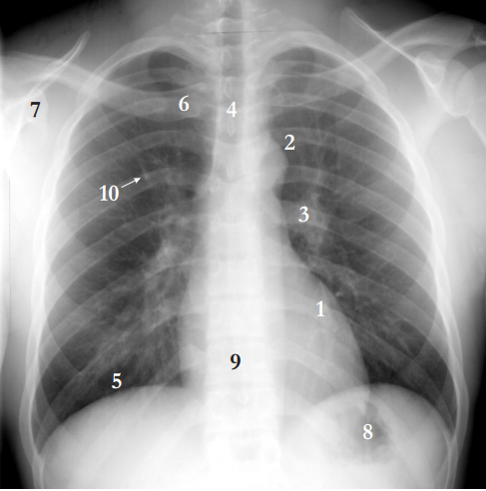

Fig2.1: Normal PA chest radiography

It indicates a normal chest radiograph with several normal structure categorised.

A ordinary PA chest radiograph (PA stands for posterior-anterior because of this that the radiation passes through the affected person from lower back to front). The patient usually faces the observer: the left aspect of the picture indicates the right lung. The lungs are radiolucent baskets of air, therefore they display up black inside the photograph(through conference brightness shows absorbed radiation). inside the lung fields,only bony structures and blood vessels are seen. The posterior ribs (within the back of the patient) are visible more surely; we could comply with them “flip” into the anterior ribs.

1) The coronary heart.

2) The aortic arch where the aorta bends.

3) The (in this exampleleft) hilum, wherein the arteries and veins enter the lung.

4) A darker vertical stripeindicates the trachea.

5) under the lung fields the diaphragm starts off evolved.

6) Clavicle.

7) Shoulder blade.

8) usually stomach gasses may be visible in the left diaphragm.

9) If there is sufficient contrast inside the mediastinum (the area projected among the

lung fields) the backbone can be visible.

10) A spherical dot like that is the shadow of avessel that runs inside the identical course because the X-rays. So this is a ordinary finding.

however distinguishing such end-on vessels from odd signs, which includes nodules, is on occasion very hard.

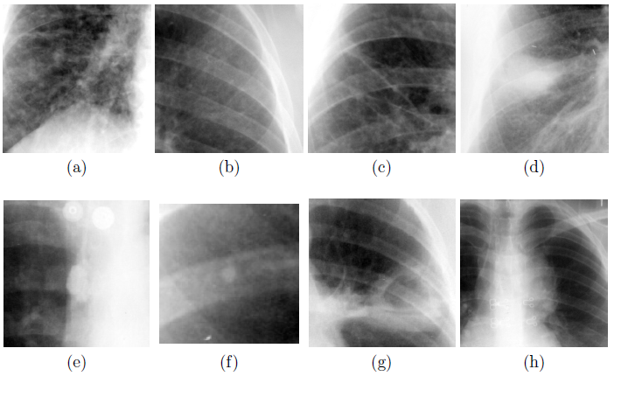 Fig2.2: Radiography in different areas of Lung

(a) obvious diffuse abnormalities within the lower right lung.

(b) greater subtle diffuse abnormalities.

(c)Linear scarring, there are peculiar strains that run from top-left to lower right.

(d) The denser region in the middle is an obvious infiltrate.

(e) The spherical dense item in the middle is a calcined lymph node. notice the two buttons inside the pinnacle, such artefacts can mimic odd structures.

(f) A small calcification positioned at the back of a rib.

(g) A cyst with a cavity.

(h) The hilum of the left lung is ordinary; the lymph nodes have swollen. This shows number one TB.

So we conclude this quick introductory phase by stating that interpreting chest radiographs is a hard hassle, for both computer systems and radiologists.

Our trendy approach to research chest images can be briefly said as follows. The image is robotically segmented and divided into areas. the feel in those areas is quantified and compared with texture in corresponding regions of image in a database. Based in this contrast the abnormality of each region can be expected. These estimates can be aggregated into a chance that the image is ordinary. Segmentation and texture evaluation are consequently the two fundamental threads in this thesis.

while image parameters of the chest radiographs are varied. moreover, studies on classier that estimate chances that patient exhibit a certain disease, given a number of features from scientific records and/or output of computer algorithms is essentially omitted here considering this work belongs to the field of pattern class cation rather than medical image processing.

Computer Aided diagnosis (CAD) system development for automated assessment of chest X-ray radiographs. The primary goal of the R&D mission is to develop an smart advisory gadget for reading chest X-ray images and detecting lung nodules. CAD system might be used as an evaluation module of a digital X-ray lung disease screening device. the main steps of the research and development work is to section the X-ray pix in line with the anatomical parts (figuring out the contours of lung, coronary heart, clavicles and the rib cage) decreasing the undesirable shadows (anatomical noise) of the bones and the coronary heart, and detecting nodules and other abnormalities within the chest pics.

Lung cancer is one of the most common causes of dying all through the sector. The chance for curing cancerous instances can be extended drastically if the illness is detected .If the infection is thought the treatment may be supplied. Benefit of X-ray radiography chest screening is its surprisingly low radiation dose as compared to the greater sensitive approaches along with CT.

Essential purpose of chest X-ray examination is lung nodule detection, chest screening can assist to diagnose other ailments along with pneumonia, emphysema,COPD, heart failure and different coronary heart troubles, and so on. The assessment of X-ray chest pics may be a alternatively tough undertaking even for skilled pulmonologists/radiologists. computer aided evaluation of images wishes complex images processing/pattern recognition algorithms, where first the images ought to be “cleaned” from demanding elements, consisting of the shadows of the bones (clavicles and the rib cage) and the heart to get such images in which nodules can be detected more without difficulty. Which means the complete mission of computer aided detection/diagnosis need to be decomposed into many distinct subtasks: in the pre-processing section the most important anatomical elements should be outstanding, the X-ray images need to be segmented. The detection of abnormalities is executed inside the pre-processed image .

Pre-processing way that the contours of the lung fields and the heart, as well as the contours of the bones – the clavicles and the rib cage – ought to be determined

we discern three important regions: generalpre-processing techniques, algorithms for segmentation of anatomical structures and finally, analysis aimed toward fixing a particular mission or software, commonly an attempt to locate a specific sort of abnormality.

* **General processing**

Enhancement

Subtraction techniques

* **Segmentation**

Lungfields

Rib cage

Other structures

* **Analysis**

Size measurements

Lung nodule detection

Texture analysis

**2.2.3.1 Enhancement**

Chest radiographs inherently show a wide dynamic range of X-ray intensities. In traditional, unprocessed photographs it's miles frequently tough to peer through" the mediastinum and assessment inside the lung fields is limited. A classical strategy to this kind of problem in image processing is using (local) histogram equalization strategies. A related approach is enhancement of high frequency info (sharpening). a diffusion of pre-processing strategies for chest radiographs primarily based on neighbourhood equalization, sharpening and mixtures and modifications of those techniques have been proposed and again not best through software but also by the use of hardware . these days almost all vendors promote digital chest gadgets with a bigger dynamic range than conventional gadgets and maximum providers automatically pre-process the images with proprietary algorithms

**2.2.3.2 Subtraction techniques**

Subtraction strategies eliminate normal structures in chest radiographs, so that abnormalities stand out more virtually, both for the radiologist to see or for computer analysis to come across. A radiograph of the equal patient is registered with the current image. The registered image is subtracted and if the registration is a hit, areas with interval change seem as either darkish or shiny on a grey background. The unique method has been progressed and evaluated using subjective rankings by way of radiologists of the pleasant of the subtraction image and the effects of the method had been as compared with manual registration. Temporal subtraction strategies can be applied on a routine basis considering interval change is one of the main reasons for making chest radiographs. it's far not unusual to attain a chest radiograph of patients on an in depth care unit every day. Subtraction can be made through mirroring the left/proper lung field, performing elastic registration on the right/left lung area and subtracting. This technique, coined contralateral subtraction, employs the symmetry of the rib cage.

**2.2.3.3 Segmentation**

Automated segmentation of the lung fields is simply mandatory earlier than computer analysis of chest radiographs can take vicinity. problem of the components, inclusive of detection of the outer ribcage , the diaphragm or the costophrenic perspective (where the diaphragm and the rib cage meet).Strategies hired are (local) thresholding, vicinity developing, aspect detection, ridge detection, morphological operations, fitting of geometrical fashions or features, dynamic programming. however, numerous tries were made to classify every pixel inside the image into an anatomical magnificence (generally lung or background, but in some instances extra training together with coronary heart, mediastinum, and diaphragm are used .The term proles" refers to a mean of consecutive 1-D lines of pixels, generally running horizontally or vertically. To estimate the heart size or lung capability use the segmentation.

**2.2.3.4 Rib cage**

Rib cage shape and morphology is important for anatomical analysis of chest CT scans. First, all excessive-intensity bone systems are segmented. second, multi-scale Hessian analysis is done to capture platens and vesselsness facts. third, with the plate/vessel features, bone systems apart from rib cage are detected. remaining, the detected bones are separated from rib cage with iterative relative fuzzy connectedness technique. Ribs can be overlooked or detected twice and the reality that consecutive ribs and left-right ribs have comparable form is regularly omitted. The number of photographs used in evaluation is in wellknown significantly smaller than within the case of lung field segmentation. Because the full rib cage has a far more complex shape than the outline of the lung fields partial failures are much more likely. Consequently we finish that the problem of automatic segmentation of the rib cage in chest radiographs continues to be a ways from solved.

**2.2.3.5 Other structures**

we mention work on segmentation that doesn't t into the lung field or rib cage segmentation proper.Toriwaki et al. describe a entire machine for the analysis of chest radiographs that includes segmentation of lung fields, rib cage, coronary heart, clavicles and bloodvessels observed with the aid of computerized detection of abnormalities. A technique to choose ROIs within the lung fields that do not include rib borders is presented by Chen et al.. The lateral lung fields are subdivided into areas which can be partly eliminated in the event that they contain edges of certain strength and orientation. Armata et al. Developed an algorithm to stumble on strange asymmetry in chest radiographs the use of a rule-based scheme for detecting lung contours and comparing the projected lung areas

**2.3 Analysis**

What kind of abnormalities does the radiologist who reads chest radiographs stumble upon in his/her day-to-day exercise?. Lung nodules are a rare abnormality however get hold of a great deal interest in CAD literature and tend to apply their detectability as a criterion for diagnostic accuracy. Pulmonary nitrates might be detected in principle through the texture evaluation schemes and are the maximum commonly going on abnormality. Catheters are subsequent, and despite the fact that catheters typically stand out truly inside the photo, locating their tip changed into the assignment that changed into most often limited with the aid of photo satisfactory. One can also argue that the presence of a catheter, or drainage tube or pacemaker is not an abnormality. But, the presence of such gadgets could have a big effect on computer evaluation and it is important to realize how common such findings are in abnormal radiographs.

The following applications of computer analysis of chest radiographs

* Lung nodule detection.
* Detection of cardiomegaly or estimation of the cardiothoracic ratio.
* Estimation of total lung volume.
* Detection of pneumothorax.
* Estimation of the severity of pneumoconiosis (coal employee's sickness).
* Detection of interstitial disorder.
* Detection of abnormalities encountered in mass screening for tuberculosis

**2.3.1 Size measurements**

Becker, Meyers, and co-workers . They detected points on the rib cage boundary and coronary heart boundary the usage of horizontal proles and anticipated the CTR of 37 radiographs. In work by Hall , Kruger and their co-employees, numerous parts of the lung and coronary heart limitations were segmented and various ratios have been computed. entering those ratios as features in linear and quadratic discriminant capabilities, they tried to classify pictures as regular, displaying rheumatic coronary heart ailment or containing other abnormalities. Sezaki and Ukena computed the CTR with the aid of proposing a scheme that detects the vertical boundary of the rib cage and the heart through evaluation of horizontal proles and the utility of some guidelines to correct failures. Roellinger et al.used the approach from to detect points on the heart boundary and fitted a Fourier shape to them. Thecoefficients of the Fourier form had been used to categorise the heart shape as regular or a typical.

**2.3.2 Lung nodule detection**

Lung most cancers is a main purpose of mortality . Early detection of lung tumours (visible on the chest lm as nodules) may increase the affected person's chance of survival.Therefore this trouble has received numerous attention and is the problem in computer analysis of chest radiographs.Nodules display up as bright (although the comparison can be very small) spherical items inside the lung fields. the difficulty, specially for CAD schemes, is to distinguish proper nodules from (overlapping) shadows from vessels and ribs.There are two step technique for nodule detection within the first stage candidate nodules are detected. thesecond one level consists of putting off as many false advantageous applicants as feasible, without sacricing too many genuine positives.This method is reminiscent of the two tasks of a radiologist in the diagnostic technique: identifying the area of abnormalities and categorizing them as benign or

representing a specific type of ailmen

**2.3.3 Texture analysis**

The interstitium of the lung is the connective tissue between the blood vessels and the alveoli, the tiny air sacs.There are over 200 forms of interstitial lung sickness, including with pneumoconiosis, sarcoidosis and tuberculosis, and finding out interstitial ailment is one of the most hard obligations for a chest radiologist.Texture evaluation in chest radiographs was applied to the detection of pneumoconiosis, or coal miners' ailment.texture capabilities based totally on the size and form of binary versions of the input image acquired via thresholding.Tully et al had been the first to focus on interstitial ailment in general, using features from co-occurrence matrices to classify manually selected on ROIs with linear discriminant evaluation and sequential characteristic choice.The principle elements of their method are automatic choice of small ROIs inside the costal and intercostal space , and computation of the standard deviation and the first moment of the Fourier spectrum. These capabilities are used to distinguish three training of interstitial ailment styles (nodular, reticular and honeycomb) from ordinary tissue.

5 CAD schemes for digital chest radiographs had been provided inside the shape of real-time observer checks.

(a) detection of pulmonary nodules

(b) temporal subtraction

(c) detection of interstitial lung ailment

(d) differential analysis of interstitial lung disorder, and

(e) difference between benign and malignant pulmonary nodules

**2.4 Uses of chest radiology:**

Chest radiology may be recommended to investigate a variety of clinical signs, including:

* Coughing
* Excessive panting
* Difficulty breathing
* Lethargy
* Weight loss

Chest radiology can evaluate the size, shape, and position of the heart. Heart enlargement, for example,may indicate heart disease.Chest radiographs also evaluate the lungs for abnormalities. Normally, the lungs should be filled with air, so they should appear relatively dark on a radiograph. If there is other material in the lungs, such a fluid, blood, or scar tissue, the lungs will appear brighter than normal. Fluid in the lungs may suggest pneumonia, haemorrhage (bleeding), heart disease, or another illness. Other densities in the lungs may suggest a tumour, scar tissue, or other abnormality. Asthma and emphysema can also change the way the lungs appear on radiographs.

Chest radiographs also show the trachea (windpipe) and large airways. Diseases and conditions such as bronchitis and a collapsing trachea can change the appearance of these organs on radiographs. Tumours, depending on their size and position, can also be detected using radiography.

**2.5 Risk of chest radiology:**

Radiography has many benefits and very minimal risks. It is very safe, completely painless, and non-invasive. It is available in most veterinary practices and can sometimes be performed during an outpatient visit while you wait. Depending on the type of radiographic study being performed, the procedure may take only a few minutes.

The risks of radiography are minimal. Because the level of radiation exposure needed to perform radiography is very low, even pregnant females and very young pets can undergo radiography. If a pet is very unstable, such as a pet with severe breathing difficulties, the stress of performing radiography may be a concern. In these cases, it may be necessary to stabilize the pet (with oxygen or other therapy) before attempting to perform radiography. In the vast majority of cases, the benefits of performing radiography far outweigh the possible risks. Radiography is a valuable tool for your veterinarian because it can provide critical information about many different illnesses and medical conditions.

**2.6 Rule-based detection of lung contours:**

Rule-based system offers freedom to the designer to express the knowledge about the problem in processing imaginable. and also it divides the problem into sub-problems. If the system is not giving the desired output, one can add pre-processing or post-processing steps to get the desired output. Concatenation of steps is one of the practical processing in rule-based system each containing many variables leads to the final scheme of many ad hoc choice and users adjustable parameters .To make plausible prove that the performance of the system is some sense optimal is impossible or impractical .

The natural way of the system is achieved by adding many rules to it and also adding complexity. Rule- based system do not generalized the system if it is applied to different tasks. These system takes the outcome of one system to the input of another one .In practise these systems give reasonable response when they are in subset compared to when they are in whole.

The observation between the anatomical structures in chest or the starting point of the rule-based approach is that boarder of radiograph is often coincide with the edges and ridges in the image. The major difficulty is that the structures correspond only partially to the borders between anatomical region.

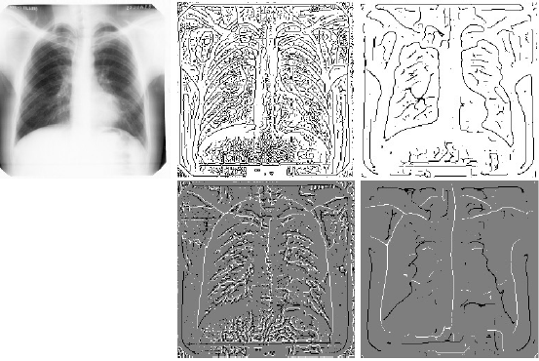

Figure2.3:Edges and ridges in chest images coincide with borders between anatomical structures. A chest radiograph (top-left) with (top-middle) edges at a fine scale of 0.004 and (top-right) a coarser scale of 0.015 and (bottom-middle) ridges (in white) and valleys (in black) at the same fine and (bottom-right) coarse scale. Scale is expressed in image-width units.

From the above figure we can say that the edge between right lung and mediastinum is connected to the edge of the clavicle.

Edges are usually defined as the points in the image where gradient have maximum magnitude in the gradient direction. Ridges are defined as the extrema in direction of the large curvature.

In this way we obtain the structures that cannot cross, because the direction defined by the consecutive points of (alpha) cannot be extreme . The order of n and the choice of minima and maxima determines the nature of detected structure .By using the order of n=0, it detects the axes of bright and the axes of dark blob; if n=1 , it yields the from dark to bright region and also from bright to dark region. If n=2 it finds the bright and dark line structures which all in the direction that are perpendicular to (alpha).A significance measure for a structure can be computed by integrating along the structure or by taking the accumulated length of a structure.

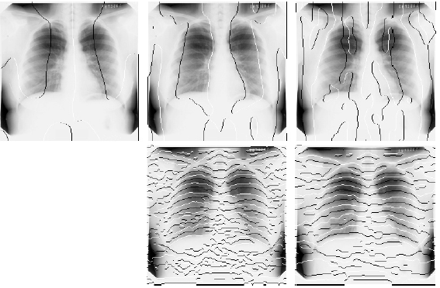

Figure2.4: Oriented extrema coincide with borders between anatomical structures. A chest radiograph with superimposed (top-left) extrema (maxima in white, minima in black) in the x-direction of the 0th order derivative at a scale of 0.047;(top-middle) extrema in the x-direction of the 1st order derivative at a scale of 0.039; (top-right) extrema in the x-direction of the 2nd order derivative at a scale of 0.031; (bottom-middle) extrema in the y-direction of the 1st order derivative at a scale of 0.0078; (bottom-right) extrema in the y-direction of the 2nd order derivative at a scale of 0.016.

Since the diaphragm are generally strongest lines and edges in the lung top we use dynamic programming to detect them. Here we will use the fact that the corresponds of the diaphragm to a maximum in the 1st derivative in y direction and the top of the rib cage corresponds to maximum in the 2nd derivative which is perpendicular to the rib cage, fact is that the contour corresponding is to the top of both lungs in approximately circular. By all these conditions putting together the estimation of the diaphragm border is between the lung field and the mediastinum, the boundaries of the rib cage and the lung top are obtained .

**2.7 Texture Analysis in chest radiographs:**

To get the abnormality score for a PA chest radiograph a fully automatic method is presented to detect that abnormalities. This method is aimed for finding the abnormal signs of a diffuse and textural nature such that they encountered in mass chest screening against tuberculosis. By using active shape model the scheme starts with automatic segmentation of the lung field this will overlapping the various size region. using moments of response to a multi-scale filter bank is extracted from each region. Additional difference features are obtained by substracting the features of vector from the corresponding region. All regions are classified by voting among to the nearest K neighbour, with leave-one-out.each results of each region are combined, Using weighted multiplier in which region with higher classification results are reliable with more heavily. It produces an abnormal score foe each single images.

We use statistical and transform parameters which are derived from the image histogram, co-occurrence matrix and wavelet analysis . The co-occurrence of the matrix parameters are calculated for 8 times with 0, 45, 90 and 135 angles with distance between neighbours from 1 and 2

.

Assume that the image is a 2D (M x N) array *f(x, y)* with horizontal and vertical coordinates x and *y, where x = 0, 1,…, M-1* and *y = 0, 1,…, N-1*. The function of *f(x, y)* can take values from *0 to G-1*, where total numbers of gray-levels in that image are G . The gray-level histogram is

h(i)=n, Where *n* is the total number of pixels in the image with intensity *i*.

Normalized histogram which is the approximate probability density of occurrence of the intensity levels in the image:

P(i)=h(i)/MN

First-Order parameters from Normalized Histogram,













|  |  |
| --- | --- |
|  |  |

Fig2.5: These are the images with abnormal lung:

|  |  |
| --- | --- |
|  |  |

Fig2.6: These are the diagrams which mention abnormal region:

**2.7.1 Texture Classification from Locally Order less Images:**

A regionally order less picture is a family of three intertwined scale-spaces that describes  
neighbourhood histograms. We generalize regionally order less picsthroughconsideringneighbourhood histogramsof a group of altered versions of the picture, and through extending them tojoint possibility distributions. thesestructurescan be used to derive texture  
capabilities and are shown to be a morepreferred description of set up texture  
classification strategies, viz. later bankstrategies and co-incidence matrices. due to the fact  
all scale parameters are stated explicitly in thiscomponent, numerous multi-resolution  
characteristicsetscan be extracted in a systematicway. every multi-resolutionapproach  
improves the overall performance of texture classification schemes, the pleasantend result being received if a multi-resolutiontechnique for all scale parameters is used. this is  
proven in experiments on a biginformation set of 1152 pictures from 72 textures  
lessons.

Texture evaluationtechniqueshave been reviewed in several papers. This segmentspecializes infilterbankmethods and co-prevalence matrices. broadlyspeaking, filterfinancial institutionstrategies use inputpicturesto provide derived photographs and use dataof those derived (filtered) pix to acquire texture functions. A largetype offilter banks have been proposed: variations of oset Gaussians ; Gabor filters , on occasion complemented with the Laplacian of Gaussian filters ; remodel filters which includes the lawsmasks and widely known transforms which includes the Hadamard filters, the discrete sine and cosine transforms, that have beenproven to resemble the bestKarhunen-Loevetransform ; not unusual filters from photograph processing which include gradient, Laplacian, Sobel operators ; mathematical morphology operations and other non-linear filters ; Fourier transforms and wavelets . (The given references are in no waywhole, and awareness on methodological papers.) Motivations for filter out banks are normally their homeswithin theexperience of being entire or orthonormal, their overall performance in exercise, or proofof theirexistenceinside the human visualdevice .

Deriving features from co-incidence matrices appears to be the mostextensivelyimplementedmethod for texture evaluation. co-prevalence matrices were first proposed with the aid of Horlick and were the difficulty of many studies. Joint histograms of twoplaceswithin thephoto with pre-defined spatial family members are built, and usuallycapabilities are extracted from those matrices. filterbankstrategies and co-incidence matrices are associated in numerousapproaches. Unser has shown that co-occurrence matrices can be approximated throughcombos of sum and difference histograms, and that maximumcapabilitiescommonly extracted from co-occurrence matrices can be computed precisely from those sum and difference histograms. Histograms of the sum of pixel places are related to the histograms of blurred images; histograms of the difference of pixels in a given course are associated with histograms of the first spinoff of the photograph in that route. This indicates that there exists a right away relation between the co-prevalencemethod and the clear outbankapproach if the clear outfinancial institutionconsists ofzero-th order and suggested first order spinoff filters.

**2.7.2 Locally order less format :**

Domestically Order less monitoring (LOT) is a visualmonitoringalgorithm that mechanically estimates the amountcontemporarylocal (dis)order in thetarget. This lets the tracker focus onbothinflexible and deformable gadgets on-line and not using aearlier assumptions. We provide a probabilistic versionultra-modern the goalversionsover the years. We then fastidiouslyshow that this model is a unique case latest the Earth Mover’s Distance optimization problemwherein the floor distance is ruledby usinga few underlying noise models. This noise model has several parameters that manage the feetrendymoving pixels and converting their colour. We increase such noise fashions and exhibit how their parameters may beanticipated on-line all throughtracking to account for the quantitymodern-daylocal (dis)order in thegoal. We additionallydiscuss the importancelatest this on-line parameter replaces and show its contribution to the performance. subsequently we show LOT’s monitoringabilities on hard video sequences, eachcommonly used and new, showingperformancecorresponding tostate-of-the-artmethods.

The term locally order less image refers to the fact that we have at our disposal at each location the probability distribution, which is a mere order less set; the spatial structure within the ﬁeld of view α cantered at x has been completely disregarded. This is the key point: with each spatial location we no longer associate a (scalar) intensity, but rather a probability distribution, parameterized by σ,α,β. Since a distribution contains more information than the intensity sec, we may expect to be able to use this information in various image processing tasks.

The LOI contains a few ordinary ideas, for example, the first picture and its scale space L(x;σ) that can be recouped from the LOI by coordinating iH(x0,i;σ,α,β) over I. The picture histogram in the traditional sense is acquired by letting α→∞. The development additionally incorporates groups of isophote pictures, which for β>0 are named delicate isophote pictures by Koenderink. What's more, perhaps much more imperative, by tuning the scale parameters the LOI can ﬁll middle of the road arranges between the picture, its histogram, and its isophotes. This can be helpful by and by. At last, we take note of that the structure sums up inconsequentially to nD pictures or shading pictures, if a shading metric is chosen

**3.THEORITICAL ANALYSIS**

**3.1 MATCHING**

Matching, or registration, of pix can be defined as finding a change that relates factors in one photo to their corresponding points in any other photo. Matching may be used for segmentation by matching a segmented reference image to an input image. The converted reference image yields a converted segmentation that, if the photos are properly matched, will be an accurate segmentation of the enter image.

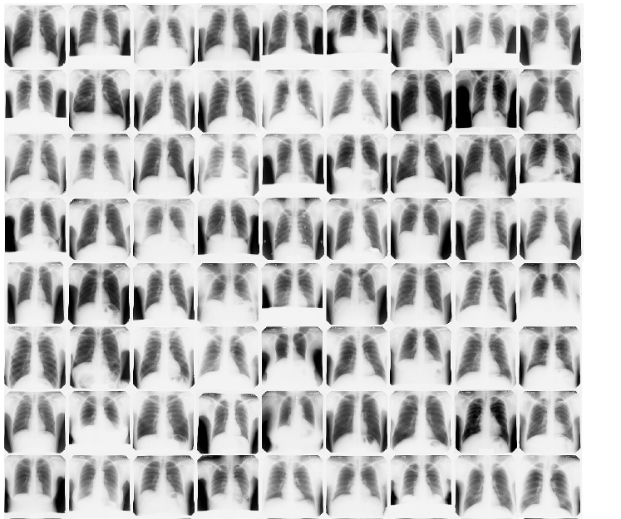

Fig:3.1 Some Images used for explaining comparison

A standard matching system is decided through 4 elements.Reference image is an crucial one since the anatomical variant between chest radiographs is big and the chosen reference image is the version used during matching. If the reference image isn't much like the input image, up to the transformation looked for, matching will fail. second, the search area is defined via the parameter area of the allowed transformation. Inside the case of lung segmentation the usage of reference and input pics from distinctive subjects, it's miles glaring that modifications that allow anisotropic scaling are required. Third, a similarity metric is required that should suggest how nicely the transformed input image and the reference image match. The final detail is the hunt method, i.e. the algorithm used to decide the transformation which maximizes the similarity metric.An essential benefit of this approach is that it incorporates version information and form information in an implicit manner. there is no want for specific analytical fashions of the objects to be segmented, the reference image is the model.

**4. Experimental Analysis**

**4.1.Code**

from PIL import Image

importopenpyxl

wb=openpyxl.load_workbook('Report.xlsx')

sheet=wb.active

Excelstr='A'

FILENAME=[]

FILENAME2=input("enter the name of image ")

FILENAME1=FILENAME2+'.png'

im=Image.open(FILENAME1).convert('RGB')

pix1=im.load()

w1=int(im.size[0])

h1=int(im.size[1])

x1=w1*h1

x2=int(x1)

codes2=[]

fori in range(w1):

for j in range(h1):

codes2.append(pix1[i,j])

fori in range(1,1001):

str1=str(i)

str2='.png'

FILENAME.append(str1+str2)

codes1=[]

for k in range(0,1000):

'''print(FILENAME[k])'''

im=Image.open(FILENAME[k]).convert('RGB')

pix=im.load()

w=int(im.size[0])

h=int(im.size[1])

codes=[]

fori in range(w):

for j in range(h):

codes.append(pix[i,j])

codes1.append(codes)

x=x2

'''result=['Normal chest','No acute cardiopulmonary process','No active disease','Increased opacity in right upper lobe','Diffusedfibrosis','Normalchest','No acute cardiopulmonary process','No active disease','Increased opacity in right upper lobe','Diffusedfibrosis','Normalchest','No acute cardiopulmonary process','No active disease','Increased opacity in right upper lobe','Diffusedfibrosis','Normalchest','No acute cardiopulmonary process','No active disease','Increased opacity in right upper lobe','Diffusedfibrosis','NormalChest','Normalchest','No acute cardiopulmonary process','No active disease','Increased opacity in right upper lobe','Diffusedfibrosis','Normalchest','No acute cardiopulmonary process','No active disease','Increased opacity in right upper lobe','Diffusedfibrosis','Normalchest','No acute cardiopulmonary process','No active disease','Increased opacity in right upper lobe','Diffusedfibrosis','Normalchest','No acute cardiopulmonary process','No active disease','Increased opacity in right upper lobe','Diffusedfibrosis','Normal Chest', 'Normal chest','No acute cardiopulmonary process','No active disease','Increased opacity in right upper lobe','Diffusedfibrosis','Normalchest','No acute cardiopulmonary process','No active disease','Increased opacity in right upper lobe','Diffusedfibrosis','Normalchest','No acute cardiopulmonary process','No active disease','Increased opacity in right upper lobe','Diffusedfibrosis','Normalchest','No acute cardiopulmonary process','No active disease','Increased opacity in right upper lobe','Diffusedfibrosis','Normal Chest', 'Normal chest','No acute cardiopulmonary process','No active disease','Increased opacity in right upper lobe','Diffusedfibrosis','Normalchest','No acute cardiopulmonary process','No active disease','Increased opacity in right upper lobe','Diffusedfibrosis','Normalchest','No acute cardiopulmonary process','No active disease','Increased opacity in right upper lobe','Diffusedfibrosis','Normalchest','No acute cardiopulmonary process','No active disease','Increased opacity in right upper lobe','Diffusedfibrosis','Normal Chest']'''

for k in range(0,1000):

x=x2

fori in range(x1):

if codes2[i]!=codes1[k][i]:

x=x-1

per=float((x/x2)*100)

if per==100:

Exceldataref=Excelstr+str(k+1)

'''print(per)'''

print('Report :'+sheet[Exceldataref].value)

'''print(result[k])'''

**4.2.Input**

|  |  |
| --- | --- |
| **C:\Python34\10.png**  **Fig:4.1.Normal Chest** | **C:\Python34\9.png**  **Fig:4.2.No Acute Cardio pulmonary**  **process** |
| **C:\Python34\8.png**  **Fig:4.3.No Active Disease** | **C:\Python34\7.png**  **Fig:4.4.Increased opacity in right upper lobe** |
| **C:\Python34\6.png**  **Fig:4.5.Diffused fibriosis** | **C:\Python34\5.png**  **Fig:4.6.Normal Chest** |
| **C:\Python34\4.png**  **Fig:4.7.No Acute Cardiopulmonary process** | **C:\Python34\3.png**  **Fig:4.8.No active disease** |
| **C:\Python34\2.png**  **Fig:4.9.Increased opacity in right upper lobe** | **C:\Python34\1.png**  **Fig:4.10.Diffused fibriosis** |
| **C:\Python34\20.png**  **Fig:4.11.Normal Chest** | **C:\Python34\19.png**  **Fig:4.12.No Acute Cardio pulmonary process** |
| **C:\Python34\18.png**  **Fig:4.13.No Active disease** | **C:\Python34\17.png**  **Fig:4.14.Increased opacity in right upper lobe** |

|  |  |
| --- | --- |
| **C:\Python34\16.png**  **Fig:4.15.Diffused fibriosis** | **C:\Python34\15.png**  **Fig:4.16.Normal Chest** |
| **C:\Python34\14.png**  **Fig:4.17.No Acute Cardiopulmonary process** | **C:\Python34\13.png**  **Fig:4.18.No Active disease** |
| **C:\Python34\12.png**  **Fig:4.19.Increased opacity in right upper lobe** | **C:\Python34\11.png**  **Fig:4.20.Diffused fibriosis** |

|  |  |
| --- | --- |
| **C:\Python34\24.png**  **Fig:4.21.Normal Chest** | **C:\Python34\21.png**  **Fig:4.22.No Acute Cardio pulmonary abnormality** |
| **C:\Python34\22.png**  **Fig:4.23. No Acute Cardio pulmonary abnormality** | **C:\Python34\23.png**  **Fig:4.24. No Acute Cardio pulmonary abnormality** |

|  |  |
| --- | --- |
| **C:\Python34\29.png**  **Fig:4.25. No Acute Cardio pulmonary abnormality** | **C:\Python34\28.png**  **Fig:4.26. No Acute Cardio pulmonary abnormality** |
| **C:\Python34\27.png**  **Fig:4.27. No Acute Cardio pulmonary abnormality** | **C:\Python34\26.png**  **Fig:4.28.Negative Chest x-XXXX** |
| **C:\Python34\25.png**  **Fig:4.29. Negative Chest x-XXXX** | **C:\Python34\30.png**  **Fig:4.30.**  **1. Mild stable cardiomegaly and central vascular congestion. 2. Low lung volumes with elevated left hemidiaphragm and basilar subsegmental atelectasis. 3. Extensive bilateral shoulder degenerative changes with subluxation/dislocation left shoulder, possibly chronic. Suggest clinical correlation.** |

**4.3.Output**

**Experimental output 1**

enter the name of image 66

Report :1. Limited chest radiograph examination without demonstration of an acute intrathoracic abnormality.

**Experimental output 2**

enter the name of image 55

Report :Recurrent right pneumothorax, complete collapse of the right lung, near 100%. Right-to-left mediastinal shift is present, suggesting XXXX physiology.

**Experimental output 3**

enter the name of image 21

Report :Normal Chest

**Experimental output 4**

enter the name of image 70

Report :XXXX prominence of the mediastinal contour near the right hilum possibly representing the ascending aorta or mediastinal lymphadenopathy. CT chest with contrast may be helpful for further evaluation.

**Experimental output 5**

enter the name of image 27

Report :No Acute Cardiopulmonary abnormality

**Experimental output 6**

enter the name of image 36

Report :Stable mild cardiomegaly without acute cardiopulmonary abnormality.

**5. Discussion on Results**

We can see reports from the output .We will store all Radiography images in a dataset and whenever we are getting new image we will compare it with the dataset which we already have using matching process of Computer Aided Diagnosis.

It is already proven that through CAD we will achieve 17 percent more accuracy than normal or manual results.

It also consumes less time comparatively with manual result generation.

**6. Conclusion**

We can conclude that when we are using CAD technique we have to instruct radiologists that they have to take x-rays at particular dimensions only. Here we are using matching technique in CAD for pixel to pixel comparison of all the images in a dataset and display the results.