Fracture Characterization – Southern Outcrop

The Southern outcrop has been divided into three sections, lower, middle and upper. Each section has had a single 1m² mechanical inventory square painted with orange spray paint, perpendicular to the strike of the bedding plane, that has been used for both the LiDAR portion of this thesis and the facture characterization portion. This outcrop offers more space for LiDAR data collection, so the number of squares and the size of the squares is greater at this outcrop. Additionally, the bedding planes exposed at the surface, near the mechanical inventory squares has been analyzed as well, but just for the fracture characterization portion (figure 28.). The Southern outcrop has thick packages of well exposed organic rich, fissile shale beds. These packages of shale are much less eroded than the packages at the Northern outcrop.
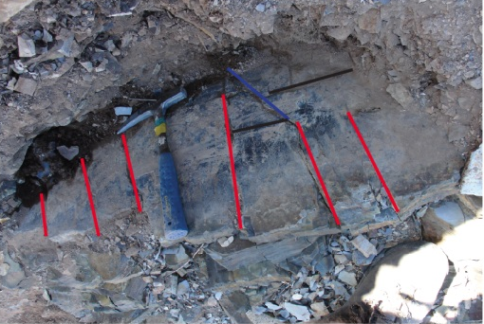
Although the fracture patterns in the Southern outcrop are less complex than its Northern counterpart, the Southern outcrop has the more consistent fracture patterns. This consistency is amplified by the general quality of the outcrop exposure.
Figure 28. Fracture orientations of the south limb fracture sets. Red - fracture sets perpendicular to bedding, black - fractures parallel to bedding and blue - fractures oblique to bedding.

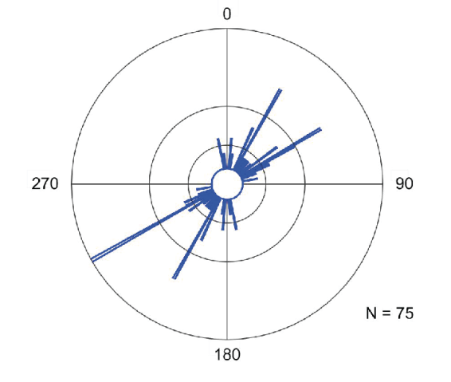
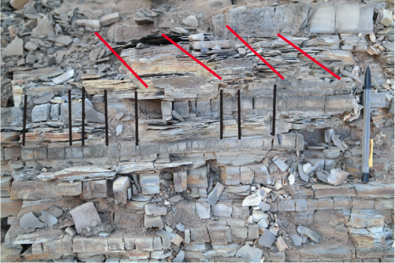
Fracture orientations at the Southern outcrop are consistence with fold-related fracture pattern discussed by various authors (Stearns, 1964; Roznovsky, 2001; Bergbauer, 2004). At the Southern outcrop, three major facture patterns have been identified: Set I, Set II and Set III. The Set IV fracture pattern that is present at the northern outcrop is absent in the Southern outcrop. This is most likely due to the fact the anticline has experienced less deformation on the back-limb outcrop compared to forelimb outcrop. Set I and Set II fractures (shear fractures) are conjugate fracture patterns with a ~60° angle between the two (figure 29 Set 1 in blue. Set II not shown in figure 29 because that picture is of the cherty (silica) rich shale instead of the organic rich shale). The Set I fracture pattern are oblique to the strike of the bedding plane. The fractures have a dip direction of N25°E and S205°W and dip between 50° and 60° (figure 30, for dip directions). These fractures are the slanted fractures present in the package of highly ductile (fissile, organic rich) shale. The Set II fractures are also oblique to the strike of the bedding plane. These fractures have a dip direction of N65°E and S245°W and dip about 75° (figure 30, for dip directions). The Set III fractures (tension fractures) dip perpendicular to the strike of the bedding plane. Just like at the Northern outcrop, the Southern limb’s, the Set II fracture sets primarily exist within the more ductile shale layers. These fractures terminate at the bedding layer where the organic rich layer meets the cherty, silica rich layer. The Set III fractures that are present in the non-fissile layer terminate the same way as the Set II fractures do. This is a major difference in fracture nature from the Northern Outcrop.

Fracture Characterization - Northern Outcrop
The northern outcrop has been divided into two sections, lower and upper respectively. Each section has had a single 50cm² mechanical inventory square painted with orange spray paint, perpendicular to the strike of the bedding plane, and has been used for both the LiDAR portion of this thesis and the facture characterization portion. Furthermore, the bedding planes exposed at the surface, near the mechanical inventory squares has been analyzed as well, but just for the fracture characterization portion. The Northern outcrop shows a pattern where there are organic rich beds, that are fissile in nature, and are much more ductile than the silica rich beds. For the purpose of this thesis, thick units of fissile, organic rich shale was counted at a single shale bed and measured accordingly.
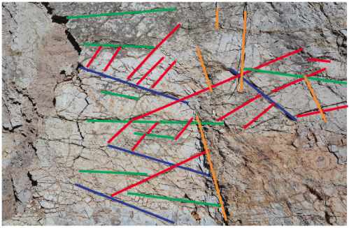
The Northern outcrop is more densely fractured than the southern outcrop. This is true for both systematic and non-systematic fracture sets. The increase in fracture density is understood to be the result of late stage fold evolution in which complex stresses and strains caused the development of higher density and randomly oriented fracture patterns (non-systematic fractures). The non-systematic fractures are abundant at the northern outcrop but often die out within the systematic fracture patterns and always terminate at the shale bedding. This means that the lengths of non-systematic fractures are actually controlled by the systematic fractures or by the joint spacing. Furthermore, thicker shale beds will, in many cases, have larger and more pervasive non-systematic fracture sets than the shale’s thinner beds. This relationship can be seen when analyzing the shale bed from the top of the bed, along a single bedding plane. Systematic fractures behave like a boundary to nonsystematic fractures and non-systematic ones terminated against them. As a result, the non-systematic fracture properties of the northern shale outcrop are significantly more complex that it’s southern counterpart. There is some evidence however, that will be referenced in the later parts of this thesis, that the presence of minerals other than quartz causes an increase in non-systematic fracture sets.
Figure 17. Dominant fracture patterns within the I-35 North Out- crop. The two dominant fracture patterns are evident in this picture (Red: Set I and Blue: Set II. The two other fracture sets are Orange: set III and Green: set IV.
Figure 17 above was taken at the northern outcrop, to the right of square one. The picture is an excellent example of the high quality fracture data that is present at these Woodford Shale outcrops. Figure 17 above shows four different fracture patterns. These fracture patterns are: 1. Red - Set I, 2. Blue – Set II, 3. Orange – Set III, 4. Green – Set IV. Figure 18 below was taken by Ataman 2006, at the northern Woodford outcrop. It is an excellent image showing shear displacement along a set II fracture. This shear displacement was most likely caused by late stage evolution and folding.

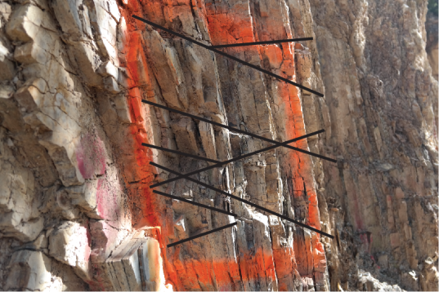
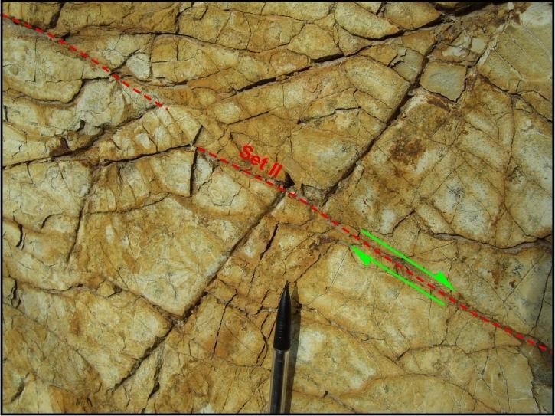
Figure 1Image showing congenate fracture sets. Some of these terminate at the shale beds, some are pervasive
Figure 2 Ataman 2006, Shear displacement
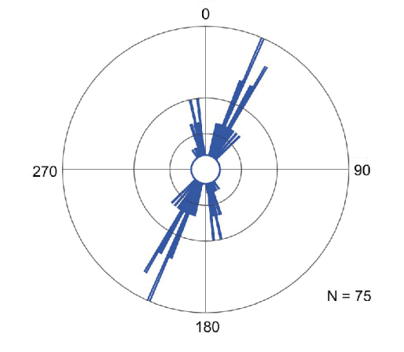
Fracture Set I and II dip with variable degrees to the NW and E-NE (Fig. X rose diagram). The dip directions of the fractures have this orientation because the shale beds are overturned (dipping to SW). The set I and set II fracture sets have been highlighted in black in figure 5 above. Fracture set I and II are conjugate fracture sets and orthogonal fracture patterns, at least on the bedding plane (figure XXX (above). Fracture sets I and II are common shear fractures for this study area, and they strike oblique to the bedding plane. The set I fractures strike around N35E. The set II fractures strike N-S and N20W. The other major facture sets, set III and set IV, are not easily shown from this angle shown in figure 5. This is because fracture set III’s orientation is perpendicular to the strike of the bedding plane and fracture set IV’s orientation is parallel to the strike of the bedding plane. Fracture sets III and IV are shown clearly in figure XXX above. Fracture set III and IV are consider tensional fracture sets, and are dominated by the primary facture sets, set I and II.

Discussion – From another author Need to rewrite this
The systematic fracture sets found at the Arbuckle Anticline limbs are directly related to the evolution of the anticline. They are quite consistent with the fold related fracture patterns proposed by Friedman and Stearns (1972). Along the northern limb of the Arbuckle Anticline, two dominant fracture patterns were recorded. The vertical beds of the overturned beds of the I35 North Limb indicate that both of the outcrops were exposed to the late folding processes. Compared to the other outcrops exposed among the study area, beds located on the I-35 North Limb outcrop were significantly deformed during fold evolution, so this should be the reason for the more complex fracture pattern develop of those. The fracture sets that are present on the Woodford Shale suggest that the principal stresses and their direction should have changed during folding. The first common fracture pattern indicates that maximum principal stress (σ₁) was parallel to the dip direction at the beginning of folding, while the intermediate stress was normal to bedding and the least principal stress parallel to bedding strike. However, when the beds have gained inclination, the direction of principal stresses changed. Consequently, the secondary fracture patterns developed under reoriented principal stresses.
Fracture orientations and relationships are more complicated on the northern limb of the Arbuckle Anticline. Observations on the northern outcrops indicate an increase in fracture patterns and complexity with proximity to the hinge of the anticline. Late fold evolution caused the development of the two patterns on the northern outcrops and that not as scattered populations on the stereonets. However, the southern limb beds have not experienced the late fold evolution. For this reason; only the first fracture pattern developed along the I35 South Limb outcrop. Fracture measurement populations are not scattered as much on the stereonets. Low-dipping beds and less deformation compared to the forelimb outcrops are the primary reasons for the absence of the second fracture pattern on the southern limb outcrop.
Based on the orientation of the fractures observed at the four outcrops and the previous studies about the structural styles of the Southern Oklahoma Aulacogen (Walper, 1977; Brown, 1995; Saxon 1998; Randel, 2008), the maximum principal stress is oriented in NE and W-NW directions. However, fractures are strongly influenced by local structures and the Arbuckle Anticline. Therefore, the proximity to local structures played a significant role in fracture development and orientations by changing the principal stress directions. In addition to this, after removing bedding dips, some fracture orientations are consistent with the regional principal stress directions and also with fractures orientations within the Ouachita outcrops. Therefore, there is a possibility of some fracture development in response to regional stresses prior to the Arbuckle Anticline evolution.
I and Arbuckle outcrops, fractures are developed under regional stresses however, evolution of local structures totally change principal stress directions and therefore fracture properties.

