INTRODUCTION

It is said that the Globally the life expectancy has risen as modern medicine has improved and persons from all age groups have become more active. Active means: participating or engaged in a particular sphere or activity. I have noticed that there is a significant amount of young persons who choose to be active their school life. I realised that the older I got the more i didn't care to be anymore. It has raised to understand what relationship does your age your exercise habitats or is is that affected by other reasons such as stress,?

Statement of Task

The main intention to evaluate the relationship between age and the amount if time you spend being To do this I be collecting raw data via questionnaires from 2 my school population. The specifically ask what type of activities they do. How much time they do it and lastly the reason behind doing it.The data collected will be analysed on a graph to see if there is a direct relationship between age and how active you
I believe will find that at a young age persons have more leisure time and they are more active.

Plan of investigation
First I will be doing research on surveys done before about the relationship between age and how active a person is. I doing a survey taking samples from a range of 1 age groups ( 15 for each group activity.rveys will remain anonymous and I will be asking a question about the activities they do they do After gathering data I am going to make a scatter plot and make a to see if there is a linear correlation between each age group and how active they are.
To get a more precise measure of strength I will be using Pearson's product - moment correlation. I will do a test data is independent of one A Pearson sample size of 30 students from my school where asked questions. These persons were chosen to represent 2 age groups . from age 12-14 early teens , another group age 15 - 19 late teens .

Collected Data

Diagram showing amount of hours of physical activity in a week for each age group

Average number of active hours | Age group
4 | 12- 14
5 | 12- 14
1.5 | 12- 14
3 | 12- 14
4 | 12- 14
4 | 12- 14
2 | 12-14
4 | 12-14
3 | 12-14
2 | 12-14

2 | 15- 19
3 | 15-19
1 | 15-19
3 | 15-19
3 | 15-19
5 | 15-19
1 | 15-19
1 | 15-19
2 | 15-19
2 | 15-19
0 | 15-19
0 | 15-19
1.5 | 15-19
1.5 | 15-19
1 | 15-19
5 | 12-14
2 | 12-14
2 | 12-14
2 | 12-14
3 | 12-14

Table 1 shows the spent doing physical one week for each pe

Graph showing average number of hours active for age group 15- 19
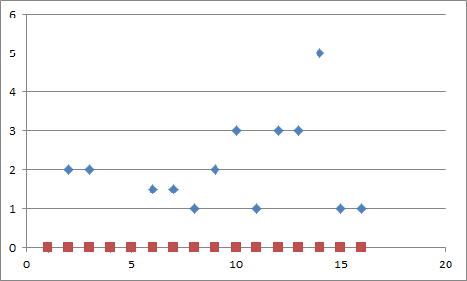

Discussion/ Validity

Limitations
Although i attempted to survey a range of different age groups and geneder , the data would have been more accurate if I had used all of the school population.

Conclusion

Works cited

https://www.ncbi.nlm.nih.gov/pmc/articles/PMC4316513/

http://www.statpac.com/statistics-calculator/correlation-regression.htm

https://www.unm.edu/~lkravitz/Article%20folder/age.html

Questionnaire

How old are you?

How many sports/ activities do you do?

Dancing

Football

Jogging

Run / walk

Swimming

Others

What sport / activity do you do ?

How many days do you do this activity / sport ?

How many hours do you spend daily on this sport/ activity?

Do you like doing it ?

Please state your reason for doing this activity .

Health reasons mandatory for school

Enjoyment stress relief

