TABLE OF CONTENTS

1.0 INTRODUCTION 3
1.1 PROJECT OVERVIEW 3
1.2 PROBLEM STATEMENT 4
1.3 SCOPE OF STUDY 4
1.4 NOVELTY CLAIM 4
2.0 LITERATURE REVIEW 5
2.1 REVIEW OF EXISTING PRODUCT 5
2.2 EXISTING METHOD AND TECHNIQUE 7
2.3 THEORIES ON EXECUTING PRODUCT 8
2.3.1 NANODUCT NENONATAL SWEAT ANALYSIS SYSTEM 8
2.3.2 MACRODUCT SWEAT COLLECTION SYSTEM 9
2.3.3 A WEARABLE SENSING PATCHES 10
2.4 CONCEPT OF NEW PRODUCT 11
3.0 OBJECTIVE 12
4.0 PROJECT EXECUTION PLAN 13
4.1 FLOWCHART 13
4.2 EXPERIMENTAL 15
4.2.1 SODIUM SENSOR 15
4.2.2 ARDUINO 16
4.2.3 SWEAT PADS 17
4.2.4 SWEAT BAND 18
4.3 SIMULATION OF SYSTEM 19
4.4 MATERIAL AND TECHNIQUE USED 20
4.5 PARAMETER INVOLVED 20
4.5.1 FACTOR CAN BE CONTROLLED 20
4.5.2 FACTOR CAN’T BE CONTROLLED 20
4.6 COST ESTIMATION 21
4.7 TIMELINE OF PROJECT 22
4.8 FINAL PRODUCT (EXPECTED) 23
5.0 EXPECTED CONTRIBUTIONS 24
6.0 MARKETING OPPORTUNITIES 25
7.0 APPLICATIONS 26
8.0 BRIEF BENCHMARK 27
9.0 CONCLUSION 28
10.0 GANTT CHART 29
11.0 REFERENCES 30

INTRODUCTION

PROJECT OVERVIEW

In our daily life, we must ensure that our health is maintaining so that we can live comfortably and happily. It is, therefore, the obligation of everyone to ensure that the practice of maintaining good health. One of the importance of maintaining good health is that we can do something like play football and exercise. As a result, we are not only able to do activities comfortably, but also to remove sweat and make our body more healthy and fit. Additionally, when we take good care of our health, we can learn comfortably and easily to pay attention when in class. As the saying goes, a healthy body, the brain becomes smart. Therefore, we must conduct a medical checkup to find out our level of health. Nevertheless, medical check-up through blood tests will take time to obtain results from the blood samples taken.
As we know, sweat is a liquid that results from the secretion of sweat glands in the human skin. Sweat has an important information in our body. Based on the latest research, human sweat contains ions such as sodium and chloride. Sodium and chloride help to maintain water in human bodies. It also controls the nerve function and muscle contraction. The concentration of sodium and chloride in human bodies can detect the level of the individual health [1].
Therefore, our group would like to discuss and suggest how sweat can be linked to monitoring our health, especially against cadets at NDUM. The sodium ion and chloride content in the sweat can be used as a material to demonstrate the health of the individual. Therefore, this project will monitor the health of cadets at NDUM as one of the tools to replace medical checkup through the blood samples.

PROBLEM STATEMENT

Military cadets need to maintain their health at all times. It is difficult to measure the level of a cadet health system unless a cadet has undergone a proper medical checkup. This situation can consume a cadet’s precious time. In various researches, a human’s sweat contains information on someone health. The concentration of sodium and chloride in cadet’s sweat can detect the level of cadet’s health. Discuss and suggest how sweat could relate and monitor a cadet’s certain health level.

SCOPE OF STUDY

To achieve this project's objective, we conducted an experiment to see the concentration of sodium and chloride in the individual body. The concept of the salt bridge is used to see the concentration of sodium and chloride in the individual body. Based on the today technology, we develop a sensor to catching the sweat and measure the concentration of sodium and chloride in human’s sweat. However, in this project, we focused more to cadets in other to detect their level of health.

NOVELTY CLAIM

We claim that this project is our own project. Next, we want to make our own device that can help others. This device can assist us to maintain our health at all time. Besides, our device is new and very useful. Our device has are many improvements than others.

LITERATURE REVIEW

REVIEW OF EXISTING PRODUCT

Sweating is a common thing to everyone. At normal levels, humans have between two to five million sweat glands throughout the body and mostly in the palms and toes. There is a need to move or do a light exercise for sweating and some just sitting lazily on the couch while watching horror films is enough to remove sweat. However, the sweat secreted by each human being is different in composition.

The sweat contains 99% water, while the remaining 1% consists of urea, uric acid, lactic acid, ammonia, vitamin C, electrolyte and different skin proteins. Sweat is a fluid in the body that contains proteins and other metabolites associated with diseases and infections Sweat contains ions such as sodium, potassium, calcium, magnesium, chloride, and lactate. Sweat is easy to reach, with an average male sweating rate of 0.85 mg cm-2 min-1 in the lower back [1].

Based on our research, we found that some products have been using sweat as a health checkup tool. Therefore, we have made a comparison of existing products with our products that we have designed. The comparison will be focused on the cost, flexibility, maintenance and on all the present of the indicator.

Products | Nanoduct Neonatal Sweat Analysis System | Macroduct Sweat Collection System | A Wearable Multisensing Patch
Cost | $129.99 | $250.00 | $16.88
Flexibility | Easy to conducted | Easy to conducted | Difficult to conducted
Maintenance | Extended battery life of lithium cell for 75 years | Extended battery life of lithium cell is 75 years | need to be cleaned every last time used
Customer’s Satisfaction | Small and easy to bring | Small and easy to bring | Easy to bring
Installations | Electrical connectivity | Electrical connectivity | Integrated bluetooth connectivity
Performance in Quality | Collect the sweat and the result will display on device | Collect the sweat and the result will display on device | Collect the sweat and the result will display on device
Eco-friendliness | Environmentally safely | Environmentally safely | Not environmentally safely

Table I Comparison between Existing Products

EXISTING METHOD AND TECHNIQUE

The existing product that measures the health of human using sweat either Nanoduct Neonatal Sweat Analysis System, Macroduct Sweat Collection System and Wearable Multisensing Patch, have used the same technique and method. The technique and method as shown below:
- Place the poligel pads on the skin.
- Ionthophoresis used to stimulate the sweat.
- The collection of sweat will be used to measure the sweat conductivity.
- Result display on the system.
- For a wearable multisensing patch the result will scan on the phone.
All of three existing products used exactly the same method by calculating the concentration of pH that contains in sweat. These devices only can be exerted either doctor or medical assistant, instead of its hard to find.

THEORIES ON EXECUTING PRODUCT

NANODUCT NENONATAL SWEAT ANALYSIS SYSTEM

Figure 2.3.1 Nanoduct Neonatal Sweat Analysis System

Figure 2.3.1 shows the Nanoduct neonatal sweat analysis system. Nanoduct neonatal is a device that tests human sweat to detect the cystic fibrosis and health level of a person. It tests the sweat like doing a laboratory test. The quality of life and life expectancy of a child can be seen from them being born by early treatment and making a diagnosis to analyze the degree of electrolyte concentration in the sweat. This existing collecting and the analyzing product have been incorporated into the Nanoduct analysis system [3].

Nanoduct System used a conductivity sensor which is followed by continuous flow analysis of sweat electrolyte concentration. A single control cable was connected to electrodes and the sensor of Nanoduct system. The total electrolyte content displays the initial sweating rate. Total electrolyte concentration has been shown to be the equal of chloride in its ability to discriminate diagnostically between CF and non-CF subjects [3].

MACRODUCT SWEAT COLLECTION SYSTEM

Figure 2.3.2 Macroduct Sweat Collection System

Figure 2.3.2 shows the Macroduct sweat collection system. Macroduct is a device that has the same action like in the laboratory sweat test for detect cystic fibrosis.Sweat Testing consists of three separate procedures, the first one being sweat stimulation.

Macroduct and Iontophoretic Discs are gel reservoirs of pilocarpinium ions that are simple and safe for iontophoretic sweat stimulation. There are no electrolyte solutions to prepare or to keep track of, and no messy electrolyte pads that must be saturated with separate solutions. Instead, a Pilogel disc is inserted into each of the recessed stainless steel electrodes, which are then attached to the patient [3].

Macroduct is a unique and safe reservoir of pilocarpinium ion gel for stimulation iontophoretic sweating. The electrolyte is not been saturated with separate solutions, but the poligel disc are inserted into each sealed stainless steel electrode and then fixed to the patient [3].

A WEARABLE SENSING PATCHES

Figure 2.3.3 A Wearable Multisensing Patch

Figure 2.3.3 shows a Wearable Multisensing patch. A Wearable Mmultisensing patch is a tool that uses a suitable microfluid for sensors for the human body. Wearable Multisensing Patch has two-step of the process. Firstly, a microfluidic platform was designed to create a constant flow of sweat within a robust and flexible embodiment for the chemical transducers. Secondly, the sensors were validated on human volunteers during running and cycling activities of increasing intensities. The fluid system has been modified and tuned depending on the attachment site on the body [2].

CONCEPT OF NEW PRODUCT

There are 3 general design factors that will be subjective for the choices of quantitative design requirements, which is the target market, available capabilities, and resources to design and manufacture, time and cost. The target market is the main key to this design, the target market of before product only focused on clinical diagnostic commercial. Now, as the new target market where the device can be used by all cadets at NDUM without help from a trained person.

Product | Product A | Product B
Cost | $65.00 | $50.00
Flexibility | Easy to conducted and multi-function | Easy to conducted and multi-function
Maintenance | Extended battery life of lithium cell for 10 years | Extended battery life of lithium cell is 10 years
Customer’s Satisfaction | Small and easy to bring | Small and easy to bring
Installations | Electrical connectivity | Electrical connectivity
Performance in Quality | Collect the sweat and the result will display on device | Collect the sweat and the result will display on device
Eco-friendliness | Environmentally safely | Environmentally safely

Table II Concept of New Product

3.0 OBJECTIVE

The main objectives of this project are to design a device that can use sweat to detect the concentration of sodium and chloride in cadet’s sweat and monitor a cadet’s health condition. Additionally, this design is a new and easy way to check the health of the cadet by looking at the level of sodium concentrations in the cadet’s sweat. Therefore, sweat plays an important role in maintaining the body's humidity. Since this design is small and easy to carry anywhere and without the need for a doctor or nurse assistant, all cadets can use this tool to see their health level. Therefore, we will produce a comfortable and easy-to-use tool for everyone.

PROJECT EXECUTION PLAN

FLOWCHART
START

COLLECT SWEAT FROM THE USER

ATTACH SWEAT PATCHES SENSOR TO THE USER

ANALYZING THE SWEAT SAMPLE

EXTRACTING THE INFORMATION OF THE SODIUM (Na+ ) OF SWEAT

ARDUINO GET THE INFORMATION

NO
YES
DISPLAY THE INFORMATION
( LEVEL CONCENTRATION OF Na+)

Na+ Concentration
Na+ ≤130 mM or Na+ ≥150 mM
135mM< Na+ <145mM
GREEN LIGHT
RED LIGHT

END

Figure 4.1: Flowchart of the device
The flowchart shows the process of the system in the device. When the power source is supply to the system, the Arduino will start interpreting the output signal from the sensor. The sensor will detect the concentration of the sodium of the sweat that attach to the sensor patches of the sweat band. When the Arduino detected the content of the sweat, the information will be display using the LED light GREEN and RED.

EXPERIMENTAL

SODIUM SENSOR

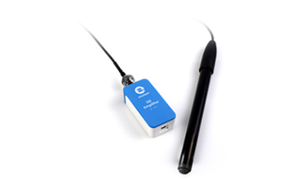

Figure 4.2.1: Sodium Sensor

The sodium sensor is most important part of the device too. The main functions of sodium sensor is to measure and detect the concentrations of the sodium of the sweat content. Sweat content which consists of sodium has it own optimum range for a normal healthy person. Sodium sensor are widely used in the laboratory to do the laboratory experiment. In this project, the main function of sodium sensor is to measure the sodium concentration of the sweat of a cadet. When the level concentration of sodium is too high in sweat, it means that the cadet’s health is not in a good state. Table III shows the sweat sensor specifications.

Table III: Sodium sensor specifications
Type | Scaled
Concentration Range | 4 x 10-6 to 1 M (0.1 to 23,000 ppm)
Response time | 90% of final reading in 1 second
Operating Temperature Range | 0°C to 80°C
Accuracy | +/- 4%

ARDUINO
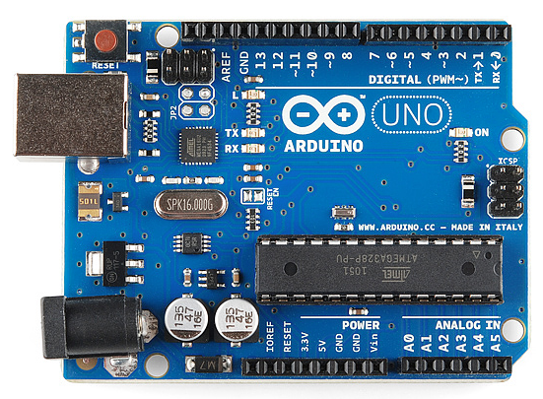

Figure 4.2.2: 5V Arduino board

Figure 4.2.2 shows the 5V Arduino board. This board is selected because its were the main component for this project. First, the Arduino hardware and software designed special for who design electronic project. Second, the board is easy to use. Besides, arduino has the main IC or integrated circuit that works as a brain of the board. Then, the power supply can connect to usb because it has the usb portable at the board. In the same time, this board is not too heavy which is to help design a device that easy to bring when needed. Table IV shows the pins connected to the arduino board.

Table IV: Pins of Arduino board
Pin | Characteristic
GND | Used to ground the circuit
5V & 3.3V | Supply power to the circuit with suitable power voltage 5V either 3.3V
Analog | To read all the analog sensor
Digital | Used for digital input or digital output
PWM | To stimulate the analog output
AREEF | Used to be pin of reference voltage

SWEAT PADS

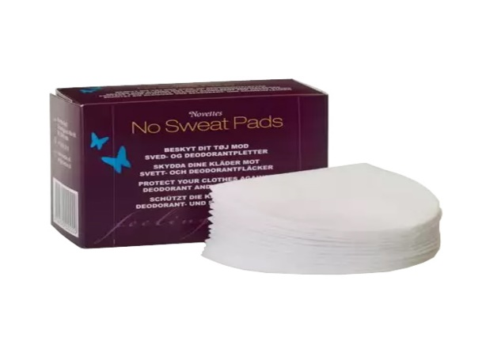

Figure 4.2.3: Sweat Pads

The pads consist of a highly absorbent soft fleece that allows perspiration to pass quickly through to the inside of the pads where they are safely enclosed. In spite of high air circulation and moisture permeability, the pads control the odor and prevent the liquids from escaping the pad.

SWEAT BAND

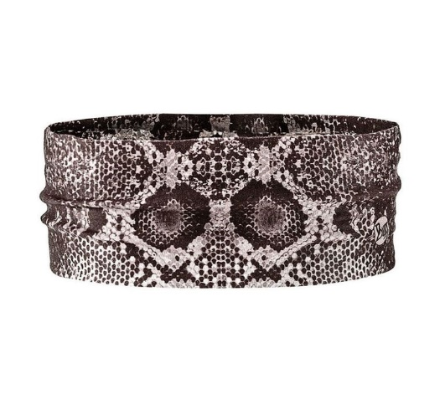

Figure 4.2.4: Sweat band

Figure 4.2.4 shows the sweat band. This sweat band is selected because it is use by the user to collect the sweat as it design can absorb the sweat quickly. So it will be easier to collect the sweat by attach the sweat patches on it.

Table V: Sweat band specifications
Type | Specifications
Size | Approximate 5 x 18 cm (2 x 7.15 inches), stretchable width. One size fit all.
Durability | Stretchable and flexible
Operating Temperature Range | 0°C to 60°C
Material | 70% Cotton, 20% Polyurethane Fiber, 10% Orlon

SIMULATION OF SYSTEM

This system is control by the Arduino board. The power source that we supply to the board is 12V. The sodium sensor that connect to the Arduino is to produce the fastest and quality for the user to get information about their sodium concentration from their sweat content that collected by the sweat pads which attach on the sweat band. The used of sweat is to replace the use of blood to check the healthiness of the body. This is because some people afraid of pain when test the healthiness by blood sample. Another advantage in this system is the system is fast, the product also causes less cost and easy to use. With this system, the user can check their level of concentration of sodium in the sweat losses from the body. It is as well-established fact that the low concentration of sodium in sweat indicates a healthy state while, the imbalance can be a sign of disease, due to hypertension, hypopotassemia conditions.

When the sweat has been tested, the sensor will analyze the information in the sweat. For example, after the analyzing, the level of sodium concentration of sweat is high. This indicate the increasing sodium losses from the body due too much loss of fluid and electrolytes through sweat. It is highly variable depending on the individual fitness, acclimatization, and humidity. This can cause the person easy feel tired then another person and may dehydrate and cause hyponatremia. The person should consume a healthy food which rich in sodium and potassium to avoid the body from losing too much sodium through sweating due to extreme exercise or training.

MATERIAL AND TECHNIQUE USED

Table VI: List of component and function
Component | Function
Sodium Sensor | Detect the concentration of sodium content
Arduino | Control all the system based on the coding
Sweat band | Absorb the sweat from the user during training
Sweat pads | Collect and trap the sweat sample from the user attach at the sweat band

PARAMETER INVOLVED

In the process of designing the system, some environment has been identified as a factor to maintain the healthiness of cadets. This factor has been differentiated into two categories, the control and uncontrolled.

FACTOR CAN BE CONTROLLED
FOOD
All cadets must take a good meal every day. We are suggested to eat base on the pyramid of food. Like cadets, they need a lot of carbohydrate, protein and food which rich in salt which contain sodium a day to give them energy and to repair the tissue. All bad junk food and food that has many fats should be avoid. In this way, the healthiness of cadets can be maintained.

FACTOR CAN’T BE CONTROLLED
SWEAT
To maintain the healthiness among cadets, they should take balance sodium and water consumption. Example by replacing water with sports beverages that contain electrolytes when participating in endurance events such as marathons, triathlons and other demanding activities.

COST ESTIMATION

Table VII: Cost each component
Item | Unit Price(RM) | Unit | Price (RM)
Sodium Sensor | 200.00 | 1 | 200.00
Arduino | 50.00 | 1 | 50.00
Sweat band | 15.00 | 1 | 15.00
Beaker | 33.00 | 1 | 33.00
Electrode | 36.00 | 2 | 72.00
 |  |  | Total: 370.00

TIMELINE OF PROJECT

Table VIII: Planning (Work breakdown)
NAME | TASK | TIME
All members | - Identify Problem  - Idea Brainstorming  - Scope Identification  - Literature Review (two articles per person)  - Presentation | - 17 days
NUR ADRIANA SYAZLEEN BT RAMLI | - Writing the proposal of the project  - Specify troubleshooting  - Development of hardware | - 16 days
MUHAMMAD AIMAN BIN AMRAN | - Analysis the data collected and present of findings  - Specify hardware and detail requirement  - Writing a report | - 16 days
CHONG YIN TAN | - Purchasing hardware and hardware listing  - Project simulation | - 15 days
MUHAMMAD FAIRUL BIN ROSLAN | - Testing the wiring and hardware  - Analysis of error occurred  - Project documentation | - 15 days

FINAL PRODUCT (EXPECTED)

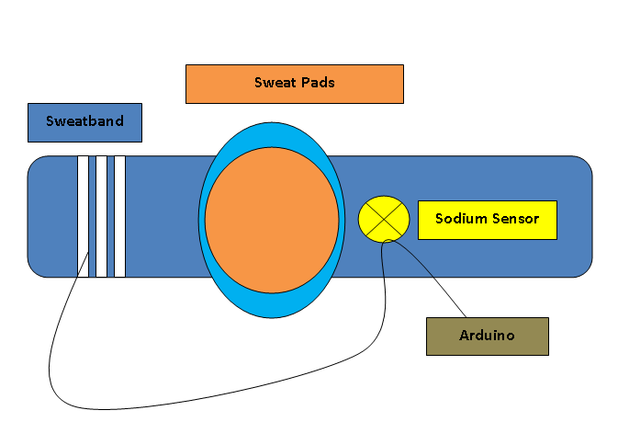
Expected of the product is the device can functionally well base on the planned. With the best and conscientious i-Sodium Sensor project may help the cadets to check their health status frequently during their daily exercise and training sessions. This will help them easy to monitor and maintain their health at once to decrease the number of sick people because lack of sodium concentration that need by the body for the electrolyte fluid to maintain body temperature. It also can analyze the sample of sodium concentration accurately by using sensor that the device used.

Figure 4.8: Expected design of i-Sodium Sensor

EXPECTED CONTRIBUTIONS

i-sodium sensor provides a faster alternative way of reviewing the healthiness of cadets by testing their sweat without doing other unnecessary procedures such as blood test and other examinations that take times to process. This device is quite easy to operate and does not require professional knowledge, so anyone can use this device whenever they want. In a world of sophistication, the i-sodium sensor is portable and simple to use in any place such as at the workplace, in school, at home or even in the shopping complex. This sensor is also suitable for all ages because it does not require blood taking which causes pain and discomfort.
With this, i-sodium sensor can detect the levels of sodium in the sweat and analyses them to determine whether the levels are in a normal state. An i-sodium sensor is very time-saving for the user as well.

MARKETING OPPORTUNITIES

In this twenty-first century, health is doubtlessly important to everyone. Due to the hectic work life, people tend to forget and do not have any free time to do regular medical check-up to review their health status. The development of technologies and facilities also cause people to become lazy to do physical exercises. Similarly, for the cadets, because of their packed schedule for studying and training every day, which makes them have limited time, they are unable to check their healthiness regularly. Therefore, this i-sodium sensor provides an opportunity to everyone to check their healthiness without having to visit a doctor. Instead, they can check by just testing their sweat. In addition, the i-sodium sensor is fast and efficient as it gives results in a short period of time to the users to review their healthiness. Not only that, this device is portable and easy to use for all ages. Moreover, the price of this device is inexpensive and affordable for all walks of life.
The main target group of this device is the cadets. To stay healthy is essential for them to survive in their harsh military life. For this reason, the cadets ought to maintain their healthiness to stay fit and prevent their performance from dropping. With the aid of this device, the cadets can always be aware and avoid themselves from being sick or affected by any kinds of diseases.
The second target group of this device is the people that are too busy to go to the hospital for medical checkups. The purpose of this device’s marketing is to achieve “one house one device”. This is vital for their family’s health as well. Besides that, this device can effectively decrease the number of patients in the hospital because instead of going to the hospital and lining up to wait for the doctor, they can review their healthiness by themselves at home.

APPLICATIONS

This sensor is created to help the cadets to know their level of health. This is possible with the uses of the sodium sensor detection to manage the cadets remains health. Cadets will be confused about their health at once decreases the quality if without this system. All lecture and cadet’s in NDUM can operate this system in real time in detecting the level of sodium concentration in sweat. These devices have a few main advantages.

- Prevention is better than cure
When a level of sodium in your blood is abnormally low, hyponatremia condition can occur. Hyponatremia signs and symptoms may include a headache, confusion and muscle weakness, spasms or cramps.

- Money saver
This device can help to save the amount of money in the long run by regular checkup. As it helps to minimize the risk of potential health issues in the future

BRIEF BENCHMARK

Based on devices made by other companies, we have found some shortcomings output. For example, A Wearable Multisensing Patch device is the cheapest but not multi-functions and not environmentally friendly. For Nanoduct Neonatal Sweat Analysis System device, the cost of a product is so expensive. For Macroduct Sweat Collection System, this device is also expensive and not multi-functions. So, we decided to make other devices that has low cost, good in design, environmentally friendly and multi-functions. Therefore, people will feel satisfied with our devices because those devices have the latest technology. Table X shows the characteristics of the sensor device and other devices.
Table IX: Characteristics of the sodium sensor device and other devices.
Product | Characteristic
 | Cost | Advantages of design | Multi-functions | Environmentally friendly
A Wearable Multisensing Patch | $16.88 | Easy to bring | No | No
Nanoduct Neonatal Sweat Analysis System | $129.99 | Small and easy to bring | No | Yes
Macroduct Sweat Collection System | $250.00 | Small and easy to bring | No | Yes
i-Sodium sensor | $50.00 | Small, easy to bring and multi-functions | Yes | Yes

CONCLUSION

As a conclusion, we know that the concentration of sodium in the body can affects our health. As we have already studied, sodium concentrations in the body can be measured by sweat. The higher the concentration of sodium in the sweat, the body of the individual loses a lot of sodium and makes the sodium in the individual body less. This shows that the individual's health level is in poor condition. For normal human health, the sodium content in the individual body is moderate. Therefore the sodium concentration in the sweat to be measured will also be modest.
Based on the objective, students able to design a device that used the sweat to detect the concentration of sodium and chloride in sweat and monitor the cadet’s health condition. The new design is the easy way to check the cadet’s health.
In a nutshell, this device is created to help the cadets to know their level of health. This device is a multi-function task device. This is possible with the help of the medical checkup. All cadet and staff in UPNM can maintain their health level at all time. Therefore, we can conclude that sodium sensor device can give many advantages to the cadets.

GANTT CHART

NO | TASKS | WEEKS
 |  | 1 | 2 | 3 | 4 | 5 | 6 | 7 | 8 | 9 | 10 | 11 | 12 | 13 | 14 | 15 | 16
1 | Develop team member and brainstorming
2 | Proposal submission
3 | Do some improvement project
4 | Proposal defense
5 | Specify detail requirement and hardware listing
6 | Analysis of collected data
7 | Final troubleshooting
8 | Presentation demonstration
9 | Submit final report
10 | Submit evaluation form

11.0 REFERENCES

[1] | M. J. Buono, "Sodium ion concentration vs. sweat rate relationship in humans," Journal of Applied Physiology, vol. 103, no. 3, pp. 990-994, 2007.
[2] | S. Anastasova, "Corrigendum to “A wearable multisensing patch for continuous sweat monitoring” (Biosensors and Bioelectronics (2016) 93 (139–145) (S0956566316309198) (10.1016/j.bios.2016.09.038))," Biosensors and Bioelectronics, vol. 94, p. 730, 2017.
[3] | A. Vernooij-van Langen, "Clinical evaluation of the Nanoduct sweat test system in the diagnosis of cystic fibrosis after newborn screening.," European journal of pediatrics, vol. 174, no. 8, pp. 1025-34, 2015.
[4] | D. H. Choi, "A wearable potentiometric sensor with integrated salt bridge for sweat chloride measurement," Sensors and Actuators, B: Chemical, vol. 250, pp. 673-678, 2017.
[5] | S. P, "A wearable sensor for measuring sweat rate," IEEE Sensors Journal, vol. 10, no. 10, pp. 1557-1558, 2010.

