Assignment Brief 2017-18
Qualification |  | Unit number and title
BTEC L3 Dipl. - L3 Ext Dipl. |  | Unit:26 Application of Computer Numerical Control in Engineering
Learner name |  | Assessor name
 |  | Chris Abrahart
Date issued | Hand in deadline |  | Submitted on
01/12/17 | 02/02/18

Assignment title: | Producing a component on a CNC machine ²
In this assessment you will have opportunities to provide evidence against the following criteria.
Indicate the page numbers where the evidence can be found.

Criteria reference | To achieve the criteria the evidence must show that the learner is able to: |  | Task no. |  | Evidence
P3 | Interpret the specification for a given component and produce an operational plan for its manufacture. |  | 1
P4 | Produce a part program for a given component. |  | 1
P5 | Manufacture a component using a two or three axis  CNC machine. |  | 1
M1 | Explain the importance of producing an accurate and detailed operational plan for a component which is to be manufactured using CNC machine tool. |  | 2
M2 | Explain the importance of correct programming and setting up in order to produce a component to a required specification. |  | 2

Learner declaration
I certify that the work submitted for this assignment is my own. I have clearly referenced any sources used in the work. I understand that false declaration is a form of malpractice.
Learner signature: Date:

Internal Verifier declaration This assessment must not be photocopied and released to learners without IV approval.
I agree that this assignment is fit for purpose and has been approved for release to learners.
IV signature: Date: 20-09-17

Assignment Brief
Qualification | BTEC L3 Dipl. - L3 Ext Dipl.
Unit number and title | Unit:26 Application of Computer Numerical Control in Engineering
Learning aim(s) (For NQF only)
Assignment title | Producing a component on a CNC machine
Assessor | Chris Abrahart
Issue date | 01/12/17
Hand in deadline | 02/02/18
Vocational Scenario or Context | Scenario:  Your training officer has give you an introduction to CNC, and now wants to see that you are capable of implementing the skills you have learnt through carrying out the following assessment..This assessment provides you with the opportunity to manufacture a component on a CNC machine.  In order to produce the component to specification it is necessary to  study a detailed drawing of the part. (Supplied via Moodle).The shape  of the part, its features, tolerances and surface finish requirements will  be used to determine the work holding methods, cutting tools and feed  and speeds to be used.  A part program to manufacture the part can then be developed and  tested. Finally the machine will be set, and part manufactured and  inspection undertaken to check the component is manufactured to  specification. In some companies this may be carried out by a single  person and in others divided into job functions such as a programmer  and CNC setter/operator. This assessment requires you to take on the  part of an individual in a small company who completes all activities.
Task 1 | Student guidance: You are asked to complete the questions below,  ensuring that you reference any material out sourced. This includes  schematics, diagrams and technical data.  - Produce an operational plan to manufacture the component  specified in the drawing CNC 2ndAssignment resource folder  (Moodle) (P3)  Note: Appropriate component drawing to be supplied before issue of  assignment via (VLE) moodle  - Produce a CNC part program for the component. (P4)  Note: Profile of component must be cut using appropriate  cutters with reference to the material guide.(Moodle  - Manufacture the component using the CNC machine tools. (P5)  Note: Use Note the use of Denford CNC machine tools, is required to  procure manufacture of component.
Checklist of evidence required
Criteria covered by this task:
Unit/Criteria reference | To achieve the criteria you must show that you are able to:
P3 | Interpret the specification for a given component and produce an operational plan for its manufacture.
P4 | Produce a part program for a given component.
P5 | Manufacture a component using a two or three axis  CNC machine
Task 2 | - Explain why the operational plan must be well thought out,  accurate and detailed. (M1)  - Explain the importance of correct programming and setting  up in order to produce a component to the required  specification. (M2)
Checklist of evidence required
Criteria covered by this task:
Unit/Criteria reference | To achieve the criteria you must show that you are able to:
M1 | Explain the importance of producing an accurate and detailed operational plan for a component which is to be manufactured using CNC machine tool.
M2 | Explain the importance of correct programming and setting up in order to produce a component to a required specification.
Other assessment materials attached to this Assignment Brief | Reference material for this assignment to be located on VLE (moodle)
FOR NQF LEVEL 2 ONLY: If you have not achieved the Level 2 criteria, your work will be assessed to determine if the following Level 1 criteria have been met.
To achieve the criteria you must show that you are able to: | Unit | Criterion reference

ASSESSMENT RECORD SHEET
Programme |  | BTEC L3 Dipl. - L3 Ext Dipl. | Learner name
Assignment title |  | Producing a component on a CNC machine | Assessor name | Chris Abrahart
Unit no. & title |  | Unit:26 Application of Computer Numerical Control in Engineering | Targeted learning aims/assessment criteria | P3 P4 P5 M1 M2
First Submission
Deadline |  | 02/02/18 | Date submitted
Targeted criteria | Criteria achieved?  (Yes / No) | Assessment comments
P3
P4
P5
M1
M2
General comments
Assessor declaration |  | I certify that the evidence submitted for this assignment is the learner’s own. The learner has clearly referenced any sources used in the work. I understand that false declaration is a form of malpractice.
Assessor signature |  |  | Date
 |  |  | Date of feedback to learner
Resubmission authorisation  by Lead Internal Verifier* |  |  | Date
* All resubmissions must be authorised by the Lead Internal Verifier. Only one resubmission is possible per assignment, providing:
- The learner has met initial deadlines set in the assignment, or has met an agreed deadline extension.
- The tutor considers that the learner will be able to provide improved evidence without further guidance.
- Evidence submitted for assessment has been authenticated and accompanied by a signed and dated declaration of authenticity by the learner.
**Any resubmission evidence must be submitted within 10 working days of receipt of results of assessment.

Learner Feedback

Complete the questions below before you submit your work to your tutor:

Did you find the assessment challenging & interesting?

What feedback would you like from your tutor?
E.g: on your layout / presentation, how to improve writing style, referencing.
Note: Your tutor cannot give you specific feedback on what to add to meet / improve the assessment criteria.

Complete the questions below after you get your feedback from your tutor:

Was the feedback from your tutor useful and will it allow you to improve future assessments?

Unit: 26 Application of Computer Numerical Control in Engineering
[Document subtitle]

March 8, 2018
kc61380
Hadeesah Mir

P3 - Interpret the specification for a given component and produce an operational plan for its manufacture.

The Operational Plan for the G-Code Program –

- When looking at G-Code the first thing you should consider is the tools and what the specification requires, this may range from the T code for the tool type as well as the diameter of the tool, the T code is specific to te tool part its self and ensure the best tool for that job. The tool size for this specific job is 10mm
  - Some examples may include D2 – the drill size will be set too 10mm and T1 is the position of the drill bit
- Choosing an appropriate work hold is crucial, when looking at our component required the most reliable work hold will be the vacuum powered, this is because the materials we require will be able to be secure, as this requires in ensuring the component fits well into the work holder in order to be worked with.
- Before working on the component ensuring that each tool is of a working standard making sure the tools are not damaged and are fit to use, if damaged ensure to replace to reduce the risk of an accident.
  - The code to change the tools is M6.
- Ensure when scanning the three-dimensional co-ordinates select the appropriate operational speed. When you scan, the co-ordinates find the datum of the piece. The feed for my component in this situation is 1400rpm, different components will have different speeds depending on the material as well as the thickness of the materials to ensure the best finish of the job
  - G54, G28 and G41 are the codes that will affect the datum position
  - When looking at this specific work piece the code G4 will start the datum position of the tool.
- Ensure to have a precise design of the component, for this work piece we were given the design and dimensions
- When inputting the code, ensure to enter it in three different sections.
  - The holes and pockets
  - The lettering
  - The machines outer profile as well as the hexagon
- To ensure that the code is perfect, test multiples time to make sure there are no errors. Using different g code simulators, I had found one online and had tested a few different ones to compare them. As I saw some errors I went back and ensured the code was perfect
- Once the code is correct, insert into the cnc machine and manufacture the components adjusting the rpm if needed for your specific job as different materials as well as thickness of materials will all alter the rpm of the feed speed.

Produce a CNC part program for the component. (P4)

G21;
[BILLET X100 Y150 Z45
[EDGEMOVE X0 Y0
[TOOLDEF T1 D2
G91 G28 X0 Y0 Z0;
M6 T1
G43 H1;
M3 S1400;
G41 G90 G00 X0 Y0;
Z-3 G01 X06 F2000
X06 Y65
X21 Y65
G03 X36 Y80 I0 J15
G01 X36 Y94
X130 Y94
G03 X150 Y74 I20 J0
G01 X150 Y15
G02 X135 Y0 I-15 J0
G01 X99 Y0
G01 X99 Y7
G03 X92 Y14 I-7 J0
G01 X72 Y14
G03 X65 Y7 I0 J-7
G01 Y0
G01 X25 Y0
Y25 X6
Z0
G00 X6 Y84
Z-3 X6 Y84
G01 X10.5 Y93
X19.5
X24 Y84
X19.5 Y75
X10.5 Y75
X6 Y84
Z-6
G01 X6 Y84
G01 X10.5 Y93
X19.5
X24 Y84
X19.5 Y75
X10.5 Y75
X6 Y84
Z0
G00 X06 Y65
Z-06
X21 Y65
G03 X36 Y80 I0 J15
G01 X36 Y94
X130 Y94
G03 X150 Y74 I20 J0
G01 X150 Y15
G02 X135 Y0 I-15 J0
G01 X99 Y0
G01 X99 Y7
G03 X92 Y14 I-7 J0
G01 X72 Y14
G03 X65 Y7 I0 J-7
G01 Y0
G01 X25 Y0
X6 Y25
X6 Y65
Z0
G00 X45 Y90
G42 Z-3
G01 X80
Y80
X45
Y90
Z0
G00 X45 Y90
G42 Z-5
G01 X80
Y80
X45
Y90
Z0
G00 X98 Y85
G83 Z-5
Z0
G00 X109 Y80
G83 Z-10
Z0
G00 X120 Y75
G83 Z-15
Z0
G00 X0 Y0 G41
G00 X15.5 Y30
G01 X15.5
Z-2.5
G01 Y42.5
X23
X15.5
Y55
X30.5
Z0
G00 X33 Y30
Z-2.5
G01 X42.5 Y55
X52 Y30
Z0
G00 X64 Y30
Z-2.5
G01 Y55
X78 Y30
Y55
Z0
G00 X91 Y55
Z-2.5
G01 Y30
X105
Y55
Z0
G00 X132 Y54
Z-2.5
G90 X132 Y54
G03 X134 Y30 I0 J-12
G00 X134 Y30 Z0
G00 X15.5 Y30
Z-5
G01 Y42.5
X23
X15.5
Y55
X30.5
Z0
G00 X33 Y30
Z-5
G01 X42.5 Y55
X52 Y30
Z0
G00 X64 Y30
Z-5
G01 Y55
X78 Y30
Y55
Z0
G00 X91 Y55
Z-5
G01 Y30
X105
Y55
Z0
G00 X132 Y54
Z-5
G90 X132 Y54
G03 X134 Y30 I0 J-12
G00 X134 Y30 Z5 M5
G00 X250 Y150

Manufacture the component using the CNC machine tools. (P5)

Below I have shown two different simulators showing the code in actions, this will show you how my piece will look when manufactured
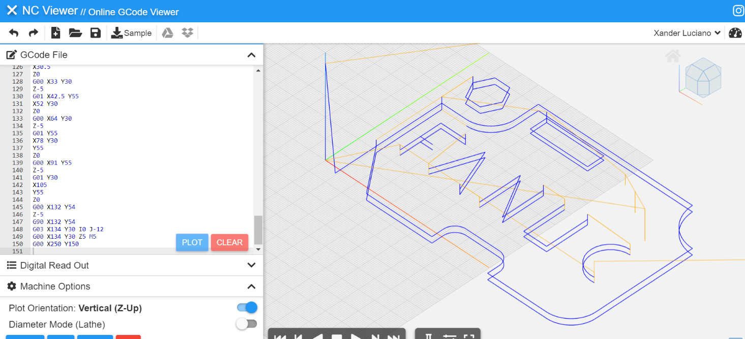

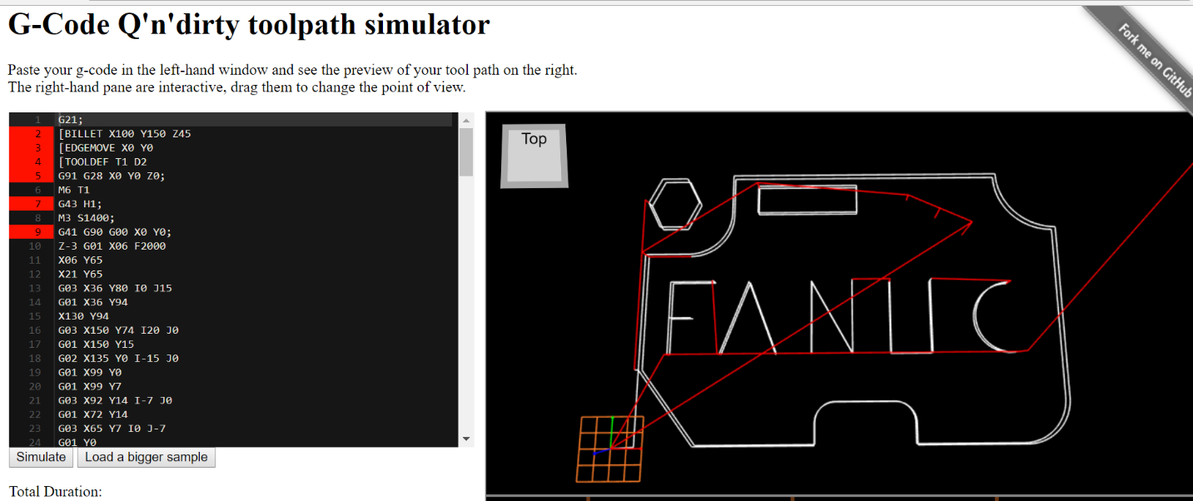
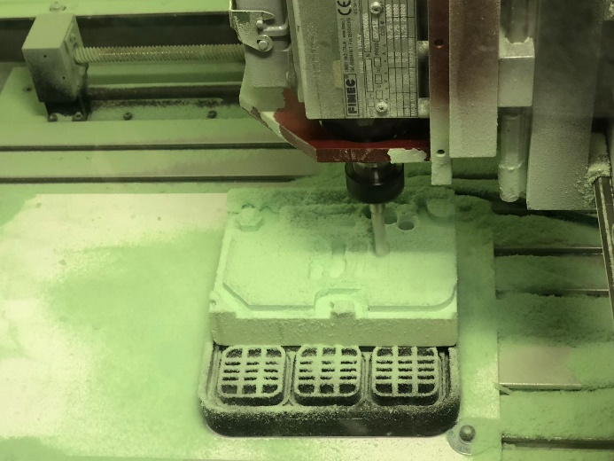
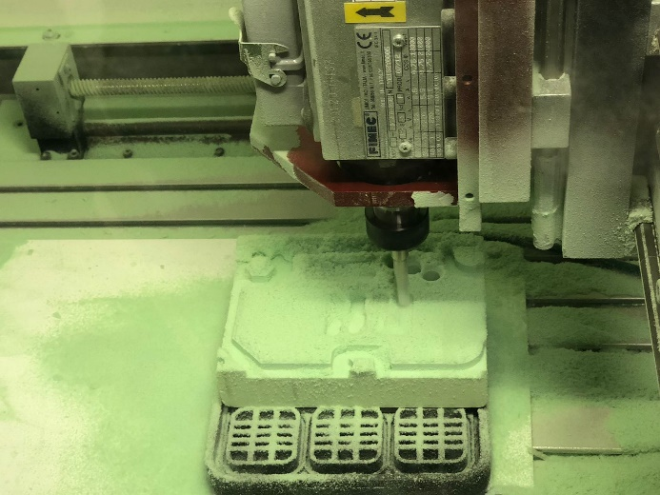
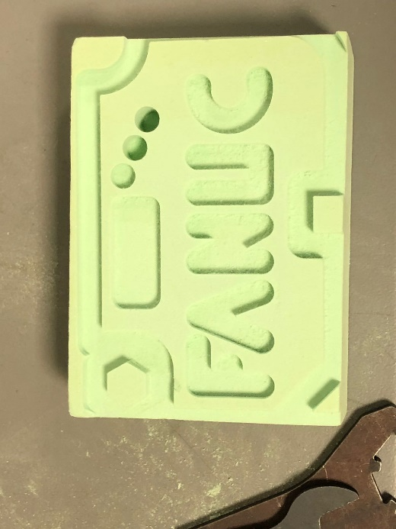
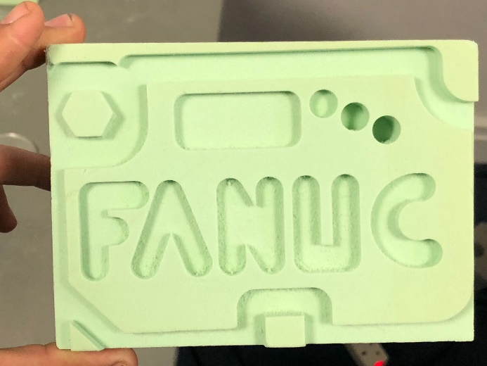
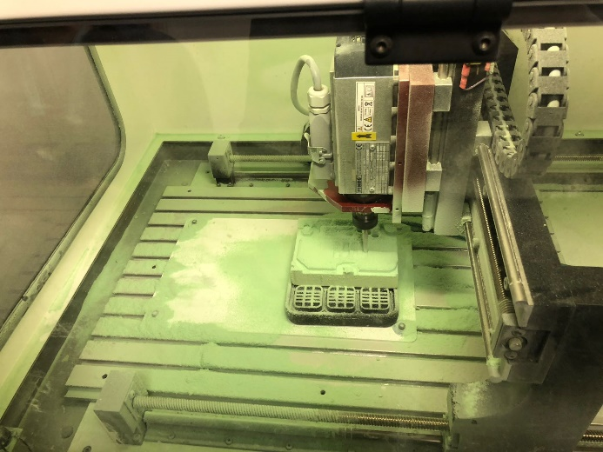
Explain why the operational plan must be well thought out,
accurate and detailed. (M1)

Planning and designing a product is very important for every component, but there are strict standards, regulations and laws that you must abide by all subject to what you are going to manufacture. As cnc machines can be dangerous, health and safety is key using these machines, you must be trained correctly to use the machine. When you prepare the process of machining as well as design it means you are well prepared for all things to come for example cost, efficiency and set backs.

The blueprints that are done by a CAD software must be well thought about, as the design must be accurate and precise in order for the component to be produced correctly. First thing first is for the drawing to be made for the component, no blueprint will result in no component. When the drawing has been completed it must be checked thoroughly for any errors, a ny small error such as measurement errors will result in the end product being wrong and therefore need a new one manufactured, these small errors can be eliminated easily by ensuring all measurements are correct. If the blueprint is incorrect and the component is produced material as well as money will be wasted

In addition to this, the device that will be holding you work piece is very important to consider when you are making the cnc program, as this will differentiate depending on the materials, thickness of the material as well as the tool size and the feed speed rpm. Also ensuring that you have the correct machine for this nib is very important to avoid any bug problems further down the line. To avoid wasting time by moving the component around, ensue that the correct work holder is chosen and also to avoid damaging the machine itself. Depending on the work piece some jobs will either need a 5-axis machine or 3-axis machine all depending on how many sides will be machined and how accurate you need your job to be.

Furthermore, one of the most important factors to creating your work piece is the tool; each job will require a different tool for various reasons. Some of the reasons may be the different type of materials, the hardness of the materials as well as the thickness of the materials. If the tool chosen is not correct, it may damage the work as well as the machine. If when creating the job piece more than one tool is required, it is key that you state which tool is used when and what step they are required for. This information will be very important for the person that is creating the program. In addition to this if the tool is incorrect and not set correctly, it could cause injury to the person using it as well as safety problems. In more advanced machine, there are sometimes tool holders, this allows the machine to hold up to 5 tools and will reduce production time.

After all the product has been made, it has to meet all the specifications needs and also requires a very clean finish otherwise it may lead to loss of profit if the customer is unhappy with the ned product and returns it, in addition to this it may also lead to the reputation of the company being damaged. A key factor is endure the correct feed speed/rate is chosen as well as the spindle speed as it may cause an injury or the damage of the product as well as the machine if chosen incorrectly. A clean and smooth finish is very important, no sharp edges or corners can be passed as well as any dent or d=ridges in the surface of the material to ensure no one is hurt

After looking at all these points, I have concluded that the planning of every part is very important to ensure the product is at its best quality. If every step and well as step backs are planned out before hand it will reduce costs as well as production times in the future. Once this plan is created yearly changes can be made to adjust, but it’s a once in a life time plan that can be altered if needed
Explain the importance of correct programming and setting
up in order to produce a component to the required
specification. (M2)

Computer Numerically Machines itself is an extremely expensive piece of hardware, regardless of whether it utilized for your very own use or whether it is for a workplace environment, when first buying the machine it is extremely costly. Workplaces cases it will pay itself off about producing products, but on the other hand, it is not as easy to pay off. In the event that the machines are very much taken care of and are kept up with administrations and general cleaning the machines will last numerous years with simply the code being updated regularly. Knowing how to operate the machine effectively without damaging the machine is an essential, and in addition utilizing the right code.

Making sure that the code is correct is an important applied aspect in order to reduce the risk of the tools and machinery from being ruined, these are both quite costly. for example, the code you have inputted is wrong and informs the machine to cut a 20mm/s in the direction of Z, but the tool you have placed within the machine will only be able to handle a 10mm/s meaning the tool is loaded with too much pressure and this will cause the clamps inside the chuck to crack or split completely, whereas if the chuck itself has more strength than the tool, the chuck will heat up and will then start to deform. In addition, if the code is incorrect with a major error it could possibly cause a major mishap and resulting in major injuries. Therefore, a qualified professional should be the only one allowed to access the machine as health and safety is a key point, which must be taken into consideration at all, times. The machine should be maintained well and any broken or missing parts should be fixed or replaced immediately otherwise it should be stated clearly that the machine should not be used whatsoever.

Adding upon this, the programme should also be exact as the component piece itself could be deteriorated, as the feed speed is too much if the work piece is stuck to, the tool and flies off could result in major injury. In some cases if the component broken then the material will become wasted and production time will therefore increase massively meaning a loss in profit. This has many knock on affects such as paying employees, employees working overtime. Extra material costs and material waste. Such as if the job is made from a expensive material such as tungsten or titanium, it could have a negative effect on the company putting them in huge loss. If there is a small error within the coding, the examination of the product is not carried out correctly and it is sent off to the customer, and the customer spots the errors sending the job back, this will lead to a deterioration in the company’s ratings and a further loss in profit.

After carefully considering the above mentioned, I have concluded that whether there is a minor or large error with the coding, either way the effect would be large in various ways on many parts of the company. I have also concluded that this can result in a huge expensive loss, and in some improbable occasion can cause the harm of an employee or even death if the machine is not used in correct manner or if the safety measures are not followed accordingly. Analysing the information, the precise coding is essential in order to reduce the risk of any damages, loss of time or loss of profit. Needing to re-programme can be very time consuming and waste a lot of precious time of production causing further and more delays ahead. In addition will also reduce any hazards of wrecked jobs because of lack of production or poor production, the waste of materials because of any tiny errors such as dimensions being incorrect.

Bibliography

g-code simulator. 2018. g-code simulator. [ONLINE] Available at: https://nraynaud.github.io/webgcode/.

NC Viewer. 2018. NC Viewer // Online GCode Viewer and Machine Simulator. [ONLINE] Available at: https://ncviewer.com/.

CNC Tutor. 2018. Six Steps For Successful CNC Machining - CNC Tutor. [ONLINE] Available at: http://cnctutor.weebly.com/six-steps-for-successful-cnc-machining.html.

