Fanandra Martin
History 1300
Ms. Ball

The Battle of Gettysburg

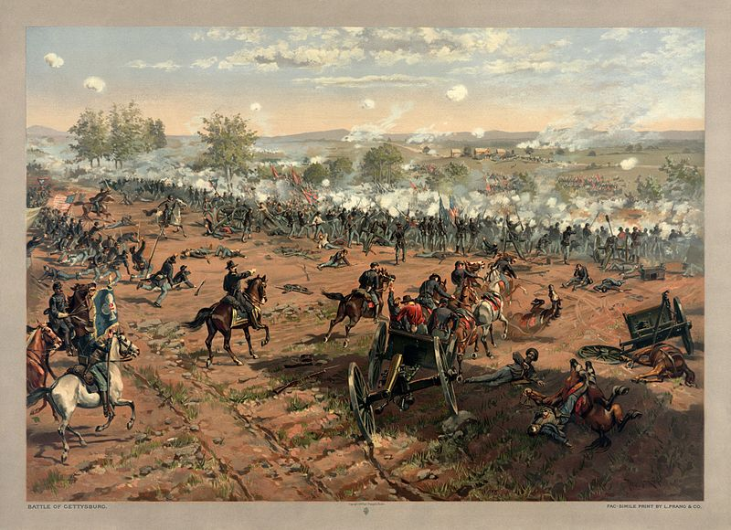

The American civil war came with multiple battles, years of long controversy, and the bloodiest conflict. The Battle of Gettysburg, is one battle many will not be forgotten. It was the largest battle, two armies face off in an American farm town, and a three-day battle that changed America.
The battle was not something the two American armies wanted. Robert E Lee, a part of the confederal army invaded the north because of the roads, where the confederal army was headed. It was not an intentional war, it was a war the was an accident by a miner incident, burst into one of the deadliest battles. Days of battling something some of us still battle till this day. (YouTube)
On July 1st, 1863 just outside of Gettysburg a battle of war begun. During the first few hours of the first battle many was dead and wounded for their country. The fight is over in 20 minutes there is 60 hundred rebels dead, the other union loses half of there men, but that battle did not solve anything, and the battle was not over yet. Robert E lee leads 75 thousand strong men that shifts the fighting out of the south and into the north. Threating major cities but runs into a problem that started it all at Gettysburg.
(YouTube)
General Robert E lee a part of the confederal war most people thought they should not mess with. When he crosses those baths getting up a Gettysburg, “one word that would sum up Robert E Lee feelings in marching to Gettysburg was confident, he thought maybe if they win in the north maybe the war would be over.” Captain Steven Knott. Robert has had many victory in battle across the south, therefore, he was not there to win another battle, he was there to win the war. (YouTube)

As many may know, one of the many causes of the civil war was slavery. This created a division between the north and the south that eventually caused the war. Most of the slaves was always in hiding. There were many safe houses just north from Gettysburg, an underground railroad that slaves use to escape. (Frank Reevespittsburgh)
They had people who provide protection for slavery such as New York and Philadelphia. But it was hard for the salves to make it threw to freedom and make it to places where they had protection. There was a network of people called “slave catchers” for slaves who was trying to escape and for people of color who was not salves to become a slave. “African American always faced the threat of kidnapping and re- enslavement.” James DeWolff Perry
Life for African Americans was never easy back then. It’s a battle people still fight amongst themselves. Slaves was the largest asset in American history. Most of the history in all kinds was revolved around slavery. There was always a saying of “Never let history repeat its self again”, and it took a while for slavery to end during the civil war.
Racism caused lots of conflict throughout the world. Hatred traveled through people’s blood because of the color of others skin. Black was always at the bottom. From one of my favorite movies Remember the tiatis there was one powerful line coach said “This is where they fought the Battle of Gettysburg. Fifty thousand men died right here on this field, fighting the same fight that we are still fighting amongst ourselves today. This green field right here was painted red, bubbling with the blood of young boys, smoke and hot lead pouring right through their bodies. Listen to their souls. If we don't come together, right now, on this hallowed ground, we too will be destroyed” Coach Boone
On day two of the Gettysburg battle, the rebels were surprising attack on the union troops. The goal of the rebels is to break the fish hook from the other troops and win the battle of Gettysburg on the Cemetery ridge. As general William takes him and his troops to the battle field, on their way, something interfered where they had to turn around and take a different route. Which cause the troops a delay of two hours, but if they had arrived two hours earlier the battle may have been different. (history net)
The Calvary is missing, with the Calvary to guide the troops where each other is headed, but they union did not know when the troops coming, the union was unbale to keep tract of the rebels movement because the cavalry. Once the troops finally made it they were ready for war. Fierce fighting was also being taken place on little round top. Thousands of troops were wounded and died on the field, but the battle did not end yet. This sets the stage of day three. (history net)
This three-day battle continues, and the last day sets up the civil war history. Pickets charge is the most famous attack in the civil war history. Lees defended army moves south, and never again the confederates will threat the north. The moment of truth for both army are settle out on day three at Gettysburg. More then half of the men who started Pickett’s charge is dead, wounded, captured, or missing. This one the bloodiest battle in America. This battle states out in a pivotal event. (YouTube)
Abraham Lincoln Gettysburg address was presented November 19, 1863. The speech was short but powerful working has made it one of the public address in history. Lincoln gave his most famous speech at the memorial, the Gettysburg Address “fourscore and seven years ago, our father brought forth upon this continent a new nation, conceived in liberty, and dedicated to the proposition that all men are created equal. God, shall have new birth of freedom, the government of the people, by the people, for the people, shall not perish from the earth.” (Abraham Lincoln). The Battle of Gettysburg, three long days that changed America, but a battle that has now ended.

Word cites
Secondary
https://www.youtube.com/watch?v=_{UJjwb4eyAy=o}
http://www.tracingcenter.org/blog/2013/07/what-to-the-slave-was-the-battle-of-gettysburg/
http://www.post-gazette.com/ne=ws=/state/2013/06/30/Confederates-slave-hunt-in-North-a-military-disgrace/stories/201306300221
http://www.monologuedb.com/dramatic-male-monologues/remember-the-titans-coach-herman-boone/
http://www.historynet.com/battle-of-g=ettysburg

Primary
http://www.historystudycenter.com.lscsproxy2.lonestar.edu/search/displayMultiResultHistoricalDocItem.do?Multi=yes&ResultsID=1611A0F2F27&fromPage=search&ItemNumber=2&QueryName=historicalDoc

