DESIGN ANALYSIS OF SOLAR ASSISTED HYBRID COOLING SYSTEM WITH ROTATING BED SILICA GEL ADSORPTION FOR FOOD PROCESSING.
Niraj Vijoy
Energy Technology, Department of Mechanical Engineering
Birla Institute of Technology, Mesra, Ranchi
Email- nvijoy@gmail.com
Abstract
Solar energy is the world’s most abundant, permanent, and clean source of energy. Conversion to clean energy sources, such as solar energy, will improve the quality of life on earth. Solar radiation is a clean form of energy, which is required for almost all natural processes on earth. Solar-powered air-conditioning has many advantages when compared to a conventional electrical system. Refrigeration plays an important role in our world, primarily for the preservation of food, healthcare materials (storage of vaccines, blood and medicine), and human thermal comfort (air conditioning and temperature regulation).Cooling in industrial countries depends heavily on grid electricity which is supplied continuously and reliably to every part of the country. This paper presents a solar cooling system that has been designed for India and similar tropical regions using evacuated tube solar collectors and silica gel absorption unit. The modeling and simulation of the absorption solar cooling system is carried out with TRNSYS program. The solar powered adsorption system proposed is a hybrid system capable of heating and cooling to achieve higher efficiency and better usefulness in practice. The system is to operate on silica gel adsorption pair. The system consisting of the following components: solar collector, water tank, adsorbers, hot water storage tank, condenser, desiccant, an evaporator and valves for control of flow can be grouped into two subsystems - the solar collector subsystem (heating) and the refrigeration subsystem.

Introduction
In coming years, global warming and energy scarcity have become more and more serious cop-out of economic development all over the world. Adsorption cooling technology Sourced by solar energy or waste heat have stressed increasing attention, as such systems need neither CFCs nor HCFCs as the working fluid and neither fossil fuel nor electricity to drive them.
Water adsorption chiller based on silica gel can be used in combination with solar energy because of the possibility of using the low-grade solar energy under 80° C, which can be easily obtained with evacuated type flat-plate collectors. Even supposing that adsorption chillers are thought to be very favorable in the future for the application of solar cooling and waste heat recovery, the wide spread of this technology is not yet possible. The reason is mostly attributed to the less COP value (COP, coefficient of performance, defined as the ratio of the output cooling power and the input heating power) and higher product cost of adsorption chillers.
Energy is an integral part of society. In earlier days fire was only the source of producing energy. But nowadays several sources of energy are derived. The industrial revolution led to the massive use of coal as fuel and various other oil also became extremely important. Electrical power became widespread at the end of the 19th century. Several other sources of energy which are also used by todays manufacturers like hydropower, geothermal, nuclear and solar are more relevant topic in todays industrialised revolution for developing countries like In India.

Cycle Description
The adsorption cooling unit prepared in this paper consists of seven major components:
- One rotating bed adsorbers(silica gel bed),
- Solar collector,
- Cooling well,
- Indirect evaporator,
- Two check valves,
- Pump,
- Rotor,
- Blower,
- Panel.
As shown in Fig. 1.
The adsorbent is packed in the rotating bed heat exchangers, which undergo alternate humidification and dehumidification to allow air to adsorption and desorption, as illustrated in Fig. 1. For description of the cycle, it is assumed that the half cycle of adsorber is initially to be cold at T = T_{c}, while the other half cycle of adsorber is to be at T_{h}. In the beginning, hot water at T_{h} is passed through heat exchanger which will convert ambient air into hot air and goes through moisture content half adsorber bed.
At same time outside air is passed through lower silica bed adsorber, which will extract the moisture content of outside air and make it dry air at T_{dry} .Therefore, the regeneration process begins at 1st half of adsorber bed and adsorption process begins at 2nd half of adsorber bed. In the beginning, all the valves are closed, the dry air then pass through indirect evaporative cooler where dry air passes through small diameter copper tubes like heat exchanger which is coupled with evaporative pads, cool water were sprinkled over evaporative pads to extract heat from air. Cool water were recycled and condensed with the help of cooling well. After completing the first half cycle, that is, when the 1st half adsorber bed is heated and 2nd half adsorber bed is cooled, at the same time of cooling and heating of adsorber, the silica bed is also rotating but at very slow speed with the help of rotor. In the second half cycle, the regeneration process begins at 2nd half of adsorberbed, and adsorption process begins at 1st half of adsorber bed. In this way, adsorption and desorption processes begin at 1st half adsorbers bed and 2nd half, respectively.

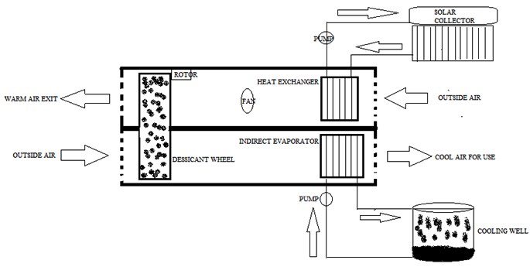
Fig. 1. Schematic diagram of the system for cooling.
Psychometric Processes
In the domestic and industrial air conditioning applications some psychrometric processes have to be performed on the air to change the psychrometric properties of air so as to obtain certain values of temperature and humidity of air within the enclosed space. Some of the common psychrometric processes carried out on air are: sensible heating and cooling of air, humidification and dehumidification of air, mixing of various streams of air, or there may be combinations of the various processes.

Sensible Cooling of the Air

Cooling of the air is one of the most common psychrometric processes in the air conditioning systems. The basic function of the air-conditioners is to cool the air absorbed from the room or the atmosphere, which is at higher temperatures. The sensible cooling of air is the process in which only the sensible heat of the air is removed so as to reduce its temperature, and there is no change in the moisture content (kg/kg of dry air) of the air. During sensible cooling process the dry bulb (DB) temperature and wet bulb (WB) temperature of the air reduces, while the latent heat of the air and the dew point (DP) temperature of the air remains constant. There is overall reduction in the enthalpy of the air.
In the ordinary window or the split air conditioner the cooling of air is carried out by passing it over the evaporator coil, also called as the cooling coil. The room air or the atmospheric air passes over this coil carrying the refrigerant at extremely low temperatures, and gets cooled and passes to the space which is to be maintained at the comfort conditions.
The sensible cooling process is represented by a straight horizontal line on the psychrometric chart. The line starts from the initial DB temperature of the air and ends at the final DB temperature of the air extending towards the left side from high temperature to the low temperature (see the figure below). The sensible cooling line is also the constant DP temperature line since the moisture content of the air remains constant. The initial and final points on the psychrometric chart give all the properties of the air.
Constant = W
Constant = $m_{1}{=m}_{2}$ = m
$m_{1}=m_{2}$ …(1)
$G_{1}W_{1}=G_{2}W_{2}$ … (2)
$G_{1}h_{1}{ +Q}_{1-2}{=G}_{2}h_{2}$ …(3)
$Q_{1-2}=G\left(h_{2}{-h}_{1}\right)$ …(4)
$Q_{1-2}=G\left[\left(h_{a2}{+W}_{2}h_{w2}\right)-\left(h_{\begin{aligned}a1 \\ \end{aligned}}+w_{1}h_{w1}\right)\right]$…(5)

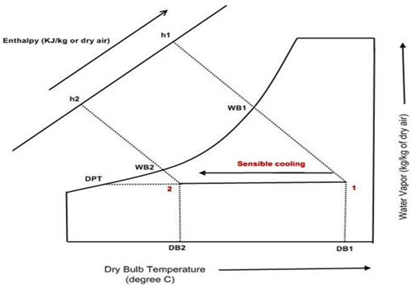
Fig. 2. Sensible cooling.

Sensible Heating of the Air
Sensible heating process is opposite to sensible cooling process. In sensible heating process the temperature of air is increased without changing its moisture content. During this process the sensible heat, DB and WB temperature of the air increases while latent of air, and the DP point temperature of the air remains constant.
Sensible heating of the air is important when the air conditioner is used as the heat pump to heat the air. In the heat pump the air is heated by passing it over the condenser coil or the heating coil that carry the high temperature refrigerant. In some cases the heating of air is also done to suit different industrial and comfort air-conditioning applications where large air conditioning systems are used.
In general the sensible heating process is carried out by passing the air over the heating coil. This coil may be heated by passing the refrigerant, the hot water, the steam or by electric resistance heating coil. The hot water and steam are used for the industrial applications.
Like the sensible cooling, the sensible heating process is also represented by a straight horizontal line on the psychrometric chart. The line starts from the initial DB temperature of air and ends at the final temperature extending towards the right (see the figure). The sensible heating line is also the constant DP temperature line.
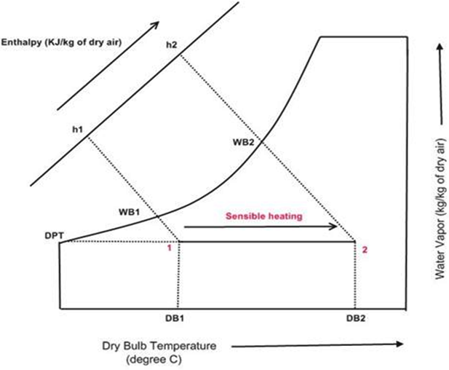
Fig. 3. Sensible heating.

Cooling and Dehumidification Process
The process in which the air is cooled sensibly and at the same time the moisture is removed from it is called as cooling and dehumidification process. Cooling and dehumidification process is obtained when the air at the given dry bulb and dew point (DP) temperature is cooled below the dew point temperature.
The cooling and dehumidification process is most widely used air conditioning application. It is used in all types of window, split, packaged and central air conditioning systems for producing the comfort conditions inside the space to be cooled. In the window and split air conditioners the evaporator coil or cooling coil is maintained at temperature lower than the dew point temperature of the room air or the atmospheric air by the cool refrigerant passing through it. When the room air passes over this coil its DB temperature reduces and at the same time moisture is also removed since the air is cooled below its DP temperature. The dew formed on the cooling coil is removed out by small tubing. In the central air conditioning systems the cooling coil is cooled by the refrigerant or the chilled water. When the room air passes over this coil, it gets cooled and dehumidified.
In the general the cooling and dehumidification process is obtained by passing the air over coil through which the cool refrigerant, chilled water or cooled gas is passed.
During the cooling and dehumidification process the dry bulb, wet bulb and the dew point temperature of air reduces. Similarly, the sensible heat and the latent heat of the air also reduce leading to overall reduction in the enthalpy of the air. The cooling and dehumidification process is represented by a straight angular line on the psychrometric chart. The line starts from the given value of the DB temperature and extends downwards towards left.

G₁ = G₂ = G

$m_{1}=m_{2}+L$ …(6)
L = G ($W_{1}W_{2}$)
The Energy equation gives:
$G_{1}h_{1}$ =$G_{2}h_{2}$+ $Q_{1-2}$ + L.$h_{f2}$ …(7)
Where $h_{f2}$ is the specific enthalpy of water at temperature $t_{2}$.
$Q_{1-2}$ = G ($h_{1}-h_{2}$) – ($W_{1}-W_{2}$) $h_{f2}$ …(8)
If (W₁ – W₂) h_{f2} is small the amount of heat removed
$Q_{1-2}$ = G ($h_{1}-h_{2}$) …(9)

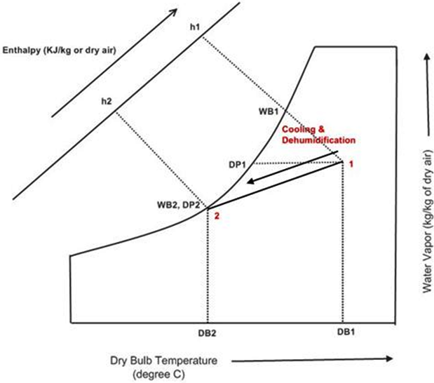

Fig. 4. Cooling and dehumidification.
Heating and Humidification Process
In heating and humidification psychrometric process of the air, the dry bulb temperature as well as the humidity of the air increases. The heating and humidification process is carried out by passing the air over spray of water, which is maintained at temperature higher than the dry bulb temperature of air or by mixing air and the steam.
When the ordinary air is passed over the spray of water maintained at temperature higher than the dry bulb temperature of the air, the moisture particles from the spray tend to get evaporated and get absorbed in the air due to which the moisture content of the air increase. At the same time, since the temperature of the moisture is greater than the dry bulb temperature of the air, there is overall increase in its temperature.
During heating and humidification process the dry bulb, wet bulb, and dew point temperature of the air increases along with its relative humidity. The heating and humidification process is represented on the psychrometric chart by an angular line that starts from the given value of the dry bulb temperature and extends upwards towards right.
$G_{1= }G_{2=}$G
$m1+L=m_{2}$ …(10)
L = $m_{2- }m_{ 1 }= G {(W}_{2}W_{1})$ …(11)
$G_{1}h_{1}=L.h_{f }+ Q_{1-2 }=G_{2}h_{2}$ …(12)
$Q_{1-2}= G \left(h_{2}{-h}_{1}\right)-G {(W}_{2}W_{1}) h_{f}$
= G $\left[\left(h_{2}{-h}_{1}\right)-\left(W_{2}-W_{1}\right)h_{f}\right]$ …(13)

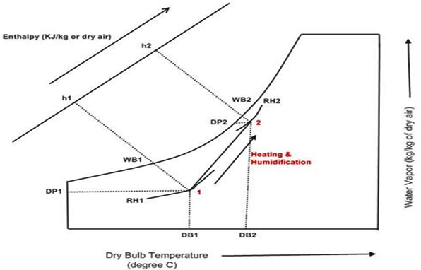

Fig. 5. Heating and humidification.
Conclusion
In this paper, a honeycomb silica gel bed–water adsorption chiller with indirect evaporation was newly developed. A solar powered compound system for drying and cooling was designed and constructed in BIT Mesra to conduct the field test. Based on the experimental results in the laboratory when this adsorption chiller were conducted in the laboratory. Under the standard test conditions of 80 C hot water, 30 C cooling water, and 14 C chilled water inlet temperatures, a cooling power of 9 kW and a COP of 0.37 can be achieved.

Nomenclature
W₁ = Humidity ratio at inlet
W₂ = Humidity ratio at outlet
m₁ = mass of water vapour at inlet
m₂ = mass of water vapour at inlet
G₁ = mass of dry air at inlet
G₂ = mass of dry air at outlet
h₁ = Specific enthalpy at inlet
h₂ = Specific enthalpy at outlet
h_{a1} = Specific enthalpy of dry air at inlet
h_{a2} = Specific enthalpy of dry air at outlet
h_{w1} =Specific enthalpy of water vapour in air at inlet
h_{w2} = Specific enthalpy of water vapour in air at outlet
Q = Total heat transfer
h_{f2} =ℎ_{𝑓2} is the specific enthalpy of water at temperature 𝑡₂
L = amount of moisture removed

References
- Alam, K.A., Saha, B.B., Kang, Y.T., Akisawa, A. and Kashiwagi, T., (2000). Heat exchanger design effect on the system performance of silica gel adsorption refrigeration systems. International journal of heat and mass transfer, pp.4419-4431.
- Christy, A.A., (2012). Effect of heat on the adsorption properties of silica gel. International Journal of Engineering and Technology, p.484.
- Saha, B.B., Chakraborty, A., Koyama, S. and Aristov, Y.I., (2009). A new generation cooling device employing CaCl 2-in-silica gel–water system. International Journal of Heat and Mass Transfer, pp.516-524.
- Assilzadeh, F., Kalogirou, S.A., Ali, Y. and Sopian, K., (2005). Simulation and optimization of a LiBr solar absorption cooling system with evacuated tube collectors. Renewable Energy, pp.1143-1159.
- Jakob, U. and Mittelbach, W., (2008), September. Development and investigation of a compact silica gel/water adsorption chiller integrated in solar cooling systems. In VII Minsk international seminar “Heat pipes, heat pumps, refrigerators, power sources”, Minsk, Belarus, pp. 8-11.
- Chang, W.S., Wang, C.C. and Shieh, C.C., (2009). Design and performance of a solar-powered heating and cooling system using silica gel/water adsorption chiller. Applied Thermal Engineering, pp.2100-2105.
- Tso, C.Y. and Chao, C.Y., (2012). Activated carbon, silica-gel and calcium chloride composite adsorbents for energy efficient solar adsorption cooling and dehumidification systems. International Journal of Refrigeration, pp.1626-1638.
- Suleiman, R.B.O., Suleiman, R., Folayan, C., Anafi, F. and Kulla, D., 2012. Transient Simulation of a Flat Plate Solar Powered Adsorption Refrigeration System. International Journal of Renewable Energy Research (IJRER), pp.657-664.
- Saha, B.B., Akisawa, A. and Kashiwagi, T., (2001). Solar/waste heat driven two-stage adsorption chiller: the prototype. Renewable Energy, pp.93-101.

