In the earlier lessons you read about Spain, Portugal, and England expanding colonies into the new world. When a country expands in this way, gaining economic, political, or military control over another country it is called imperialism. That is a concept that was popular for many years and in so me areas it is still going on.
When the United States could go no further within its boundaries, it began to seek other avenues for extending economic and political power outside of the continental United States.
Why is this Important To Us Now?
- It is important to be aware of how the United States acquired Alaska, Hawaii, and other territories.
- It is helpful to know what situations draw the United States into wars.
- United States trade with other countries continues.
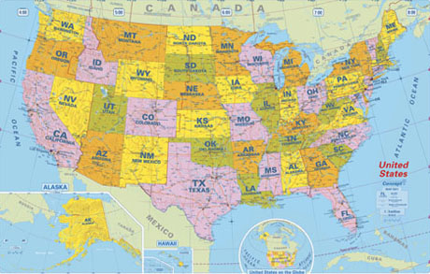

Lesson Objectives
When you have finished with this lesson, you will be able to:
- Identify what led the United States to become imperialistic.
- Analyze the results of the Spanish American War.
- Analyze American involvement in Latin America.

Lesson Assignments
As you work through this lesson, you will complete the following graded assignments:
- Discussion Assignment
- Project: Spanish American War Cause and Effect Chart
- Writing: Expansion and Imperialism
- Lesson Quiz

The Alaska Purchase
Russia was in a difficult financial position in 1867 and feared losing the Alaskan territory, especially to their rivals the British. When the Emperor Alexander II decided to sell the territory to the United States, the Russian minister negotiated with the US Secretary of State, William Seward. The United States purchased the land for a little less than two cents an acre with the total purchase price of $7,200,000. This was referred as the "Seward's Folly." Many newspaper articles of the time reported the purchase to be wasteful and unnecessary.
Those who were in favor of the purchase pointed out that Alaska was rich in natural resources like forests, fisheries, furs, and mines. They also pointed out that with the purchase of Alaska, Canada was now surrounded by the United States and of less value to the British.

Hawaii
The Hawaiian Islands have always been appealing because of their great beauty and the wealth of their natural resources. American involvement started with missionaries who established themselves on the islands in the early 1800s.
Some of the missionaries’ descendants stayed and became sugar planters. When the political and economic situation became difficult for the missionaries in 1893, they overthrew the leader, Queen Liliuokalani, and set up their own government. They then requested that the islands be annexed by the U. S.
The United States was interested in the possibility of annexing Hawaii. It was an excellent place for U.S. ships to refuel if they were traveling further east to Asia. They were able to win an agreement from the Hawaiian government to establish a naval port at Pearl Harbor in 1887.
President Harrison was in favor of annexing the islands and sent a treaty to Congress. Congress never had a chance to act however, because President Cleveland, who followed Harrison, took the treaty out of circulation. It took twenty years before Hawaii was annexed to the U. S., and it was not until 1959 that Hawaii became a state.
Reasons for United States Expansion
There were a few reasons the United States wanted to expand. These were based on political, social, economic, and religious beliefs.
In addition, it made a lot of financial sense for the United States to take expand into other islands and small countries. In doing so, America increased the natural resource availability, and added new markets for selling products. In addition, it made sense to expand the United States military presence around the world.
For a country of growing influence and power, it also seemed expedient to maintain a military force beyond the U.S. shores. That gave the advantage of being closer to a target if the U.S. should be drawn into a war overseas. In many instances, the United States presence helped the economies and educational levels of the people whose territories were taken over.
What Draws a Country into War?
You have examined the causes of the Revolutionary War, the Civil War, and the Mexican American War. The reasons behind each conflict differed. Now, you will explore the Spanish American War and its causes.
In the 1890s, Spain’s holdings in the Americans had dwindled to Cuba and Puerto Rico, and a few little islands like the Philippines. Cuba was not happy with Spanish rule and had staged a few uprisings.

There were a few reasons for the U.S. to become involved in the conflict between Cuba and Spain: the Cubans were struggling for independence from the Spanish rulers, and the U.S. stepped in to help. Battles taking place in Cuba with the Spanish affected U.S. trade. And, America was ready to expand, pursuing the ideal of American Imperialism. U.S. President William McKinley did not embrace the war. He had been through the Civil War and did not want to fight another one.
When riots broke out in Havana, a large city in Cuba, the U.S sent in the USS Maine to protect American citizens who were living or visiting there. The USS Maine blew up, killing 260 people aboard. Although it later proved to be an accident, it was at first thought that the Spanish had blown up the ship. Based on this incorrect assumption, America went to war.

The Spanish American War
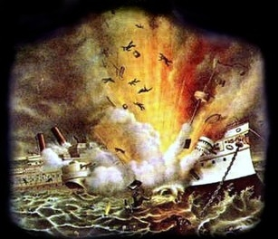
President McKinley asked Congress to demand that Spain pull out of Cuba, allowing Cuba to declare its independence. Spain did not comply, and thus began the Spanish American War.Commodore George Dewey
The Spanish American War began in the Philippines. This first battle was the Battle of Manila Bay where Commodore George Dewey defeated the Spanish in a matter of hours. There was only one death and that was due to a heart attack.

The Rough Riders
On July 1, 1898 a combined force of about 15,000 American troops in regular infantry, cavalry and volunteer regiments, including Theodore Roosevelt and his “Rough Riders” attacked 1,270 Spaniards in dangerous Civil War style frontal assaults of the Battle of El Caney and the Battle of San Juan Hill outside of Santiago. More than 200 U.S. soldiers were killed and close to 1,200 wounded in the fighting. When Spanish ships tried to escape San Juan harbor, America’s fleet destroyed them. That caused the city to surrender. Spanish forces in Puerto Rico were conquered one week later.
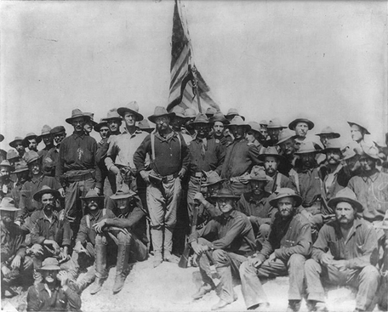

The United States is Changed by the Spanish American War
With both of its fleets incapacitated, Spain sued for peace. The Treaty of Paris was signed on December 10, 1898. The United States gained almost all of Spain’s colonies, including the Philippines, Guam, and Puerto Rico. Cuba formed its own civil governments and gained its independence on May 20, 1902. When the U.S. sent ground troops in to occupy the Philippines, warfare broke out because the Philippine people also wanted independence.
The war marked American entry into world affairs. Over the course of the next century, the United States became involved in various conflicts around the world. The war also marked the effective end of the Spanish empire; declining in power for most of the 19th century.
Many Americans were disappointed in America’s actions in the Philippines and Guam because the U. S. had proved itself to be imperialistic. A new group was formed calling itself the Anti-Imperialist League. Among its distinguished members were Jane Adams, Mark Twain, and Andrew Carnegie.
Involvement in Asia
Commodore Matthew C. Perry had actually opened the doors to trade in the east when he embarked from Norfolk, Virginia for Japan, in command of a squadron in search of a Japanese trade treaty. He had studied the culture carefully and learned all he could. He traveled aboard a black-hulled steam frigate and with several other ships he anchored at Tokyo Bay.
The Japanese had never seen steamships and thought they were looking at “giant dragons puffing smoke.” So impressed were the Japanese with the “Black Ships” that they let Commodore Perry come ashore. It took him a year of negotiations to sign the historic treaty that opened the door to trade with Japan. The Japanese learned a great deal from the westerners and began to modernize and soon became a world power as well. In 1890, Japan went to war with China and won.
Once the U.S. had a strong foothold in the Philippines, it was so close to China that it made sense to join other nations that were trading and investing in China. France, Germany, Britain, Russia, and Japan were already trading in China and had successful settlements there as well.

Involvement in Asia (continued)
The competition for trade in China prompted Secretary of State, John Jay to propose an Open Door Policy among all of the nations who traded there. It effectively stated that no one nation would hold a monopoly on trade with China.
European attitudes soon took its toll on the Chinese people who resented being treated as inferior to those who came to trade and live in their country. There was a war called the “Boxer Rebellion”. Those countries who were foreigners in China were called the warriors or soldiers. The nickname expanded to “Boxers”, because the soldiers used martial arts to fight. They called themselves the Society of Right and Harmonious Fists. The war lasted two years and 230 foreigners and diplomats were killed. A multi-nation coalition finally ended the “Boxer Rebellion”.

The Panama Canal
America’s involvement in Asia made it important to find easy trade routes between the two countries. Until the Panama Canal was built, the best route was to travel all the way around South America. There was no other way to go from the Atlantic to the Pacific oceans. Against opposition from Colombia, who did not want to give up its land to build the canal, the United States sent in a naval force to create and support a revolution. The revolution created the new country of Panama from whom we bought the land to build the canal.
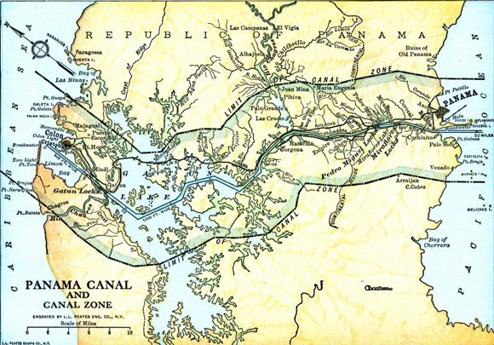
The Panama Canal is a man-made canal that joins the Pacific and Atlantic oceans. One of the largest and most difficult engineering projects ever undertaken, it had an enormous impact on shipping between the two oceans, replacing the previous long and treacherous route. Many of the men who worked on the canal died from accidents and mosquitoes that carried malaria. It is said that almost 30,000 workers died building the canal.
The passageway of the canal is at different levels of elevation. Therefore, the only way to get ships back and forth through the different elevations is through small locks which, once a ship is in place, fill or empty of water to take the ship to the next level and so on until the ship reaches its destination.
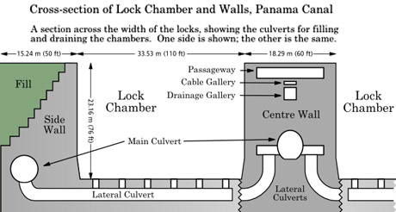

The United States’ Participation in Latin America
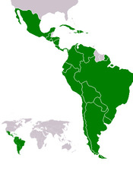
The United States and its citizens saw Latin America as a place where it could purchase raw materials cheaply and sell it for higher prices at home. U.S. citizens bought land in Latin America inexpensively and farmed it.
America kept other countries out of Latin America by relying heavily on the Monroe Doctrine, which you may remember let other countries know that if they intervened, in any way, with the United States (including its holdings) that it would be considered a hostile move, which is the same as saying it would be considered an act of war.
President Roosevelt added what was called the Roosevelt Corollary, which let other countries know that the United States intended to act as the police for Latin America and would take action in the domestic affairs of Latin American countries. This might be seen as a way of President Roosevelt showing the world that he meant what he said when he spoke his famous words, “Walk softly and carry a big stick.”

Think About It
Thinking about history in terms of cause and effect, it is easy to follow the events that occur. Looking back at the Spanish American War, it is easy to follow American involvement in Latin America, which took the U.S. to China and the East. The effect of the new relationship with China was a need to build the Panama Canal. From the beginning of the building of the Panama Canal, the U.S. has kept its fingers on the pulse of all of Latin America. The stability of the governments in those countries is important to United States economic interests.
Writing: Expansion and Imperialism
Imagine that you are a citizen of a country in which a larger country comes in to expand its social, political, and economic policies as the United States has done in Latin America.
Write a paragraph telling how this might make you feel, both the positives and the negatives. Be sure to refer to details from this lesson as you express your opinion.
When you have finished, please submit this assignment, and be sure to document your sources.

