ACTIVITY
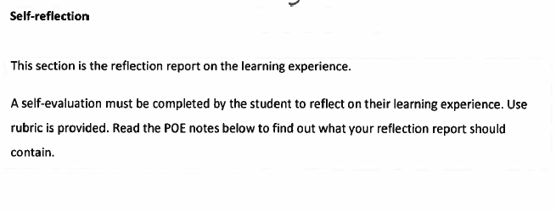
- Based on my experience really enjoyed the course
- Was hard to work and study
- Difficult to work in a team – something I should work on
- Something I would consider doing in the future
