Problem 1 (TAX RETURN)

Tim and Sarah Lawrence are married and file a joint return. Tim’s Social Security number is 123-45-6789, and Sarah’s Social Security number is 111-11-1111. They
reside at 100 Olive Lane, Covington, LA 70434. They have two dependent children,
Sean and Debra, ages 12 and 16, respectively. Sean’s Social Security number is
123-45-6788, and Debra’s Social Security number is 123-45-6787. Tim is a self-employed businessperson (sole proprietor of an unincorporated business), and Sarah is a corporate executive. Tim has the following income and expenses from his business.

Gross income $325,000
Business expenses 201,000

Records related to Sarah’s employment provide the following information.

Salary $145,000
Unreimbursed travel expenses (including $200 of meals) 1,100
Unreimbursed entertainment expenses 500

Other pertinent information for the tax year includes the following.

Proceeds from sale of stock acquired on July 15, 2017
(cost of $12,000), and sold on August 1, 2017 $ 9,800

Proceeds from sale of stock acquired on September 18, 2016
(cost of $5,000), and sold on October 5, 2017 3,800

Wages paid to full-time domestic worker for housekeeping and
child supervision 10,000

Interest income received 7,000
Total itemized deductions (not including any potential
deductions above) 27,900

Federal income tax withheld 31,850

Estimated payments of Federal income tax 34,000

Compute the net tax payable or refund due for Tim and Sarah Lawrence for 2017.

Download the necessary tax forms from the Internal Revenue website at: http://www.irs.gov/app/picklist/list/formsInstructions.html

By using an Adobe reader (free download available), you can save your work on the tax forms and be able to give them to me as PDF files. A PDF reader, which is free, is available for download at: http://get.adobe.com/reader/

For purposes of this tax return, please support all your computations with proper references. For example, if you are deducting items on Form 1040, Schedule A, line 7, for "Personal Property Taxes," please list the items you are deducting.

PROBLEM 2

Bart and Elizabeth Forrest are married and have no dependents. They have asked you to advise them whether they should file jointly or separately in 2017. They present you with the following information:

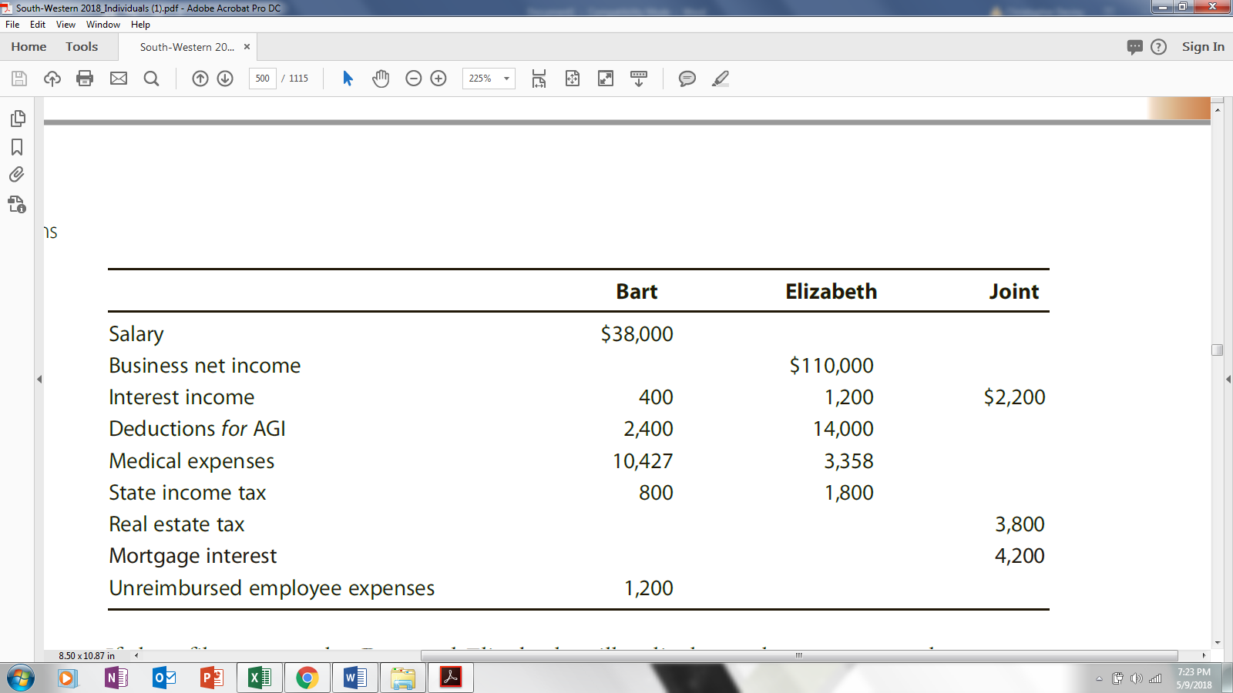

If they file separately, Bart and Elizabeth will split the real estate tax and mortgage interest deductions equally.

a. Write Bart and Elizabeth a letter in which you make and explain a recommendation on filing status for 2017. Bart and Elizabeth reside at 2003 Highland Drive, Durham, NC 27707.

b. Complete Bart’s Schedule A for 2017 (use the most current version of Schedule A available). For this purpose, assume that Bart and Elizabeth file separate returns. Bart’s Social Security number is 123-45-6789.

PROBLEM 3

Assume the same facts as in Problem 56 (below). Kirby Turner is a 20% shareholder in Thrasher Corporation. She is aware of the tax consequences of the various items listed on the Schedule K–1 (Form 1120S) she received but does not understand their effect on basis. She is considering selling her stock and wants to estimate the gain or loss that will result. In response to Kirby’s request for assistance, write a letter to her (1120 Garden Way, Elizabeth, NJ 07207), summarizing the changes to stock basis that the 2017 transactions caused.

Problem 56 facts
During 2017, Thrasher (a calendar year, accrual basis S corporation) has the following transactions:
Sales $1,500,000
Cost of goods sold 900,000
Long-term capital gain 11,000
Short-term capital gain 5,000
Salaries 210,000
Qualified dividends from stock investments 30,000
Rent expense 170,000
Advertising expense 20,000
Interest expense on business loan 15,000
§ 1231 gain 25,000
Organizational expenditures 3,000
Charitable contributions 5,000
Bad debt (trade account receivable deemed to be uncollectible) 10,000
Cash dividend distributed to shareholders 120,000

