Mini-Project Case Assignments with Student Guidelines
It is imperative to read each case carefully and identify the important information. Recognizing and eliminating unimportant information is equally valuable. All necessary information will be provided in the case narrative and from associated tables.
Case questions will dictate how to respond. Typically, a few well written short paragraphs are adequate to answer most questions. Sometimes a list of terms or individual sentences will provide the best response. Use your judgment.
Important: Students should clearly craft their answers and not merely write down a few words, as if responding to a fill-in-the-blank question. When preparing detailed responses, write complete, descriptive sentences and paragraphs that fully explain your thinking.
Always explain your answer, while applying the concepts learned from the chapter material and instruction. Never answer simply yes or no. Remember you are not giving your opinion; you are developing an informed answer to a management problem supplemented with supporting facts and examples.
Take the time necessary to provide thorough answers written at the college level. Be professional and turn in good quality work:
Required Step:
- To answer the questions:
a. Type/write the entire question, including the question number.
b. Type/write the word “Answer” below the question and then complete the answer.
c. Type/write the second question, etc.
Mini Project #1
Case A one page per case

INVESTING IN MUTUAL FUNDS
Jamie Lee and Ross did several weeks' worth of research trying to choose the right stock to invest in. After all, the $50,000 inheritance was a lot of money and they wanted to make the most informed investment choices they could. They discovered, by doing their homework, the various companies' stocks that they were looking to invest in did not seem like they were going to have the promising future that Jamie Lee and Ross were hoping for. They were aware that they were taking a chance with any investment instrument, but they were both nervous about “putting all of their eggs in one basket” and wanted to be more confident in making their investment choices. But how could they be more assured?
Page 454
They decided to speak to their professional investment advisor, who suggested that investing in mutual funds may be the way to lessen the risk by joining a pool of other investors in a variety, or bundle, of securities chosen by the mutual fund manager. This way, Jamie Lee and Ross could lessen the pressure of choosing the right company, and minimize the chances of losing all of their investment money by diversifying their portfolio.
A mutual fund sounded like the sensible investment choice for them, but which mutual fund would best match their investment strategy? Jamie Lee and Ross are in their mid-40s and well on their way to reaching their long-term investment goals, as they committed to reaching their objectives early in their marriage. They set their sights on having the triplets graduate from college debt-free and saving enough to purchase a beach house when they retire. They are looking for a mutual fund that will provide investment income while maintaining the moderate risk investment path that they are on, as they have some time to go before retirement.
Current Financial Situation
- Assets (Jamie Lee and Ross combined):
- Checking account, $$7,500
- Savings account, $83,000 (including the $50,000 inheritance)
- Emergency fund savings account, $$45,000
- House, $$410,000
- IRA balance, $$78,000
- Life insurance cash value, $$110,000
- Investments (stocks, bonds), $$230,000
- Cars, $18,500 (Jamie Lee) and $24,000 (Ross)
- Liabilities (Jamie Lee and Ross combined):
- Mortgage balance, $73,000
- Student loan balance, $0
- Credit card balance, $0
- Car loans, $0
- Income:
- Jamie Lee, $45,000 gross income ($31,500 net income after taxes)
- Ross, $135,000 gross income ($97,200 net income after taxes)
- Monthly Expenses
- Mortgage, $1,225
- Property taxes, $500
- Homeowner's insurance, $300
- IRA contribution, $300
- Utilities, $250
- Food, $600
- Gas/Maintenance, $275
- Entertainment, $300
- Life insurance, $375
Questions
1. | It has been suggested by Jamie Lee and Ross's professional investment counselor that they perform a financial checkup as the first step in investing in mutual funds, even though they are investing $50,000 that was inherited from Ross's late uncle's estate. Is it a good time to invest the inheritance, or should Jamie Lee and Ross balance their budget first?
2. | Jamie Lee and Ross have been reading quite a lot about stock funds while researching the classifications of mutual funds. At Jamie Lee and Ross's stage in life, what different types of stock funds would be recommended for them to invest their $50,000 inheritance in? Why?
3. | The investment advisor recommended looking into managed funds, which could help remove from Jamie Lee and Ross the burden of decision making about when to buy and sell. But Ross was considering index funds, which have a lower management expense. Using your text as a guide, compare managed funds and index funds.  Managed Funds Index Funds

Which fund would you recommend for Ross and Jamie Lee? Why?
4. | Jamie Lee and Ross are ready to evaluate a mutual fund more closely. Choose a mutual fund that has been mentioned in your Chapter 13 text or one that has been recommended by a friend or family member, and complete “Your Personal Financial Plan” sheet 41. Would you recommend this mutual fund for Jamie Lee and Ross? Why or why not?  Appendix D  D  Daily Spending Diary  Effective short-term money management and long-term financial security are dependent on spending less than you earn. The use of a Daily Spending Diary will provide information to better understand your spending patterns and to help you achieve desired financial goals.  The following sheets should be used to record every cent of your spending each day in the categories provided. You can indicate the use of a credit card with (CR). Or you can create your own format to monitor your spending. Various apps (see below) are also available for this purpose.  This experience will help you better understand your spending habits and identify desired changes you might want to make in your spending activities. Your comments should reflect what you have learned about your spending and can assist with changes you might want to make. Ask yourself, “What spending amounts can I reduce or eliminate?”  Many people who take on this task find it difficult at first, and may consider it a waste of time. However, nearly everyone who makes a serious effort to keep a Daily Spending Diary has found it beneficial. The process may seem tedious at first, but after a while recording this information becomes easier and faster. Most important, you will know where your money is going. Then you will be able to better decide if that is truly how you want to spend your available financial resources. A sincere effort with this activity will result in very beneficial information for monitoring and controlling your spending. At the end of each chapter, questions are provided to guide your daily spending related to the topic covered in the chapter.  Using a Daily Spending Diary can help to:  - Reveal hidden aspects of your spending habits so you can better save for the future.  - Create and achieve financial goals.  - Revise buying habits and reduce wasted spending.  - Control credit card purchases.  - Improve recordkeeping for measuring your financial progress and filing your taxes.  - Plan for major expenditures encountered during the year.  - Start an investment program with the money you save through controlled spending.  The following Daily Spending Diary sheets are also available in an Excel format in Connect Finance.  Various apps are available for you to monitor your daily spending; these include:  - Spending Tracker  - Track Every Coin  - Mint  - Level Money  - Spendee  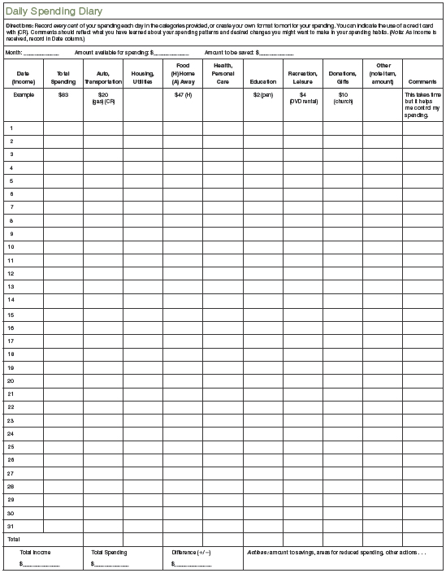  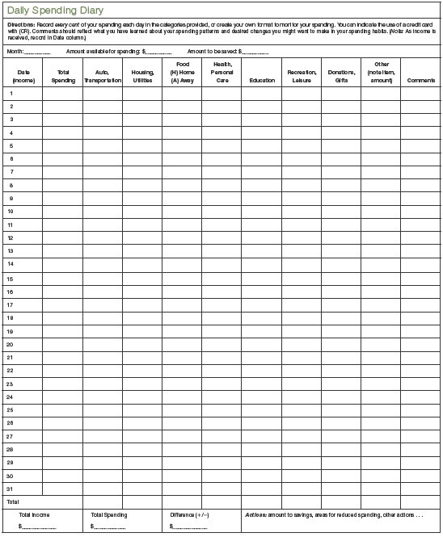  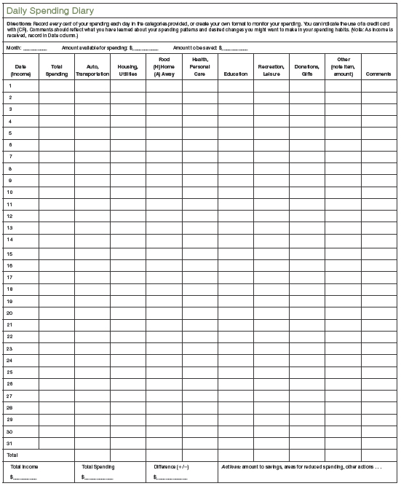  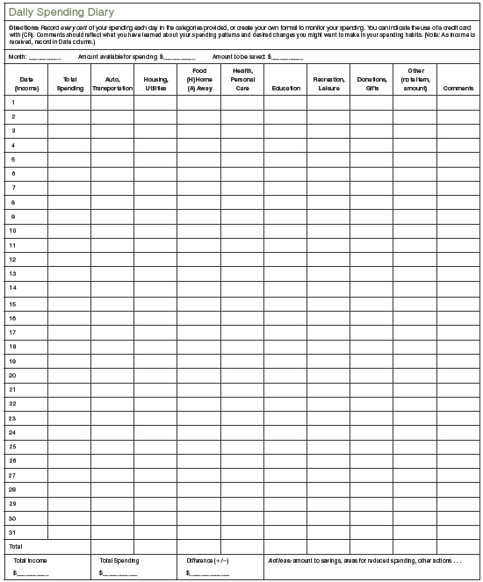

Case B ---- > one page per case
STARTING EARLY: RETIREMENT AND ESTATE PLANNING
Jamie Lee and Ross, now in their 50s, have plenty of time on their hands now that the triplets are away at college. They both realize that time has flown by; more than 24 years have passed since they married!
Looking back over the years, they realize that they have worked hard in their careers, Jamie Lee as the proprietor of a cupcake café and Ross, self-employed as a web page designer. They enjoyed raising their family and strived to be financially sound as they looked forward to a retirement that is just around the corner. They saved regularly and invested wisely over the years. They rebounded nicely from the recent economic crisis over the past few years, as they watched their investments closely and adjusted their strategies when they felt it necessary. They purchase vehicles with cash and do not carry credit card balances, choosing to use them for convenience only. The triplets are pursuing their master's degrees and have tuition covered through work-study programs at the university.
Jamie Lee and Ross are just a few short years from realizing their goals of retiring at 65 and purchasing the home at the beach!

Current Financial Situation
Assets (Jamie Lee and Ross combined):
- Checking account, $5,500
- Savings account, $53,000
- Emergency fund savings account, $45,000
- House, $475,000
- IRA balance, $92,000
- Life insurance cash value, $125,000
- Investments (stocks, bonds), $750,000
- Cars, $12,500 (Jamie Lee) and $16,000 (Ross)
Liabilities (Jamie Lee and Ross combined):
- Mortgage balance, $43,000
- Credit card balance, $0
- Car loans, $0
Income:
- Jamie Lee, $45,000 gross income ($31,500 net income after taxes)
- Ross, $135,000 gross income ($97,200 net income after taxes)
Monthly Expenses
- Mortgage, $1,225
- Property taxes, $500
- Homeowner's insurance, $300
- IRA contribution, $300
- Utilities, $250
- Food, $600
- Gas/Maintenance, $275
- Entertainment, $300
- Life insurance, $375

Questions
 | 1. | As Jamie Lee and Ross review their assets, can you tell them which will be valuable to them for income as retirement approaches?
 | 2. | Jamie Lee and Ross estimate that they will have $1 million in liquid assets to withdraw from at the start of their retirement. They plan to be in retirement for 30 years. Using Exhibit 14–5 how much do you think Jamie Lee and Ross can withdraw each month and still leave their next egg intact? How much can they withdraw each month that will reduce their nest egg to zero?
 | 3. | Jamie Lee and Ross have been hearing many stories recently about acquaintances who are passing away without leaving a will, which made Jamie Lee and Ross anxious to review their estate plan with an attorney. They do not want to think about eventually passing on, but they know it is an essential part to careful financial planning. It was suggested that they assemble all of their legal documents in a place where their heirs would be able to access them if necessary. What documents would you suggest that Jamie Lee and Ross make accessible?
 | 4. | Jamie Lee and Ross are now having the attorney draw up a will for each of them. What is the purpose of having a will? Do they need to have an attorney to draft a will? What type of will would you recommend they have, based on their marital/family status?
Exhibit 14–5 |  | Dipping into Your Nest Egg
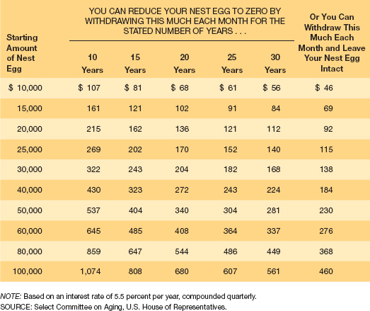

d

