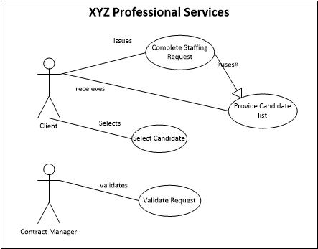
CATEGORY | 4 - Above Standards | 3 - Meets Standards | 2 - Approaching Standards | 1 - Below Standards | Score
Content | Identify the high level interface containing content for:  1. Complete staffing request  2. Candidate List  3. Select Candidate  4. Command for Validate Request | Identify content for only three of the four items  1. Complete staffing request  2. Candidate List  3. Select Candidate  4. Command for Validate Request | Identify content for only two of the four items  1. Complete staffing request  2. Candidate List  3. Select Candidate  4. Command for Validate Request | Identified content for one or fewer content items.
Controls | Used appropriate controls such as:  1. application title  2. labels for each field  3. text input fields  4. Option buttons  5. Command buttons | Used appropriate controls, but misused one control, such as not labeling controls, using radio buttons when check boxes where required. | Used appropriate controls, but misused two control, such as not labeling controls, using radio buttons when check boxes where required. | Did not use controls for the correct purpose
Layout | Layout of controls is logical, panels and controls are equally spaced both vertically and horizontally, and all controls are aligned appropriately. | Layout of controls is logical, panels and controls are equally spaced both vertically and horizontally, and controls are aligned appropriately, except that one control element or group is misaligned or out of place. | Layout of controls is logical, panels and controls are equally spaced both vertically and horizontally, and controls are aligned appropriately, except that two control element or group is misaligned or out of place. | Layout of controls is not structured and control elements are not aligned.

